AI AND THE HUMAN HEART OF CONFLICT
TRAINER WORKBOOK & FACILITATOR GUIDE

Conflict Resolution Day Alberta • September 2026
Content developed by Fresh Start Mediation | Supported by the Dispute Resolution Network (Government of Alberta) and ADR Institute of Alberta (ADRIA)
Companion to: AI_Conflict_Resolution_Branded_Chris Edits(20260902-015948).pptx

How to Use This Workbook
This workbook is designed so another trainer can deliver the session accurately without needing the original content developer in the room. It combines the approved speaker notes from the presentation with trainer-proofing, timing guidance, privacy and ethics safeguards, media checks, and a slide-by-slide facilitation guide.
OPERATING PRINCIPLE
Human-led. AI-assisted — when appropriate.
The course is an exploration, not a sales pitch. Understanding AI is not the same as recommending it.
Current deck order — production note
Slide numbering in this workbook follows the uploaded 52-slide deck. The current file places the “last word” voice clip at Slide 52, after the final Thank You. For the intended closing rhythm, deliver Slide 52 before the acknowledgements/final Thank You sequence (recommended delivery order near the end: 49 → 52 → 50 → 51). If the deck is reordered, renumber the workbook in the next revision.
Approved note format
- Purpose — why the slide exists.
- Suggested Script — language the trainer can use or adapt.
- Key Teaching Point — the idea participants should leave with.
- Important Nuance — what the trainer must qualify or must not overstate.
- Audience Interaction — how to engage the room without inviting unsafe disclosure.
- Transition — how to connect the slide to what follows.
Delivery modes
The deck is modular. A full delivery with all exercises and philosophical discussion can exceed three hours. The public Conflict Resolution Day workshop is 90 minutes, so trainers should use the Core 90-Minute Route in Appendix A and treat optional media, discussions, and worksheets as modules rather than mandatory stops.

Course at a Glance
Learning objectives  - Explain a practical working model of generative AI and language-model output without overstating “understanding.”  - Identify useful AI-assisted communication tasks while distinguishing capability from reliability.  - Recognize hallucination, bias, privacy, confidentiality, over-reliance, and false-neutrality risks.  - Use a human-led decision framework for task risk, authorization, fairness, judgment, and verification.  - Practise reframing communication while preserving substance, authenticity, boundaries, and accountability.  - Decide where AI may assist, where caution is needed, and what should remain human-led. | Core teaching lines  - Fluency is not accuracy.  - Confidence is not competence.  - Capability does not transfer accountability.  - Human-led does not mean human-only.  - Convenience is not permission.  - AI can analyze available signals; it cannot recover context never provided.  - The better question is not only “Can AI do this?” but “Should AI be used for this — and under what conditions?”  - Behaviour is observable. Motive is an interpretation.
Suggested timing
Block | Slides | Full / extended | 90-minute core approach
Opening & baseline | 1–6 | 15–20 min | 8–10 min; Worksheet 1 may be take-home
AI foundations & context | 7–13 | 25–30 min | 15 min; use one media clip at most
Conflict model, capabilities & risks | 14–20 | 20–25 min | 12–15 min
Reframing & communication practice | 21–25 | 25–35 min | 10–12 min; choose live demo OR worksheet
Human context & professional judgment | 26–31 | 20–25 min | 10–12 min; prioritize Good Will Hunting
Philosophical inquiry | 32–38 | 20–30 min | 8–10 min; use 33, 36, 37 only
Ethics, privacy & decision framework | 39–43 | 25–35 min | 15–18 min; this is a core block
Tools & mediation practice | 44–46 | 15–20 min | 7–10 min
Reflection & close | 47–52 | 25–35 min | 8–10 min; Practice Plan can be take-home
90-minute principle
In a 90-minute delivery, do not try to give every optional slide its full discussion time. Protect the ethics/privacy/decision-framework block, one meaningful communication exercise, one human-context illustration, and the neutral closing reflection. Appendix A gives a recommended route.

Trainer Preparation Checklist
48–72 hours before
[ ] Replace the Land Acknowledgement with wording approved for the host/location; confirm Nation names, spelling, and pronunciation.
[ ] Confirm the organization’s current AI policy, approved tools, approved use cases, and escalation/contact path for privacy or security questions.
[ ] Review Slide 44 (AI Landscape) within 30 days of delivery; product names, categories, features, and privacy practices change quickly.
[ ] Verify the Alberta AI Academy and ConflictResolutionDay.ca links and QR codes.
[ ] Confirm source, rights/permission, captions, and content notes for every media clip.
[ ] Prepare fictional or fully de-identified examples for all live exercises. Never improvise with real client/workplace information.
[ ] Print or distribute the four participant worksheets; decide which are in-session versus take-home.
Same day
[ ] Test slide deck, videos, audio, internet, QR codes, and any approved live AI tool.
[ ] Have an offline fallback for each live demo or video.
[ ] Confirm room setup for polls/pair discussions without requiring personal disclosure.
[ ] Remind co-facilitators of the course boundary: this is not an endorsement of AI or any named product.
[ ] Keep a visible clock. Philosophical questions expand quickly; protect the core ethics/privacy block.
After delivery
[ ] Capture questions the deck did not answer and flag them for content review rather than improvising a legal/technical answer.
[ ] Note any product-name or policy changes for the next version.
[ ] Record media or accessibility issues and update fallback instructions.
[ ] Invite interested participants to contact the Conflict Resolution Day Committee.

What Trainers Must Not Overstate
Memorable teaching shorthand is useful only if the trainer knows the technically precise version. Use the right-hand column when a participant challenges the shorthand.
Avoid / qualify this shorthand | Trainer-precise explanation
“AI understands meaning.” | Language models model relationships in context and can generate useful interpretations. That is not the same as lived human understanding.
“AI cannot hear tone / read body language.” | Some multimodal systems can analyze audio, images, pauses, emphasis, or facial signals when supplied. They still work only with available signals and may misinterpret them.
“People are emotional; AI is logical/objective.” | People can reason logically; AI output can be inconsistent, biased, incomplete, or wrong. Treat “objective AI” as a false binary.
“AI is empathetic.” | AI can generate empathetic-sounding language. Producing that language is not the same as experiencing empathy or holding a relationship.
“Human + AI always produces better outcomes.” | Human-AI performance varies by task, configuration, user, safeguards, and oversight. “Human-led, AI-assisted” is a responsible-use principle, not a performance guarantee.
“AI only recommends; humans decide.” | AI systems can be configured to make or execute decisions. The course’s point is normative: consequential professional authority and accountability should remain appropriately human/organizational.
“Consent makes AI use okay.” | Consent may be one legal authority, but it does not replace appropriate purpose, organizational approval, contractual duties, professional obligations, or safeguards.
“Approved tool means the data is safe.” | Approval is not blanket permission. The specific information, use case, account, contract, settings, and policy still matter.
“AI always stores or trains on prompts.” | Retention, access, and training practices vary by product, account type, contract, deployment, and settings.
“De-identified means anonymous.” | Removing names may reduce risk but detailed facts can still identify a person. Authorization and data minimization still matter.
“AI cannot assess sincerity or credibility.” | AI can generate credibility or sincerity assessments. It should not be treated as the authority for consequential professional judgments of that kind.
“AI has no intention / meaning.” | Avoid unnecessary consciousness claims. A generative model is not a human moral agent that bears accountability; human users can still have clear intentions around prompts, selection, editing, and sending.
“AI does not mediate.” | Automated or AI-mediated dispute systems exist. The safer personal statement is: “In my practice, I do not delegate mediation to AI; I remain the mediator.”
“AI will keep getting better.” | Capabilities change unevenly. Visible improvement in one task does not prove uniform progress across systems or capabilities.
“More context guarantees a better answer.” | Relevant context often helps, but supplied context can still be incomplete, biased, mistaken, or misleading. Verification remains necessary.

Privacy, Ethics & Exercise Non-Negotiables
THE SAFE DEFAULT
If you are unsure whether information may be entered into an AI system, pause and check before proceeding. Do not guess.
For every live activity
- Use fictional, generic, or fully de-identified examples unless the use of real information is explicitly authorized and appropriately protected.
- Do not ask participants to paste client, mediation, privileged, health, financial, investigation, family, security-sensitive, or workplace-conflict information into a general AI tool.
- Do not require participants to disclose personal conflicts to the room. Ask about the process, not the underlying story.
- Use only tools approved by the host organization and only for approved use cases.
- Remind participants that “not sure” is a legitimate outcome in the decision framework.
- Do not pressure participants to identify an AI use. Deliberate non-use may be the responsible choice.
If a participant asks, “Can I put this into AI?”
Do not give a categorical answer from the front of the room unless the rule is known and within your authority. Ask: What information is involved? What is the purpose? What tool/account is being used? Is the use authorized and approved? What policy, contract, privacy, security, or professional rules apply? If any of those are unclear, direct the participant to pause and check.

Media, Clip & Live-Demo Checklist
Slide | Media | Teaching purpose | Content / nuance | Rights / source | Fallback
11 | Data / Star Trek clip | Literal language vs missing context | Fictional illustration; not a technical demonstration | Confirm source + permission | Prepared still or verbal example
16 | Generated-video progress clip | Visible improvement in one capability | Do not extrapolate to all AI; not evidence of continuous learning/general intelligence | Confirm source + permission | Use two stills and describe comparison
22 | Live I-statement demo | Show AI as first-draft assistance | Fictional input only; approved tool only; review assumptions | N/A / approved platform | Use prepared sample output
27 | Good Will Hunting clip | Relationship, timing, intuition, professional judgment | Content note: emotional distress/trauma; dramatic portrayal, not clinical model | Licensed/captioned copy | Use still + guided questions
31 | Tony Stark / fictional AI clip | Human frames problem; system contributes; human interprets | Science fiction; contains profanity; not evidence of real AI capability | Confirm source + permission | Summarize the four observation questions
52 | Voice “last word” social-media clip | Anthropomorphism; behaviour vs inferred motive | Do not infer ego, annoyance, intention, or consciousness; provenance may be uncertain | Record source/date/model/editing/permission | Describe observed behaviour or use screenshot
Before pressing Play
- Source recorded
- Permission/licensing confirmed
- Captions available
- Content note prepared if needed
- Audio tested
- Offline fallback ready
- Trainer knows the precise teaching point and what the clip does not prove

Participant Worksheets — Facilitation Overview
Slide | Worksheet | Purpose | Suggested use | Privacy reminder
6 | AI & Me: Where Do I Stand? | Personal baseline and reflection | 3–4 min; keep for end-of-session comparison | Do not write confidential workplace, client, family, or personal details.
23 | From Reaction to Response | Move from reactive message to intentional human version; optional AI draft | 8–12 min extended; in 90 min use as take-home or replace live demo | Use fictional or fully de-identified situations only.
43 | Before You Prompt | Decide whether and how AI belongs in a task | 6–8 min or pair debrief | Do not record sensitive real-world details; Pause is a valid outcome.
48 | My AI Practice Plan | Convert learning into deliberate practice, restraint, safeguards, and human skill protection | 8–10 min extended; take-home in 90 min | The 30-day experiment may involve AI, human-led change, or deliberate non-use.
TRAINER RULE
A worksheet is not an invitation to collect sensitive stories. Ask participants to discuss which check or step changed their thinking—not the underlying confidential situation.

Slide 1 — When AI Meets Human Conflict
TRAINER SNAPSHOT
Delivery: CORE
Suggested time: 2 min
Purpose: Welcome participants and establish a balanced, human-centred tone.
Suggested Script
“Good morning/afternoon, everyone. We’re really glad to be here.
Today we’re talking about something that barely existed as a workplace conversation a few years ago: what happens when artificial intelligence begins entering human conflict.
Before we begin, I have a confession. ChatGPT helped us prepare parts of this presentation—which seemed appropriate.
Then we spent twice as long making it sound human.
Today, we’ll explore what AI can do, where it may help, where it can fail, and—most importantly—what responsibility remains with us.”
Key teaching point: This is an exploration, not a sales pitch.
TRANSITION
“Before we begin that conversation, we want to acknowledge the lands from which we are gathering.”

Slide 2 — Land Acknowledgement
 | TRAINER SNAPSHOT  Delivery: LOCALIZE  Suggested time: 1–2 min  Purpose: Ensure the acknowledgement is accurate, local, and respectfully delivered.  ⚠ LOCALIZE before delivery: approved Land Acknowledgement wording and pronunciation.
Trainer / Facilitation Instructions
Replace the master-slide language before presenting.
Use wording approved by the host organization or relevant Indigenous Relations office.
Confirm current Nation names and preferred spellings.
Practise unfamiliar pronunciations before the session.
For virtual sessions, acknowledge both the location from which the presenter is speaking and that participants may be joining from many different territories.
Do not improvise a generic acknowledgement.
TRANSITION
“Conflict resolution begins with relationship, respect, and awareness of the context in which we meet.”

Slide 3 — What Is Conflict Resolution Day?
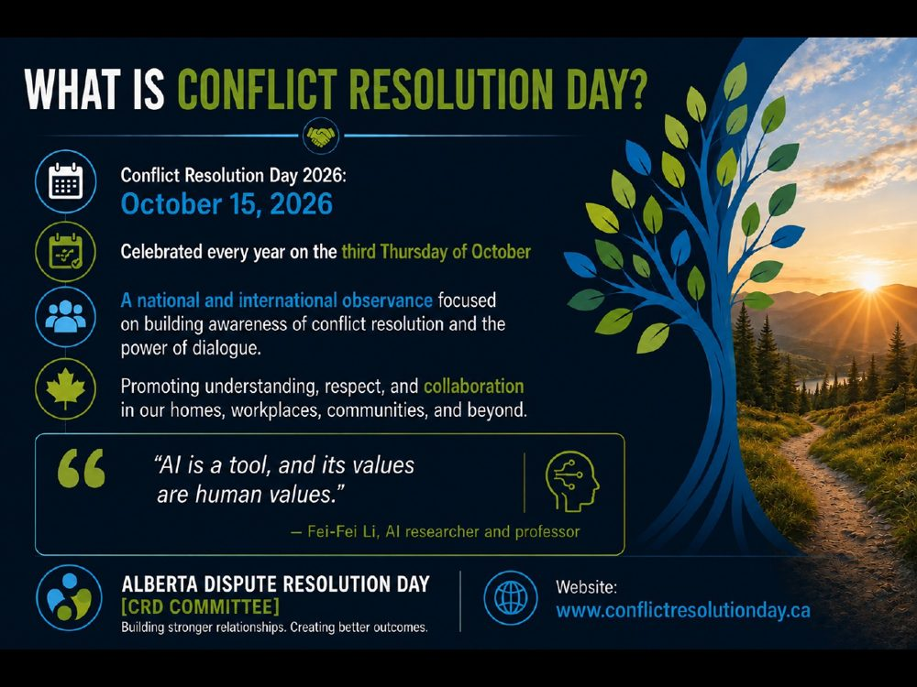 | TRAINER SNAPSHOT  Delivery: CORE  Suggested time: 2 min  Purpose: Connect the AI topic to the purpose of Conflict Resolution Day.
Suggested Script
“Conflict Resolution Day is observed on the third Thursday of October each year.
Its purpose is to increase awareness of constructive ways to prevent, manage, and resolve conflict.
This year’s topic may sound technological, but the central question is deeply human: how can we use emerging tools without surrendering the values, relationships, and judgment that make conflict resolution work?”
Key teaching point: The session is about human choices surrounding AI—not merely AI technology.
TRANSITION
“That brings us to an important clarification before we begin.”
Sources named in the deck
• Conflict Resolution Day Alberta
• Fei-Fei Li interview, “AI Is a Tool, and Its Values Are Human Values”

Slide 4 — A Note Before We Begin
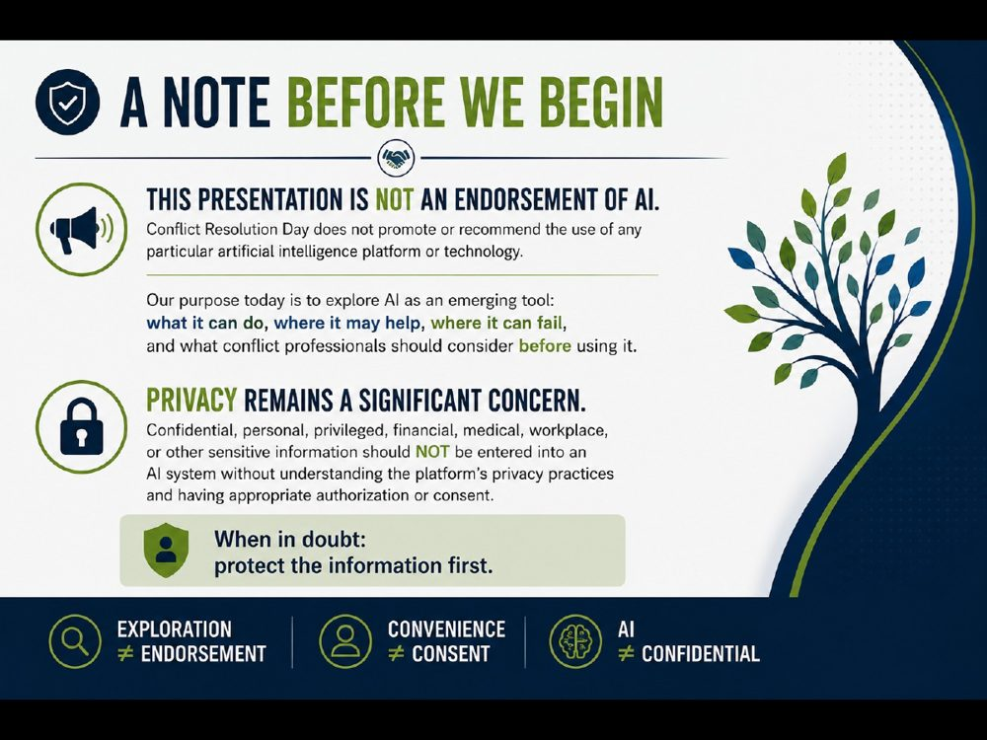 | TRAINER SNAPSHOT  Delivery: CORE  Suggested time: 2 min  Purpose: Establish the session’s boundaries before demonstrating any AI use.
Suggested Script
“This presentation is not an endorsement of AI or of any particular product.
We’re exploring these tools because people are already using them. Understanding a technology is not the same thing as recommending it.
The privacy warning is equally important. Consent can matter, but consent alone does not make every use appropriate. We also need legal authority, organizational approval, an appropriate purpose, safeguards, and an understanding of what the particular platform does with information.
If you work within an organization, its policies and approved tools apply.
If you are uncertain, protect the information first and find out before prompting.”
IMPORTANT NUANCE — DO NOT OVERSTATE
Privacy practices differ by product, account type, contract, settings, and jurisdiction.
TRANSITION
“With those boundaries established, let’s begin with an honest question about how we’re already using AI.”
Sources named in the deck
• Canadian privacy commissioners’ generative-AI principles
• Law Society of Alberta Generative AI Playbook

Slide 5 — How Often Do You Let AI Write for You?
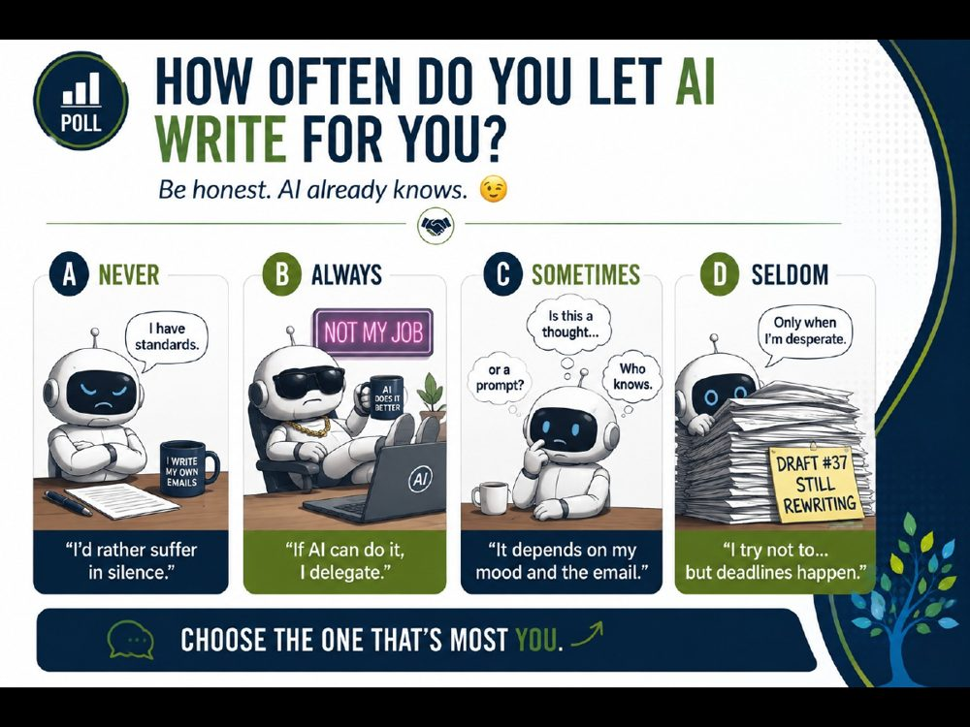 | TRAINER SNAPSHOT  Delivery: CORE • POLL  Suggested time: 2–3 min  Purpose: Surface the room’s current level of AI use without judgment.
Suggested Script
“Let’s begin with a quick poll.
How often do you use AI to draft or revise something you write?
Not necessarily to write the entire thing. Maybe you use it to begin, reorganize, shorten, soften, or proofread.
Choose the answer that sounds most like you.”
Audience Interaction
Ask for hands, use an online poll, or invite participants to stand along an imaginary continuum.
“Notice the range in the room. Some people use AI every day. Some have never opened it. Neither position tells us whether someone is using it responsibly. That’s what we’re here to examine.”
TRANSITION
“Let’s take that reflection one step further.”

Slide 6 — AI & Me: Where Do I Stand?
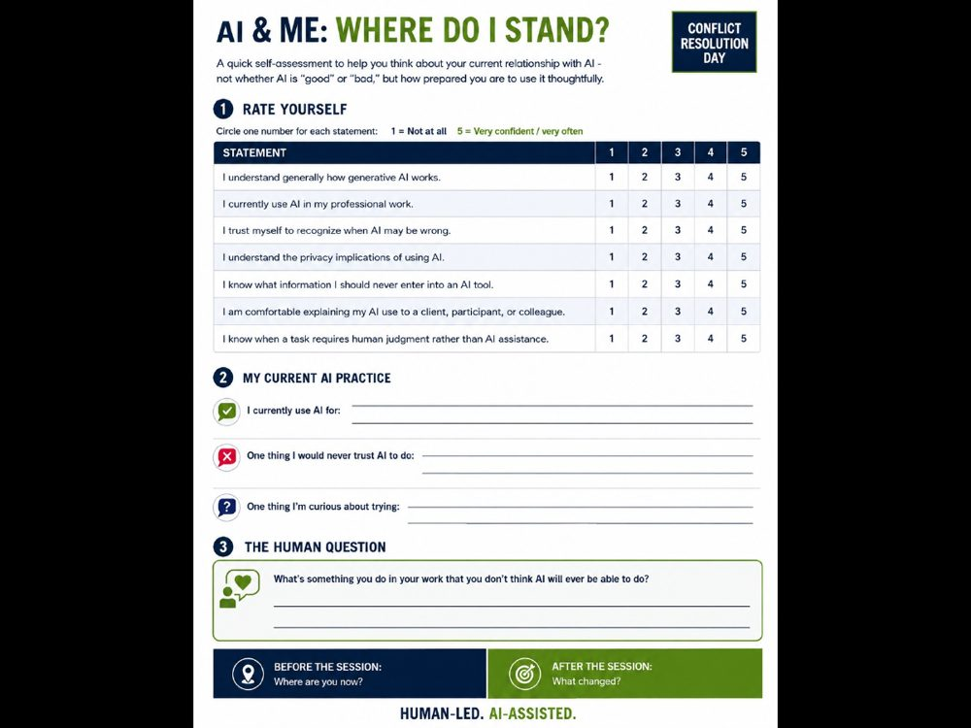 | TRAINER SNAPSHOT  Delivery: OPTIONAL • WORKSHEET  Suggested time: 3–4 min  Purpose: Establish a personal baseline participants can revisit at the end.
Suggested Script
“This is not a test, and you won’t be asked to hand it in.
Take a few minutes to assess where you are right now—your confidence, your current use, your understanding of privacy, and your comfort explaining your AI use to someone affected by it.
Please do not write down confidential workplace, client, family, or personal details.
The final question is deliberately different from asking what AI will ‘never’ be capable of. None of us can reliably predict that.
Instead, ask yourself: what should remain human-led because human presence, judgment, responsibility, or relationship matters?”
Timing: Three to four minutes.
Audience Interaction
Ask participants to keep the worksheet. Return to it during slide 49.
TRANSITION
“To answer those questions thoughtfully, we first need a better distinction between what AI can process and what people experience.”
Sources named in the deck
• Canadian privacy commissioners’ generative-AI principles

Slide 7 — AI and Human Conflict
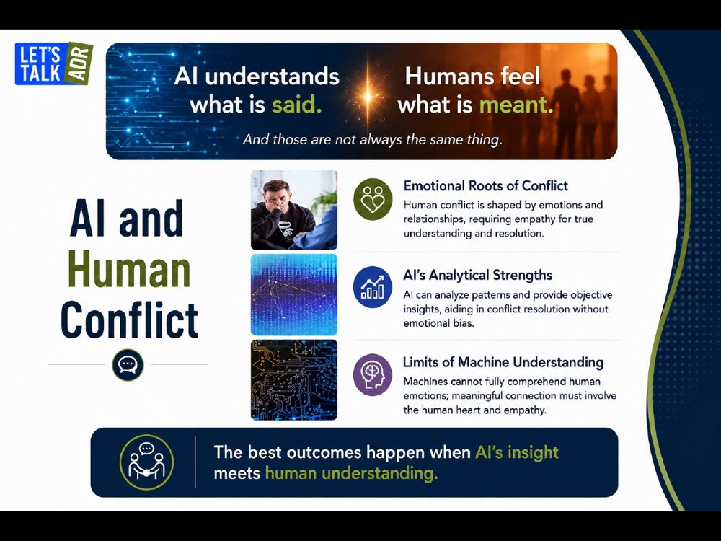 | TRAINER SNAPSHOT  Delivery: CORE  Suggested time: 2 min  Purpose: Introduce the distinction between linguistic capability and lived human experience.
Suggested Script
“Conflict isn’t only about what happened. It’s also about what the event meant to the people involved.
AI can analyze the words we provide. It can identify patterns, summarize positions, and suggest different ways of expressing something.
But it does not enter the conversation carrying a relationship, a childhood, a fear, a reputation, or a history with the other person.
It can produce empathetic language. That can be genuinely useful.
But producing empathetic language is not the same thing as experiencing empathy.”
IMPORTANT NUANCE — DO NOT OVERSTATE
Do not say AI is objective or free from bias. AI may identify patterns that people miss, but the model, its training data, the prompt, and the user’s framing can all introduce bias.
Audience question: “What is the shortest conflict you have experienced? What is the longest? If conflict were only about facts, how long would most conflicts last?”
TRANSITION
“This is not really a competition between people and machines. They play fundamentally different roles.”
Sources named in the deck
• NIST Generative AI Risk Management Profile

Slide 8 — People + AI
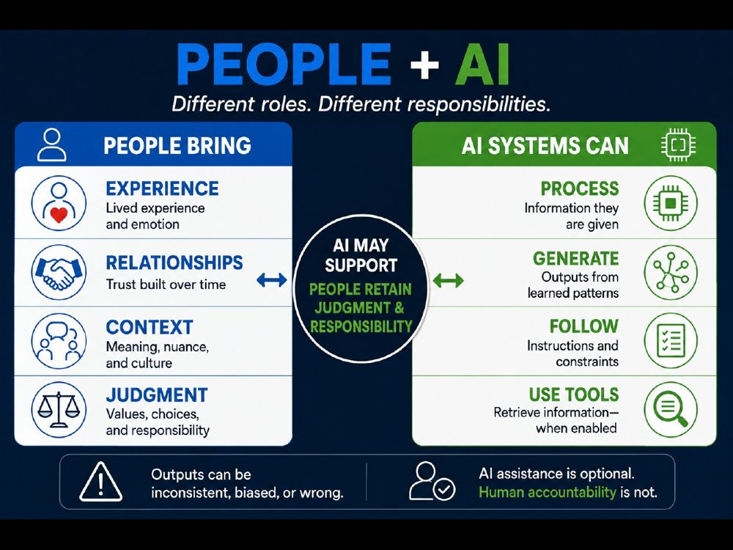 | TRAINER SNAPSHOT  Delivery: CORE  Suggested time: 2 min  Purpose: Replace the inaccurate emotional-human-versus-logical-AI binary.
Suggested Script
“It is tempting to describe people as emotional and AI as logical.
But people can be highly logical, and AI output can be inconsistent, biased, or simply wrong.
The more useful distinction is about roles.
People bring lived experience, relationships, context, values, and responsibility.
AI systems process the information they are given and generate outputs based on learned patterns, instructions, and—depending on the product—information retrieved through tools.
AI may contribute to the process. It should not inherit the judgment or responsibility.”
IMPORTANT NUANCE — DO NOT OVERSTATE
Effective conflict management does not require AI. AI assistance is optional; human accountability is not.
TRANSITION
“Now that we’ve distinguished the roles, let’s demystify the technology behind tools such as ChatGPT.”
Sources named in the deck
• NIST Generative AI Risk Management Profile

Slide 9 — What Does GPT Mean?
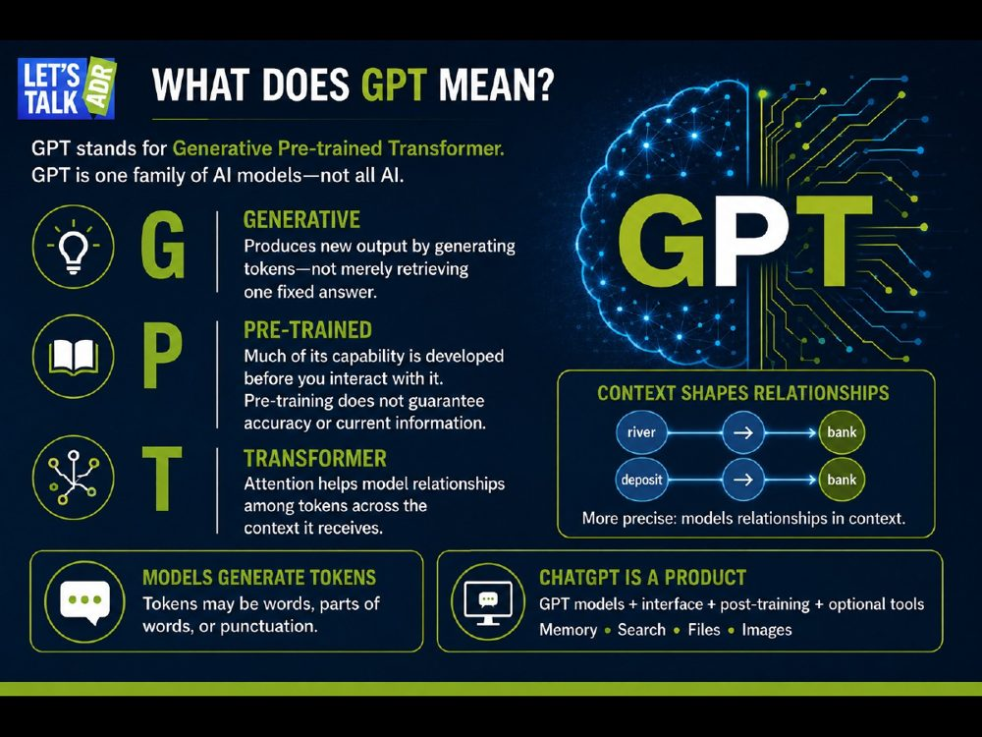 | TRAINER SNAPSHOT  Delivery: CORE  Suggested time: 3 min  Purpose: Explain the acronym accurately without turning the session into a computer-science lecture.
Suggested Script
“GPT stands for Generative Pre-trained Transformer.
Generative means it produces new output rather than simply retrieving one fixed answer from a database.
Pre-trained means much of its capability was developed before we began interacting with it.
Transformer refers to the architecture. Its attention mechanisms help the model represent relationships among tokens across the context it receives.
People often say it understands which meaning of ‘bank’ applies because of the words around it. That is useful shorthand. More precisely, it is modelling relationships within the context.”
IMPORTANT NUANCE — DO NOT OVERSTATE
Models generally generate tokens, not whole words.
GPT is not synonymous with all AI.
ChatGPT is a product that uses GPT models plus interfaces, post-training, and—in some modes—memory, search, file analysis, images, or other tools.
Pre-training does not guarantee that information is accurate or current.
TRANSITION
“So what is actually happening when a language model produces a response?”
Sources named in the deck
• Attention Is All You Need
• OpenAI’s description of the GPT training process

Slide 10 — How Language Models Work
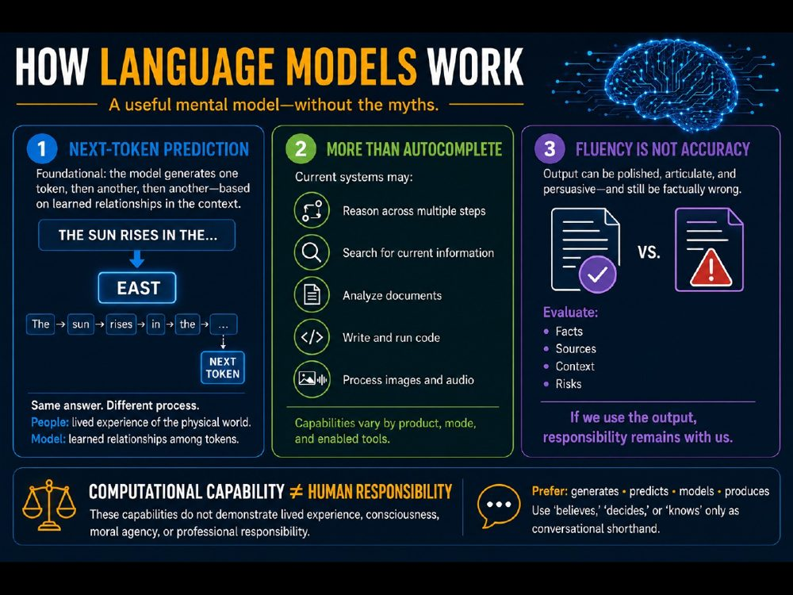 | TRAINER SNAPSHOT  Delivery: CORE  Suggested time: 4–5 min  Purpose: Provide an accurate but accessible mental model of generative language technology.
Suggested Script
“This is the simplified version—but it is important that our simplified version not become a false one.
For the language models we’re discussing, next-token prediction is foundational. The model generates one token, then another, then another.
But ‘autocomplete’ is no longer the whole story. Current systems may also reason across multiple steps, search for current information, analyze documents, write and run code, or process images and audio.
Those capabilities remain computational capabilities. They do not demonstrate lived experience, consciousness, moral agency, or professional responsibility.
The model may produce something polished, articulate, and persuasive—and still be factually wrong.
That is why the practical distinction matters more than the philosophical one:
Fluency is not accuracy.
If we use the output, the responsibility to evaluate it remains with us.”
IMPORTANT NUANCE — DO NOT OVERSTATE
Avoid saying the model “believes,” “decides,” or “knows” unless clearly using conversational shorthand.
Audience Interaction
Ask: “The sun rises in the…?”
After the audience says east:
“You and the model can produce the same answer through very different processes. You understand the sun, direction, and the physical world through lived experience. The model can generate the expected token through learned relationships.”
TRANSITION
“AI is exceptionally good at detecting patterns in the information we give it. But how much of what we mean is actually contained in the words?”
Advance to the Data clip and then the “I never said he stole my money” exercise.
Sources named in the deck
• GPT-4 training process and limitations
• Why language models hallucinate
• OpenAI reasoning-model documentation
• NIST Generative AI Risk Management Profile

Slide 11 — Video Clip: Data and Missing Context
 | TRAINER SNAPSHOT  Delivery: OPTIONAL • MEDIA  Suggested time: 2–3 min  Purpose: Use a fictional Data clip to set up the distinction between literal language and the broader context needed to interpret meaning.  ⚠ MEDIA: confirm source/permission, captions, AV, and fallback.
Suggested Script
“Before we use this clip as an example, a quick reminder: Data is fictional. This is an illustration, not a technical demonstration. Watch what happens when a character works mainly with the literal content of language while the human meaning depends on tone, emphasis, timing, relationship, or shared context. The joke works because the words alone are not always enough.”
KEY TEACHING POINT
Missing context can materially change interpretation. The useful question is not whether AI can process language, but what information was actually available to it.
IMPORTANT NUANCE — DO NOT OVERSTATE
Do not say AI universally “cannot hear tone” or “cannot understand emphasis.” Multimodal systems may analyze audio or video signals when provided. The limitation illustrated here is unavailable or incomplete context.
Audience Interaction
Briefly introduce the characters if needed. After the clip ask: “What information mattered here that was not contained in the literal words?”
TRANSITION
“Let’s test that same idea with a sentence where the words stay exactly the same but the possible meaning changes.”

Slide 12 — Does AI Have the Context You Mean?
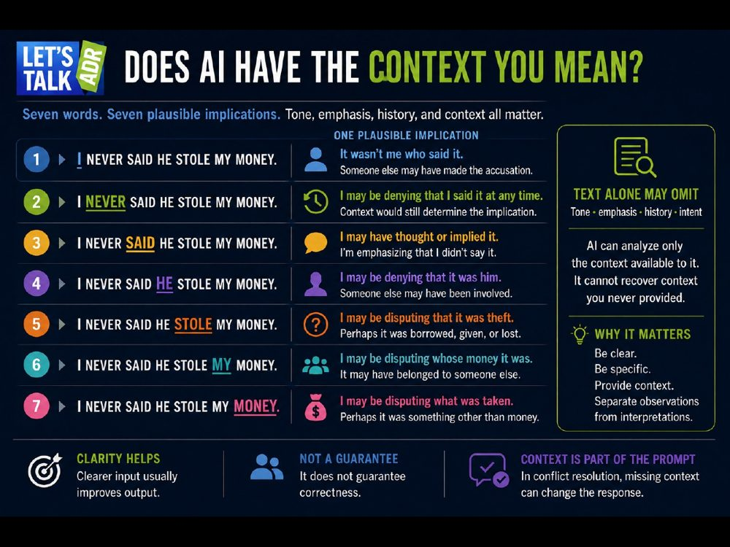 | TRAINER SNAPSHOT  Delivery: CORE  Suggested time: 5–7 min  Purpose: Demonstrate that identical words can carry several plausible implications depending on emphasis and context—and clarify that AI’s central limitation is unavailable information, not a universal inability to analyze tone.
Suggested Script
“I want to try something with you.
There are seven words on this slide:
I never said he stole my money.
I’m going to say exactly the same seven words seven different ways. Listen to what happens to the possible meaning.
One important qualification: these are plausible implications, not seven fixed meanings. Emphasis gives us clues, but context still determines what the speaker actually intends.”
1. Emphasize “I”
“I never said he stole my money.”
“What might that imply?”
Allow responses.
“One possibility is that I’m denying that I made the accusation. Perhaps someone else said it.”
2. Emphasize “never”
“I never said he stole my money.”
“This may strengthen my denial. I might be saying that I did not say it at any time.
But emphasis alone does not prove that interpretation. We would still need context.”
3. Emphasize “said”
“I never said he stole my money.”
“One possible implication is that I thought it, suggested it, or communicated it another way—but did not actually say the words.”
4. Emphasize “he”
“I never said he stole my money.”
“This might suggest that I’m disputing who was involved. Perhaps I suspect someone else.”
5. Emphasize “stole”
“I never said he stole my money.”
“Maybe I’m disputing whether it was theft. Perhaps the money was borrowed, given, misplaced, or lost.”
6. Emphasize “my”
“I never said he stole my money.”
“This may shift the question of ownership. Perhaps the money belonged to someone else.”
7. Emphasize “money”
“I never said he stole my money.”
“Perhaps I’m disputing what was taken. Maybe it was something other than money.”
Pause.
“Same seven words. Several plausible implications.
When another person hears me speak, they may be processing much more than the words. They hear my tone, pace, timing, and emphasis. They may see my facial expression and body language. They also bring their knowledge of the situation—and perhaps their history with me.
If an AI system receives audio or video, it may be able to analyze some of those signals.
But if it receives only the typed sentence, much of that information is absent.
And regardless of the technology, it cannot recover context that we never provided.
That matters enormously in conflict resolution.
Consider statements such as:
‘My ex is being unreasonable.’
‘My employee has an attitude.’
‘She was aggressive in the meeting.’
Those statements communicate an interpretation, but they do not tell us specifically what happened.
What did the person say or do?
When did it happen?
What preceded it?
What effect did it have?
What outcome is the speaker seeking?
If we give AI an interpretation as though it were an established fact, it may build its response on the premise we supplied.
So the lesson is not simply ‘give AI more words.’
The lesson is:
Be clear.
Be specific.
Provide relevant context.
Separate observations from interpretations.
Clearer input will usually improve the output.
It does not guarantee that the output will be correct.”
KEY TEACHING POINT
AI can analyze only the information and context available to it. Missing context can materially change the response.
IMPORTANT NUANCE — DO NOT OVERSTATE
The seven interpretations are possibilities, not definitive meanings.
Multimodal systems may analyze tone, pace, emphasis, facial expressions, audio, or video when those signals are provided.
An AI system can analyze tone without experiencing or “feeling” it.
More context does not guarantee correctness. The supplied context may itself be incomplete, biased, mistaken, or misleading.
Even with a clear prompt, an AI system may make an incorrect inference or generate unsupported information.
Avoid saying the system “knows what we mean.” More precisely, it generates an interpretation from the information available to it.
Audience Interaction
After emphasizing each word, ask:
“What is one possible implication?”
If the audience provides only the interpretation displayed on the slide, follow with:
“Can anyone imagine another interpretation?”
During the debrief, ask:
“What additional context would you need before deciding what the speaker actually meant?”
TRANSITION
“AI can process words—and, in some modes, audio and visual cues. But conflict also involves relationships, lived experience, professional judgment, and responsibility.
That brings us to our next question: which parts of conflict work should remain human-led, even when AI assists?”
Sources named in the deck
• OpenAI — Advancing voice intelligence with new models
• NIST — Generative Artificial Intelligence Risk Management Profile

Slide 13 — Where People Must Lead Even When AI Assists
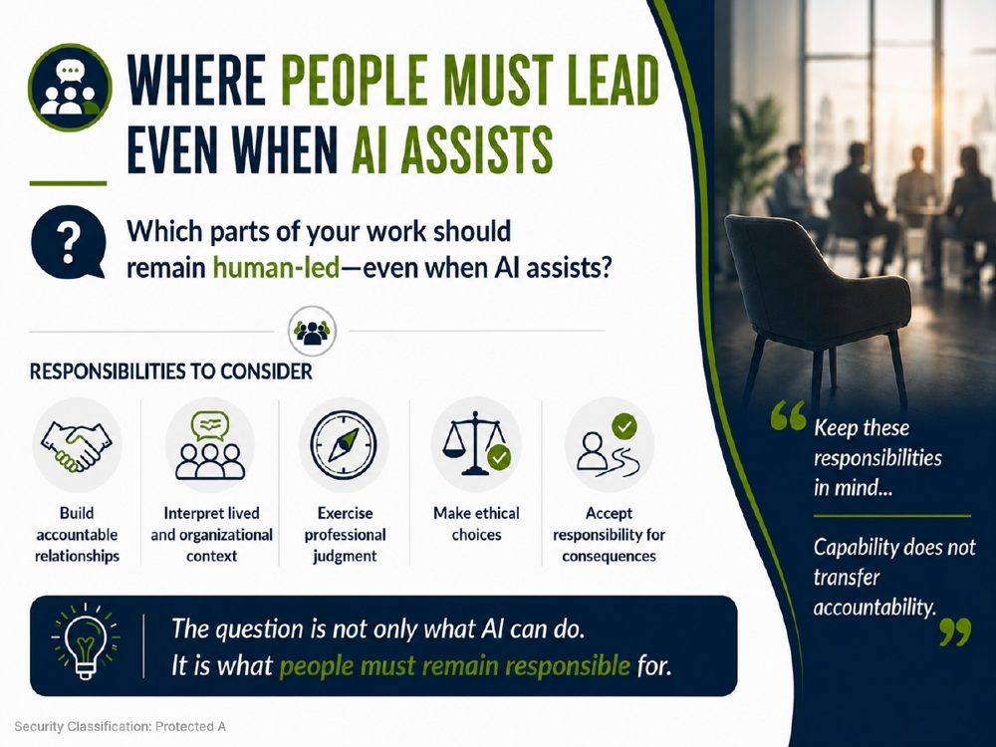 | TRAINER SNAPSHOT  Delivery: CORE  Suggested time: 3–4 min  Purpose: Shift the discussion away from speculative claims about what AI will “never” do and toward the responsibilities people should retain when AI is used in professional conflict-resolution work.
Suggested Script
“Before we continue, I want to ask you a different kind of question.
Not: What will AI never be able to do?
None of us can responsibly predict the permanent limits of this technology.
The more useful question is:
Which parts of your work should remain human-led—even when AI assists?
Take a moment and think about your own work.
Where might AI contribute ideas, analysis, drafting, or organization—but a person must still lead the process?”
Pause for reflection and collect several answers.
“Here are five responsibilities you may have identified.
First, building accountable relationships.
AI might help us prepare for a conversation or draft a message. But the people involved still have to establish trust, repair harm, make commitments, and remain accountable to one another.
Second, interpreting lived and organizational context.
An AI system can work with the context we provide, but it may not have access to the history, culture, power dynamics, relationships, policies, or unwritten expectations shaping the situation.
Third, exercising professional judgment.
AI can generate options and identify considerations. It can even challenge our thinking. But the professional remains responsible for deciding what information is relevant, what risks matter, and what course of action is appropriate.
Fourth, making ethical choices.
AI can summarize ethical frameworks or generate arguments from different perspectives. But it does not assume our professional duties or become morally accountable for the choice we make.
Finally, accepting responsibility for consequences.
An AI-generated recommendation does not attend the difficult meeting, repair the relationship, defend the decision, or live with the outcome.
We do.
That is the distinction I want you to remember:
Capability does not transfer accountability.
The question is not only what AI can do.
It is what people must remain responsible for.”
KEY TEACHING POINT
AI may assist with a professional task without becoming responsible for the judgment, relationship, ethical duty, or consequences involved.
IMPORTANT NUANCE — DO NOT OVERSTATE
Human-led does not mean human-only.
AI may contribute meaningfully to research, preparation, drafting, analysis, option generation, and communication. The appropriate division of work depends on the task, risks, professional obligations, organizational policy, and applicable law.
The slide makes a normative point about responsible role allocation—not a prediction that AI will remain technically incapable of performing particular tasks.
Audience Interaction
Suggested timing: 3–4 minutes
Give participants 20 seconds to reflect individually.
Ask them to discuss their answer with one nearby person for approximately 45 seconds.
Invite three or four responses from the room.
Ask one or two debrief questions:
“Why should that responsibility remain human-led?”
“Could AI still assist with part of it?”
“Where would you draw the boundary?”
“Who is accountable if the AI-assisted decision causes harm?”
“Would your answer change in a low-risk versus high-risk situation?”
Reveal or review the five examples on the slide.
Avoid treating audience answers as proof that AI cannot perform the activity. Redirect the discussion toward why people should retain leadership and accountability.
TRANSITION
“If people must remain responsible for context, judgment, relationships, and consequences, we need to look more closely at what makes conflict more than a simple disagreement.”
Sources named in the deck
• NIST — Generative Artificial Intelligence Risk Management Profile
• NIST — Artificial Intelligence Risk Management Framework

Slide 14 — A Useful Working Model of Conflict
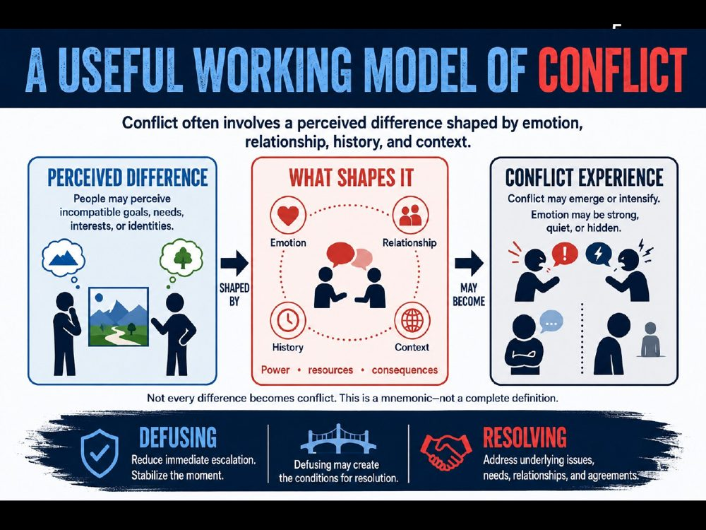 | TRAINER SNAPSHOT  Delivery: CORE  Suggested time: 2–3 min  Purpose: Introduce a useful working model of conflict while making clear that conflict is more complex than a simple formula. Distinguish calming immediate escalation from resolving the underlying conflict.
Suggested Script
“Conflict is sometimes summarized as difference plus emotion. That is a useful mnemonic, but it is not a complete definition.
A difference by itself does not necessarily create conflict. People disagree every day without experiencing conflict. Emotions also do not need to be intense, obvious, or openly expressed. They may be quiet, mixed, or hidden.
A more useful working model is this:
Conflict often involves a perceived difference shaped by emotion, relationships, history, and context.
The word perceived matters. Conflict may arise not only from what is objectively happening, but also from what people believe is happening and what they think it means.
Other factors may also shape the conflict: interdependence, identity, competing needs or interests, limited resources, power imbalances, and the consequences people anticipate.
So conflict is rarely only about the issue visible on the surface. Two people may appear to be arguing about a deadline, for example, while the deeper concerns involve respect, fairness, trust, authority, or a history of unmet expectations.
And here is the deliberately humorous version: If conflict were only about facts, some disagreements might last about thirty seconds.
Of course, facts matter. But resolving conflict usually requires us to understand what those facts mean to the people involved.
That also helps us distinguish two different goals. Defusing means reducing immediate escalation and stabilizing the moment. Resolving means addressing the underlying issues, needs, relationships, and possible agreements.
Defusing can create the conditions for resolution—but it is not the same as resolution.”
IMPORTANT NUANCE — DO NOT OVERSTATE
Do not present conflict equals difference plus emotion as a universal definition. Conflict may involve perceived incompatibility even when emotions are not visible. Likewise, reducing emotional intensity may make a conversation safer without resolving its underlying causes.
The “thirty seconds” line is humour intended to make the concept memorable, not a factual claim.
Audience Interaction
Timing: 2–3 minutes
Ask participants:
“Think of a workplace conflict that appeared to be about one issue but was influenced by something beneath the surface. What else was shaping it?”
Invite two or three brief responses. If needed, prompt with:
Relationship or history?
Trust or respect?
Identity or values?
Power or authority?
Resources or consequences?
Then ask:
“What might help defuse that situation immediately—and what would still need to happen for it to be resolved?”
Reinforce that the answers may be different.
TRANSITION
“Once we recognize that conflict is shaped by more than the visible disagreement, we can begin examining where AI may assist—and where human context, judgment, and responsibility remain essential.”

Slide 15 — AI Isn't Coming. It's Already Here.
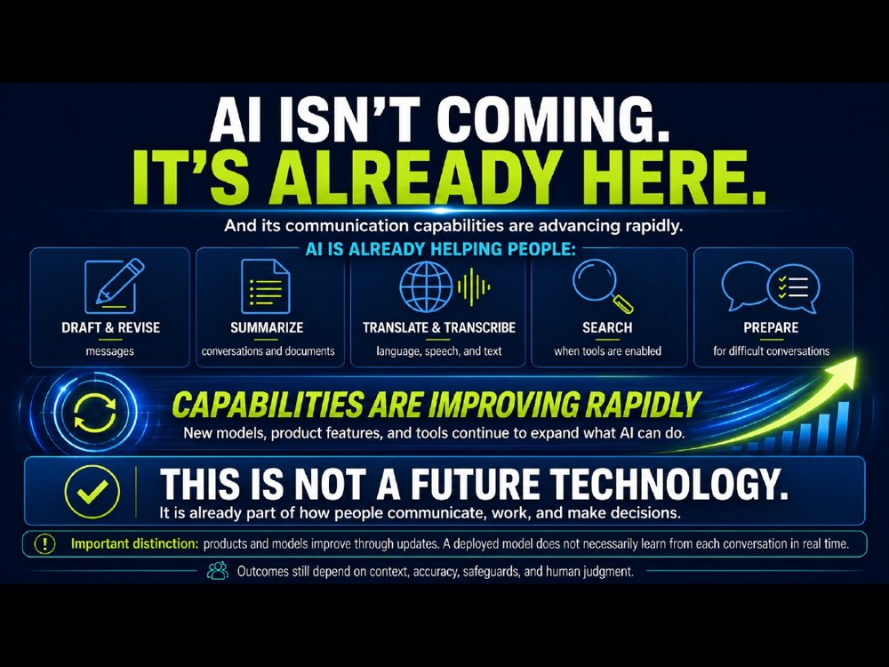 | TRAINER SNAPSHOT  Delivery: CORE  Suggested time: 1–2 min  Purpose: Establish that AI already affects everyday communication and preparation, without presenting adoption as inevitable or desirable.
Suggested Script
“AI is already shaping how we communicate. Emails. Texts. Search. Drafting. Even how some people prepare for difficult conversations. It is not a future-only issue. The workplace question is already here: when these tools are available, how do we decide whether and how to use them responsibly?”
KEY TEACHING POINT
The course examines a present workplace reality; understanding AI is not the same as endorsing it.
IMPORTANT NUANCE — DO NOT OVERSTATE
Avoid implying that every workplace, employee, or profession is already using AI or that adoption is inevitable.
TRANSITION
“And one reason this conversation feels urgent is how quickly some visible AI capabilities have changed.”

Slide 16 — Video Clip: Rapid Improvement in Generated Video
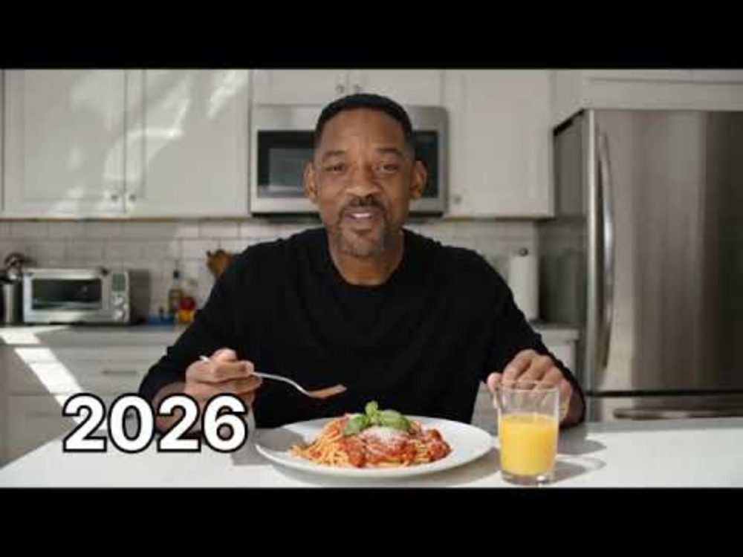 | TRAINER SNAPSHOT  Delivery: OPTIONAL • MEDIA  Suggested time: 2 min  Purpose: Use a familiar generated-video comparison to illustrate rapid improvement in one visible capability while preventing overgeneralization.  ⚠ MEDIA: confirm source/permission, captions, AV, and fallback.
Suggested Script
“This comparison is striking because one visible capability—generated video—improved quickly. But do not generalize from this clip to every AI capability. It does not show that every system is improving at the same rate, that a deployed model is continuously learning from us, or that the system possesses general intelligence.”
KEY TEACHING POINT
Rapid progress in one capability is evidence about that capability, not proof of uniform progress across all AI.
IMPORTANT NUANCE — DO NOT OVERSTATE
Treat the clip as an illustration of visible capability change, not a technical benchmark. Confirm the clip source and permission before presenting.
TRANSITION
“So rather than assuming AI is simply getting ‘better’ at everything, let’s look at the specific tasks generative AI can help with—and the limits that still matter.”

Slide 17 — Where Generative AI Can Be Useful
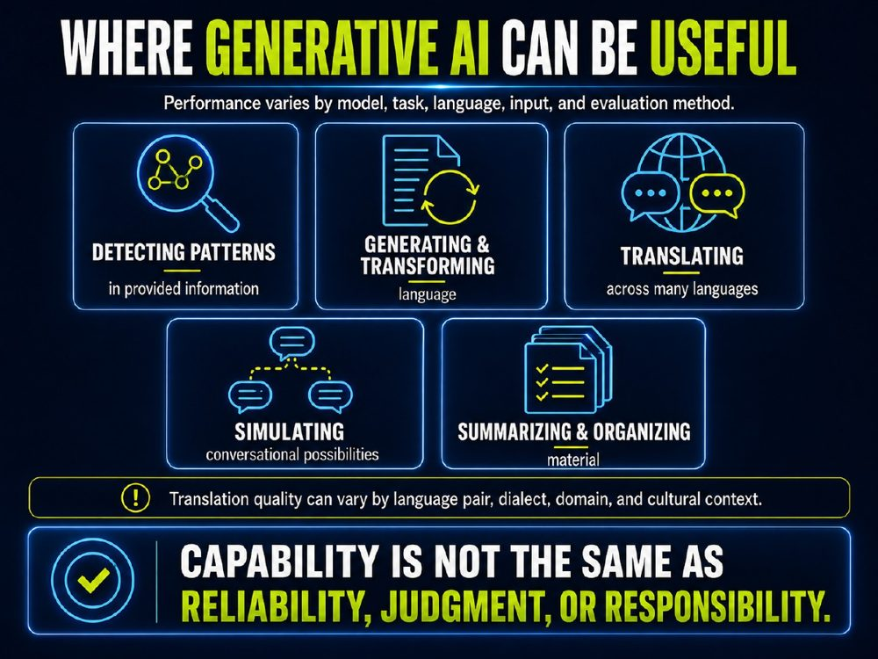 | TRAINER SNAPSHOT  Delivery: CORE  Suggested time: 2–3 min  Purpose: Identify several areas where generative AI may assist with communication while reinforcing that capability does not guarantee dependable output or transfer responsibility away from the user.
Suggested Script
“Generative AI can be useful across several communication tasks—but its performance varies by model, task, language, input, and how we evaluate the result.
First, it can detect patterns in the information we provide. For example, it may identify recurring themes in interview notes, highlight differences between documents, or organize concerns raised during a conversation.
Second, it can generate and transform language. It can produce a first draft, revise tone, simplify complicated wording, suggest questions, or reorganize an explanation.
Third, it can translate and transcribe across many languages. That can make information more accessible, but the quality is not uniform. Performance may vary depending on the language pair, dialect, technical field, cultural context, and clarity of the original material.
Fourth, it can simulate conversational possibilities. We might ask it to generate several ways someone could respond or help us rehearse a difficult conversation.
But simulation is not prediction. An AI-generated response does not tell us what a particular person will actually think, feel, say, or do.
Finally, it can summarize and organize material. That may help us work through long documents or complicated information more efficiently.
The critical point is that these are capabilities—not guarantees.
A system can produce a fluent translation that contains an important error. It can summarize a document while omitting a critical qualification. It can detect a pattern that is incomplete or misleading. It can generate a plausible conversational response that does not fit the actual person or situation.
Capability is not the same as reliability, judgment, or responsibility.
AI may help perform the task. The person using the output remains responsible for deciding whether it is accurate, appropriate, and safe to use.”
IMPORTANT NUANCE — DO NOT OVERSTATE
Avoid saying that generative AI universally “excels” at these tasks. Performance can vary substantially among models and across tasks, languages, domains, prompts, and evaluation standards.
“Simulating conversational possibilities” means generating plausible examples—not reading another person’s mind, predicting behaviour, or determining intent.
Translations, summaries, and detected patterns should be reviewed when accuracy, cultural nuance, confidentiality, or consequences matter.
Audience Interaction
Timing: 2–3 minutes
Ask participants:
“Which of these capabilities could be most useful in your work?”
Invite a quick show of hands or two or three responses.
Follow with:
“What would you need to check before relying on that output?”
Listen for answers such as:
Accuracy and missing information
Tone and cultural context
Confidentiality and approved-tool requirements
Bias or misleading assumptions
Whether professional review is required
Who will be affected by the decision
Conclude:
“The more consequential the use, the more important human review becomes.”
TRANSITION
“These capabilities can be genuinely valuable. But to use them responsibly, we also need to understand where the output may become unreliable—and why something that sounds convincing can still be wrong.”

Slide 18 — What AI Doesn't Bring to the Room
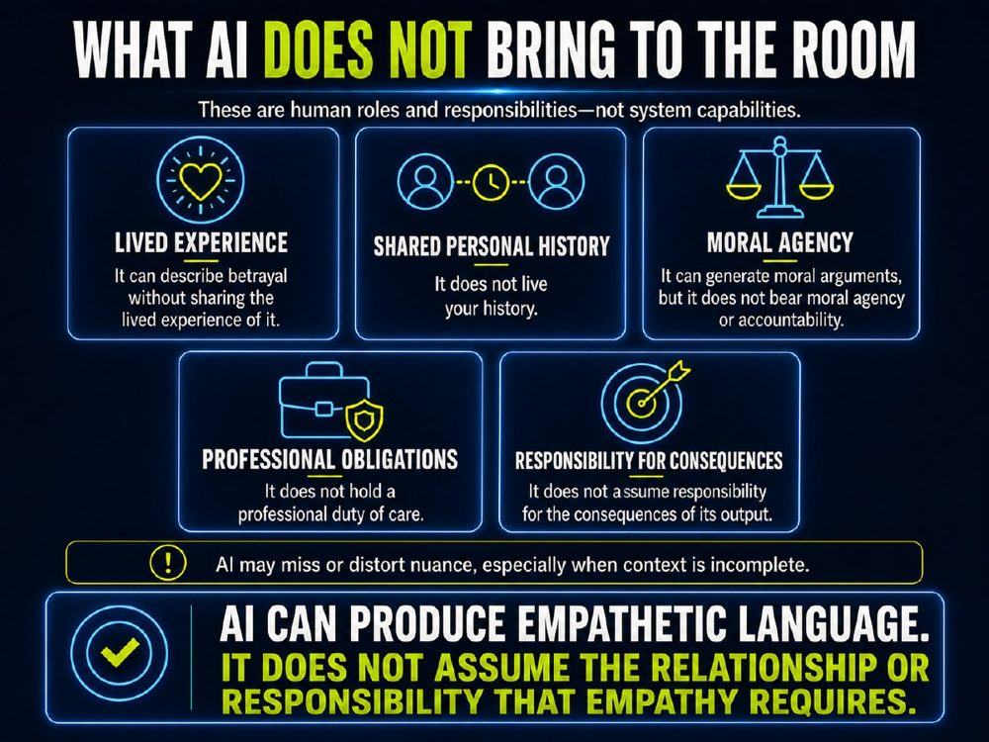 | TRAINER SNAPSHOT  Delivery: CORE  Suggested time: 2–3 min  Purpose: Clarify that AI may assist communication, but it does not bring the lived experience, relationship, professional duty, moral agency, or accountability that human conflict work requires.
Suggested Script
“We have looked at areas where generative AI can be useful. This slide identifies what it does not bring to the room.
AI can generate language about experience. It can describe betrayal, grief, fear, trust, or empathy. But it does not share the lived experience of those things.
It does not live your history. It has not participated in the relationship, experienced the earlier conversations, or carried the consequences of what has happened between the people involved.
It can generate moral arguments. It can present competing ethical perspectives or help us identify possible concerns. But it does not bear moral agency or accountability for the position it generates.
It also does not hold a professional duty of care. A mediator, manager, lawyer, health professional, or other practitioner may have obligations to clients, colleagues, organizations, and the public. The AI system does not take on those obligations.
And it does not assume responsibility for the consequences of its output. If an AI-generated message harms a relationship, escalates a dispute, misstates a fact, or leads to a poor decision, responsibility remains with the person or organization that uses it.
There is one more important qualification. AI may identify some contextual signals and generate language that appears nuanced. But it may also miss or distort nuance—especially when the context it receives is incomplete.
That is why the key teaching line matters:
AI can produce empathetic language. It does not assume the relationship or responsibility that empathy requires.
In conflict work, empathy is not only a tone of voice. It involves presence, trust, judgment, and accountability.”
IMPORTANT NUANCE — DO NOT OVERSTATE
Do not say that AI cannot discuss emotions, ethics, history, or nuance. It can generate language about all of them and may sometimes do so helpfully.
The limitation is not that it cannot produce relevant words. The limitation is that it does not live the experience, hold professional duties, bear moral agency, or accept responsibility for the result.
Audience Interaction
Timing: 2–3 minutes
Ask participants:
“Which of these five human responsibilities is most important in your work when conflict becomes difficult?”
Invite two or three brief responses.
Then ask:
“If AI assisted with drafting or preparation, which responsibility would still remain entirely yours?”
Reinforce:
“AI can support the process. It cannot take over your relationship, professional role, or accountability.”
TRANSITION
“So the question is not whether AI can produce useful language. It can. The question is where assistance ends and human responsibility must remain firmly in place.”

Slide 19 — AI Hallucinations
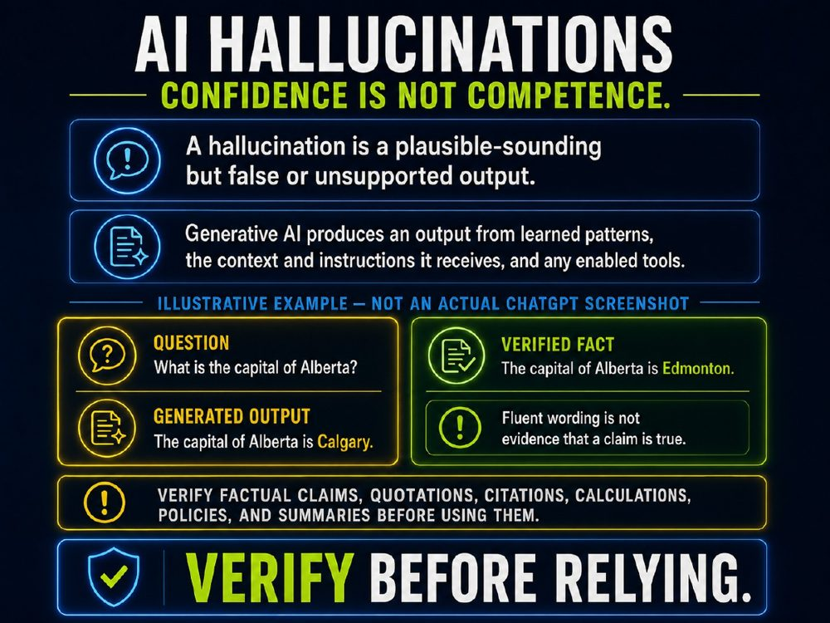 | TRAINER SNAPSHOT  Delivery: CORE  Suggested time: 2–3 min  Purpose: Explain hallucinations clearly and practically: AI can generate fluent, plausible-sounding information that is false or unsupported. Establish verification as a professional responsibility, particularly in high-stakes work.
Suggested Script
“A hallucination is a plausible-sounding but false or unsupported output.
The important word here is plausible. A hallucination may be well written, detailed, and persuasive. It may include an apparent quotation, citation, calculation, policy statement, or summary. None of that makes it reliable.
Generative AI produces an output from learned patterns, the context and instructions it receives, and any enabled tools. Those processes can be very useful—but they do not guarantee that every claim in the output is accurate, current, supported, or complete.
This example is illustrative. It is not an actual ChatGPT screenshot.
If a system generated the statement, ‘The capital of Alberta is Calgary,’ the wording might sound entirely normal. But the verified fact is that Alberta’s capital is Edmonton.
The problem is not that the sentence sounds strange. The problem is that it sounds credible.
That is why the teaching line on this slide matters: confidence is not competence.
We should also be careful about what we mean by confidence. A fluent or assertive tone does not reliably tell us whether a claim is true. It is not a substitute for evidence.
Before using AI output, verify factual claims, quotations, citations, calculations, policies, and summaries—especially when decisions, relationships, money, health, legal rights, or professional duties may be affected.
The rule is simple: verify before relying.”
IMPORTANT NUANCE — DO NOT OVERSTATE
Do not describe every inaccurate answer as deliberate deception. A language model does not need to intend to mislead in order to generate false or unsupported content.
Do not assume that a polished response, a detailed explanation, or even an apparent citation has been verified. Automation bias occurs when people give automated output more authority than it has earned.
Use the system’s output as a starting point for review, not as evidence by itself.
Audience Interaction
Timing: 2–3 minutes
Before revealing the verified-fact panel, ask:
“What is the capital of Alberta?”
After participants answer Edmonton, point to the generated-output example and ask:
“Why might someone accept this answer without checking it?”
Invite a few responses, such as:
It sounds polished.
It is stated directly.
It appears quickly.
People may assume the system has checked.
We may be rushed or already inclined to agree.
Close the interaction with:
“Those are exactly the conditions in which verification matters most.”
TRANSITION
“Once we understand that plausible language is not proof, we can use AI more responsibly: as assistance for thinking and drafting, never as a replacement for checking, judgment, or accountability.”

Slide 20 — Bias, Privacy & False Neutrality
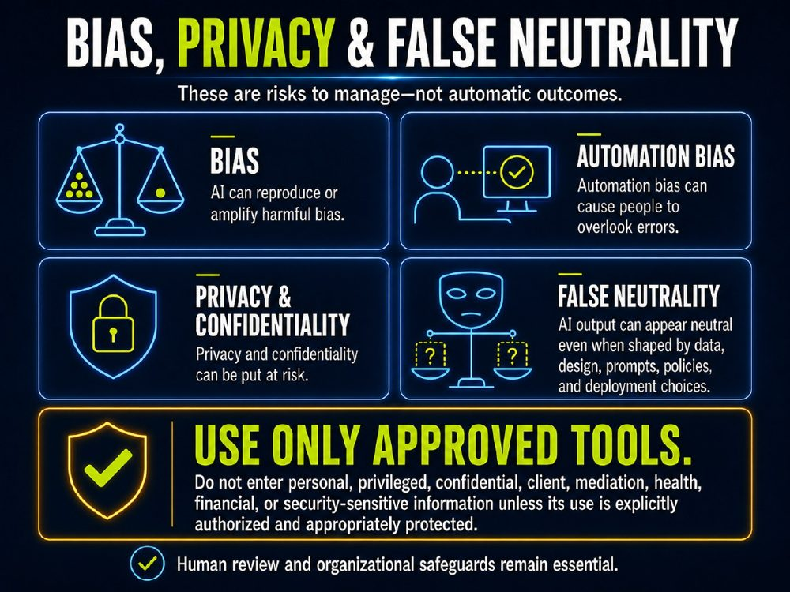 | TRAINER SNAPSHOT  Delivery: CORE  Suggested time: 3 min  Purpose: Show that bias, privacy, confidentiality, and false neutrality are manageable risks—not automatic outcomes—and give participants a clear workplace rule for safer use.
Suggested Script
“AI can be useful, but it is not neutral, risk-free, or self-governing.
First, AI can reproduce or amplify harmful bias. That can happen when patterns in data, design choices, prompts, or the way a system is deployed reflect unfair assumptions or unequal treatment.
Second, automation bias can cause people to overlook errors. This is the tendency to give automated output more authority than it has earned—particularly when it is fast, polished, or confirms what we already think.
Third, privacy and confidentiality can be put at risk. The risk is not only what an AI system might generate. It is also what we choose to enter into it.
In conflict-resolution work, that may include personal details, client information, mediation communications, health information, financial information, privileged material, or security-sensitive information.
Fourth, AI output can appear neutral even when it is shaped by data, design, prompts, policies, and deployment choices. A balanced tone is not proof that the framing is complete, fair, or free from assumptions.
That brings us to the practical workplace rule:
Use only approved tools.
Do not enter personal, privileged, confidential, client, mediation, health, financial, or security-sensitive information unless its use is explicitly authorized and appropriately protected.
This is not just a technology rule. It is part of professional responsibility.
Human review and organizational safeguards remain essential.”
IMPORTANT NUANCE — DO NOT OVERSTATE
Do not suggest that AI automatically creates bias, breaches privacy, or produces unfair outcomes. These are risks that depend on the tool, the data, the setting, the user’s choices, and the safeguards in place.
An approved tool is not a blanket authorization to enter any information. Follow organizational policy, contractual obligations, professional duties, and applicable privacy law.
Audience Interaction
Timing: 3 minutes
Ask participants:
“Before entering information into an AI tool, what should you ask yourself?”
Invite responses, then reinforce this quick check:
Is this an approved tool?
Is this information necessary?
Is it personal, confidential, privileged, or otherwise sensitive?
Has its use been explicitly authorized and appropriately protected?
Who could be affected if the information or output is mishandled?
Close with:
“If you are unsure whether information may be entered, pause and check before proceeding.”
TRANSITION
“Once we understand these risks, we can move from asking, ‘What can AI do?’ to the more important professional question: ‘What is appropriate, safe, and responsible for us to do with it?’”

Slide 21 — AI Can Help Reframe Communication
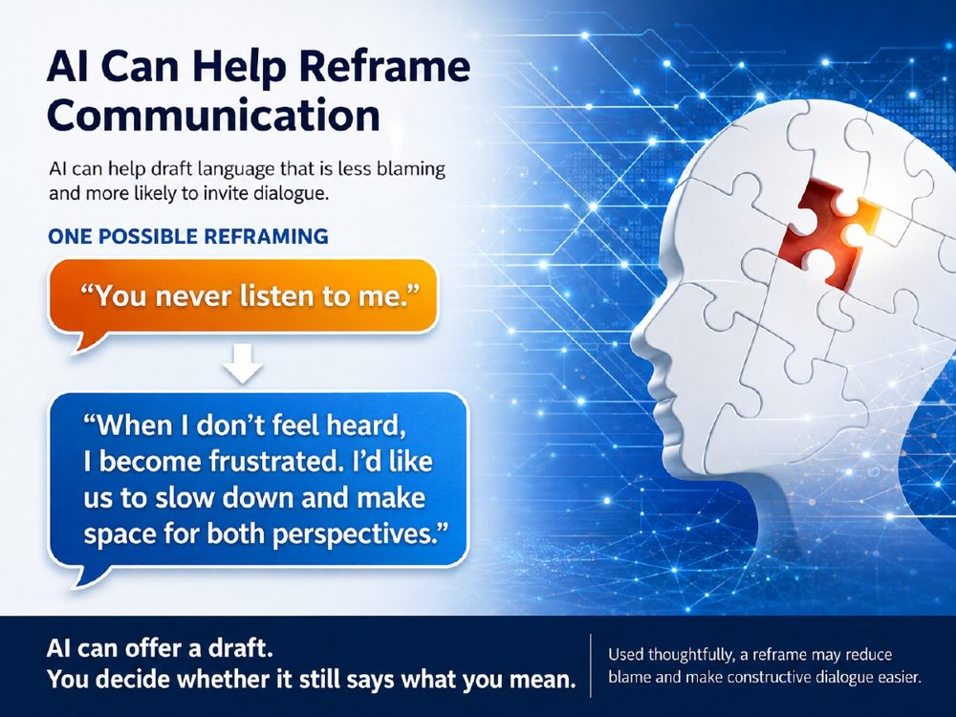 | TRAINER SNAPSHOT  Delivery: CORE  Suggested time: 2–3 min  Purpose: Show that AI can help create a less blaming first draft, while making clear that the person—not the tool—decides whether the language is accurate, appropriate, and true to what they mean.
Suggested Script
“AI can sometimes help us shift from language that invites defensiveness to language that makes dialogue more possible.
But notice the wording on this slide: this is one possible reframing. It is not a translation machine, and it is not automatically better.
‘You never listen to me’ may contain real frustration, a pattern of experience, or a boundary that matters. A tool can suggest a draft such as: ‘When I don’t feel heard, I become frustrated. I’d like us to slow down and make space for both perspectives.’
That may reduce blame and create room for a conversation. But before using it, we still have to ask: Does this preserve what I actually mean? Does it sound like me? Is it appropriate to this relationship and this moment?
AI can offer a draft. We remain responsible for the final message.”
IMPORTANT NUANCE — DO NOT OVERSTATE
A reframe should not erase justified anger, minimize harm, or turn a needed boundary into artificial politeness. The goal is not to make every message neutral; it is to communicate clearly enough that the other person can understand the concern and the request.
Use only approved tools. Do not enter real personal, client, mediation, privileged, or confidential information unless its use is explicitly authorized and appropriately protected.
Audience Interaction
Ask: “What might be gained in the revised version—and what might be lost?”
Invite two or three responses. Listen for ideas such as reduced blame, clearer feeling, a concrete request, loss of urgency, or possible softening of a legitimate concern.
Then ask: “What would you need to add or change to make this sound authentic to you?”
TRANSITION
“Now let’s test this idea together. We will use a fictional example and ask AI for a draft—not a final answer—then evaluate what it preserved, what it changed, and what still requires human judgment.”

Slide 22 — Let's Try It Together: The I-Statement Experiment
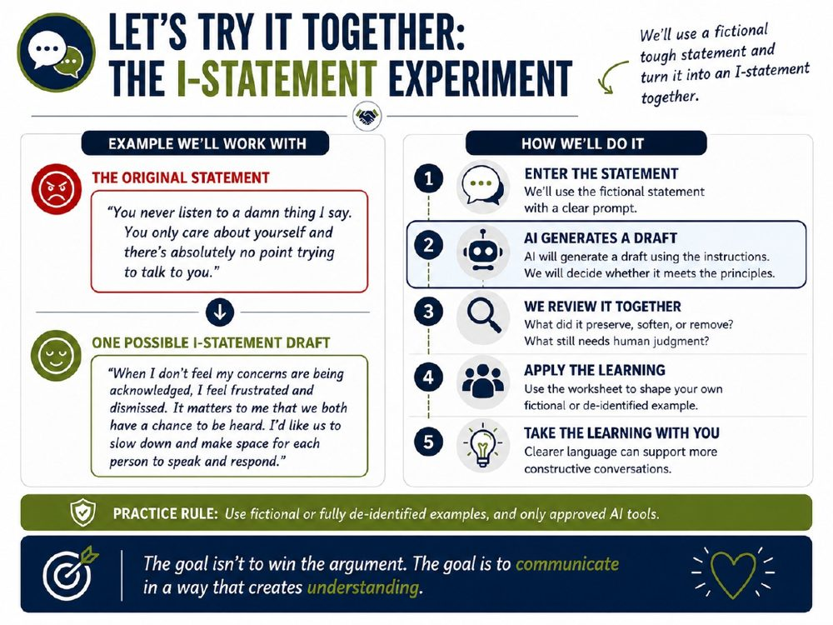 | TRAINER SNAPSHOT  Delivery: OPTIONAL • LIVE DEMO  Suggested time: 7–10 min  Purpose: Demonstrate how a detailed prompt can help AI produce a usable first draft of an I-statement—while reinforcing that the group must decide whether the draft is accurate, appropriate, and genuinely constructive.
Suggested Script
“We are going to use a fictional example, not a real workplace, client, mediation, or personal situation.
The purpose of this exercise is not to ask AI to tell us what someone should feel or say. It is to see whether a careful prompt can help turn a reactive message into a clearer first draft.
I’ll give the tool specific instructions: preserve the substance, avoid inventing facts or motives, identify the impact, and include a realistic request where appropriate.
Then we will review the output together. The important question is not, ‘Did AI make this sound nicer?’ The important questions are: Did it preserve the real concern? Did it introduce assumptions? Does it sound like something a real person could say? And would it be safe and appropriate in the actual relationship?”
IMPORTANT NUANCE — DO NOT OVERSTATE
An I-statement is not a magic formula and should not erase a legitimate boundary, concern, or feeling. A polished AI response can still omit important context, soften the issue too much, or introduce assumptions.
Use only approved AI tools. Do not enter personal, privileged, confidential, client, mediation, health, financial, or security-sensitive information unless its use is explicitly authorized and appropriately protected.
Audience Interaction
Time: 7–10 minutes
Read the fictional statement aloud.
Display or enter the facilitator prompt.
Review the generated draft as a group.
Ask:
What did the draft preserve?
What did it soften or remove?
What still needs human judgment?
Would this wording be safe and appropriate in the real relationship?
Invite participants to identify one revision they would make before using the draft.
If live AI is unavailable, display the prepared draft on the slide and conduct the same review discussion.
Trainer / Facilitation Instructions
Rewrite the fictional message below as an effective “I” statement for conflict resolution.
Preserve what the speaker is trying to communicate, but make it clearer, less accusatory, and more likely to invite a constructive conversation.
Please follow these rules:
Speak from the speaker’s perspective.
Describe the specific behaviour or situation without blame, labels, or assigning motives.
Identify the speaker’s genuine feeling or experience.
Explain the impact on the speaker or why it matters.
Include a clear, realistic request where appropriate.
Do not disguise an accusation as an I-statement. Avoid phrases such as “I feel that you…” or “I feel like you…” when what follows is actually a judgment about the other person.
Do not invent facts, feelings, intentions, motivations, or context that have not been provided.
Do not change the substance simply to make the message sound nicer.
Keep the language natural, direct, respectful, and something a real person might actually say.
Where appropriate, use this structure:
“When [specific behaviour/situation], I feel [feeling/experience] because [impact/why it matters]. I would like [specific request].”
Here is the fictional original message:
[PASTE THE PROVIDED FICTIONAL MESSAGE HERE]
After rewriting it, briefly identify any assumptions you had to make because the original message did not provide enough context.
TRANSITION
“Now that we have seen a live example, let’s move from watching the process to practising it ourselves. The worksheet will help us identify the message, the impact, the request—and where human judgment must stay in charge.”

Slide 23 — Worksheet 2: From Reaction to Response
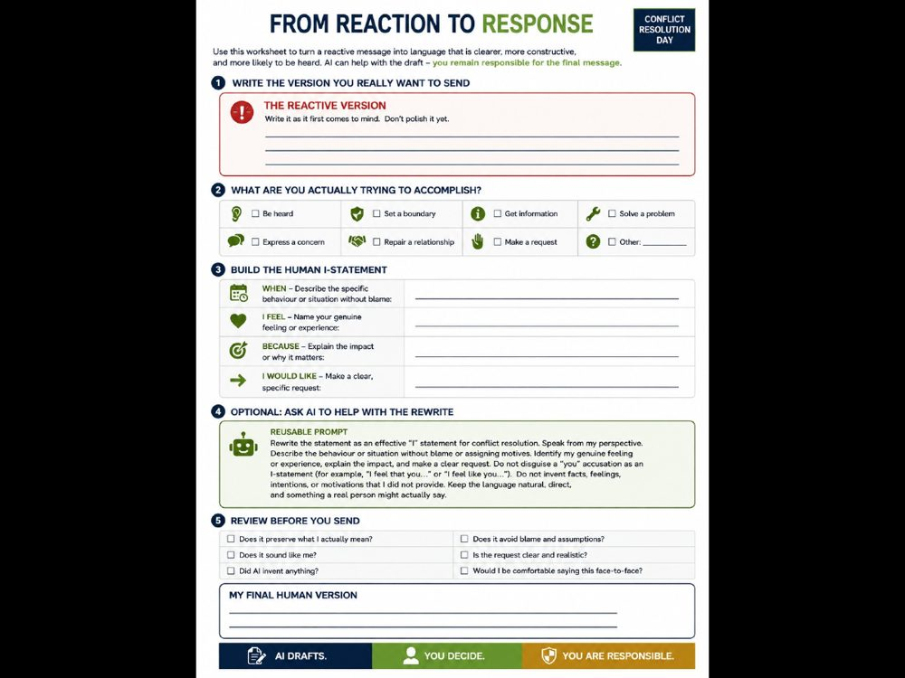 | TRAINER SNAPSHOT  Delivery: OPTIONAL • WORKSHEET  Suggested time: 8–12 min  Purpose: Give participants a structured way to move from an immediate reaction to a clearer, more intentional response. Reinforce that AI may help generate a first draft, but the participant remains responsible for the final message.
Suggested Script
“Now we move from watching the process to trying it ourselves.
Choose a fictional or fully de-identified situation. Start by writing the version you would be tempted to send in the moment. Do not polish it yet. That first reaction often tells us something important.
Next, identify what you are actually trying to accomplish. Do you want to be heard? Set a boundary? Get information? Repair a relationship? Make a request?
Then build the human version: What happened? How did it affect you? Why does it matter? What would you like to happen next?
Only after you have done that thinking yourself is there an optional AI step. If you use an approved tool, AI can offer a draft. But you decide whether it preserves what you mean, sounds like you, and is appropriate for the situation.
The final box is intentionally called ‘My Final Human Version.’ AI drafts. You decide. You are responsible.”
IMPORTANT NUANCE — DO NOT OVERSTATE
This worksheet is not about making every message nicer or neutral. A real concern, boundary, or feeling should not be erased simply to make communication more comfortable.
Do not use a real personal, client, mediation, privileged, confidential, health, financial, or security-sensitive situation in an AI tool unless its use is explicitly authorized and appropriately protected. For this activity, use only fictional or fully de-identified examples and approved tools.
Before sending any message, consider whether it is safe and appropriate for the relationship, role, power dynamics, and circumstances.
Audience Interaction
Time: 8–12 minutes
Give participants two minutes to write the reactive version.
Give them two minutes to identify their actual goal.
Give them three to four minutes to build the I-statement without AI.
Invite those using an approved tool to generate an optional draft.
Allow two minutes for the final human review.
Invite participants to privately choose one question from the “Review Before You Send” section that changed their draft most. Do not require anyone to share personal content aloud.
If time permits, ask:
Which part of the worksheet was most difficult: naming the behaviour, the feeling, the impact, or the request?
What did the AI draft preserve well?
What did you need to change to make it genuinely yours?
Facilitation Notes
Worksheet 2
TRANSITION
“Clearer language can help, but language alone does not resolve conflict. Next, we will look at what AI may miss when it does not have the full history, relationship, and context behind the words.”

Slide 24 — From Reaction to Clearer Communication
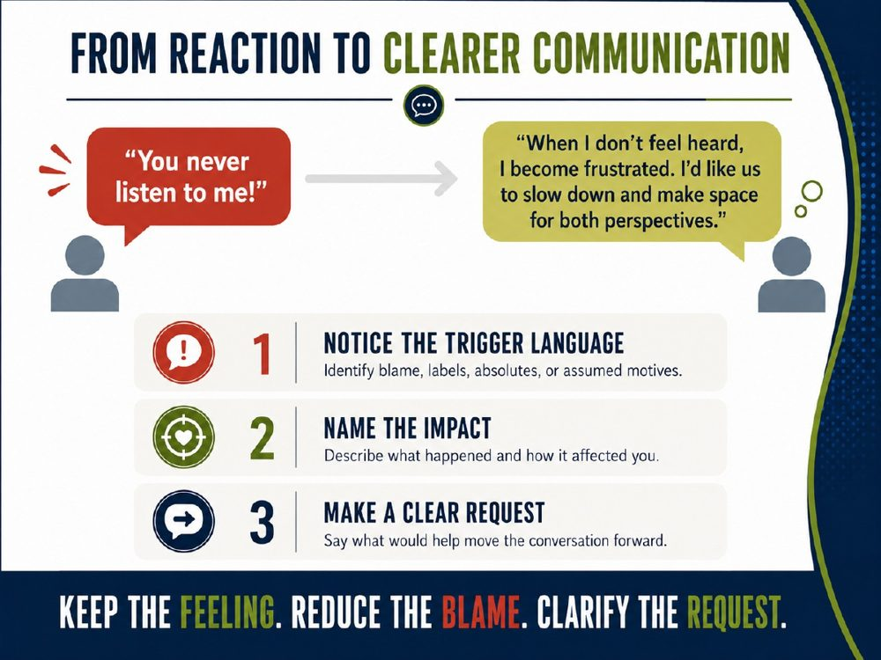 | TRAINER SNAPSHOT  Delivery: CORE  Suggested time: 3 min  Purpose: Reinforce the practical sequence for turning a reactive message into clearer communication: notice trigger language, name the impact, and make a specific request.
Suggested Script
“This slide is not asking us to remove emotion from conflict. Emotion often tells us that something matters.
The goal is to separate the feeling from the blame, labels, absolutes, or assumptions that can make the other person defensive.
First, notice the trigger language. Words such as ‘never,’ ‘always,’ or statements about someone’s motives may express a real frustration, but they can also close down the conversation.
Second, name the impact. What happened, and how did it affect you?
Third, make a clear request. What would help move the conversation forward?
The revised message is not the only correct version. It is simply one way of keeping the feeling while making the concern and request easier to understand.
Keep the feeling. Reduce the blame. Clarify the request.”
IMPORTANT NUANCE — DO NOT OVERSTATE
Do not use this framework to soften a safety concern, excuse harmful behaviour, or turn a necessary boundary into artificial politeness. In some circumstances, direct language, escalation, reporting, or professional support may be more appropriate than a communication reframe.
The goal is not neutrality. It is clarity, accuracy, and a response that fits the situation.
Audience Interaction
Ask the group to identify the trigger language in: “You never listen to me.”
Then ask:
What is the likely impact behind that statement?
What request might help?
What part of the original message should not be lost?
Invite one or two possible rewrites. Emphasize that there can be more than one appropriate answer.
TRANSITION
“We have now seen the framework and practised it. Next, let’s look at the specific ways AI may be useful in preparing communication—along with the limits and safeguards that still matter.”

Slide 25 — Possible Uses of AI — With Human Review
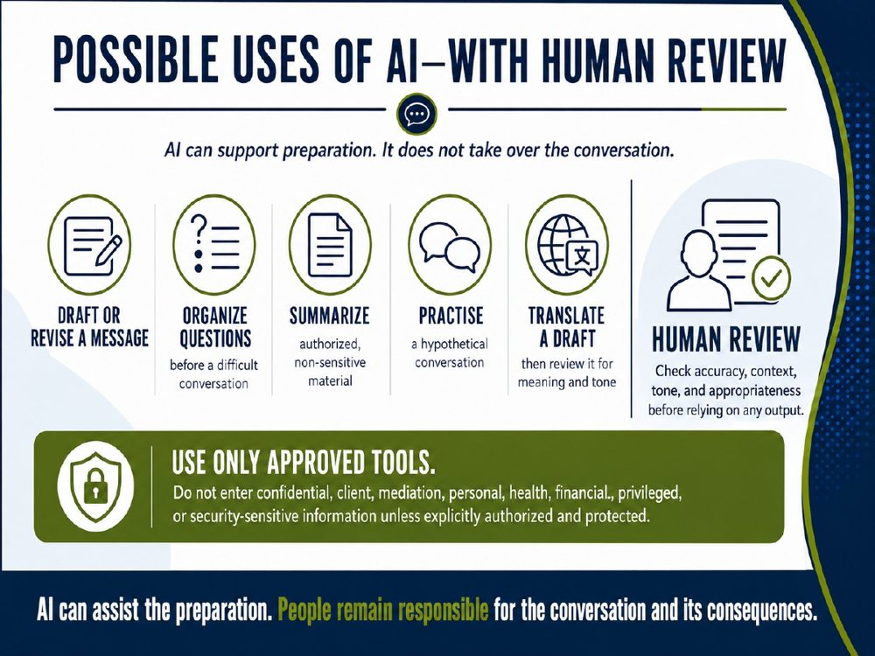 | TRAINER SNAPSHOT  Delivery: OPTIONAL  Suggested time: 2–3 min  Purpose: Show concrete ways AI can assist with communication preparation while making clear that usefulness is conditional on approved tools, appropriate inputs, and human review.
Suggested Script
“AI can be useful before a difficult conversation—not because it takes over the conversation, but because it can help us prepare.
It can help draft or revise a message, organize questions, summarize authorized non-sensitive material, practise a hypothetical conversation, or translate a draft.
But each of those uses requires human review. A draft can be inaccurate, miss context, distort tone, or fail to reflect what matters in the relationship.
The translation example is especially important. A translated draft may be useful, but it still needs review for meaning, tone, dialect, and cultural context.
The principle is simple: AI can assist the preparation. People remain responsible for the conversation and its consequences.”
IMPORTANT NUANCE — DO NOT OVERSTATE
These are possible uses, not automatic benefits. AI does not necessarily reduce conflict, improve safety, or create better outcomes. The result depends on the user, the context, the quality of the input, the tool, the safeguards, and the decisions made from the output.
Use only approved tools. Do not enter confidential, client, mediation, personal, health, financial, privileged, or security-sensitive information unless its use is explicitly authorized and appropriately protected.
Audience Interaction
Ask: “Which of these uses could genuinely help you prepare for a difficult conversation?”
Invite a few responses, then ask:
What would you need to review before relying on the output?
What information should never be entered into an unapproved tool?
Which use would be inappropriate in your role or context?
Emphasize that participants should not share real examples aloud.
TRANSITION
“Preparation can be useful, but a tool only works with the information it receives. Next, we will look at what AI may miss when the history, relationship, tone, or unspoken context is incomplete.”

Slide 26 — What AI May Miss When Context Is Incomplete
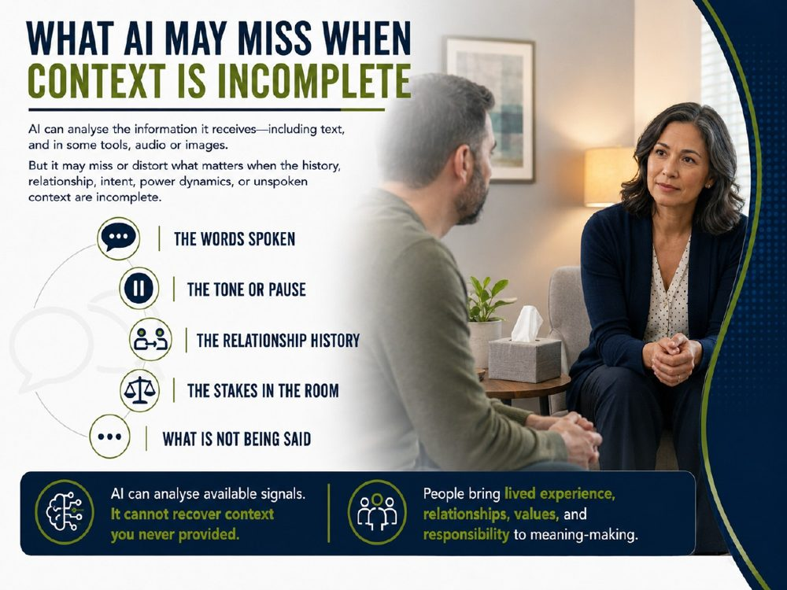 | TRAINER SNAPSHOT  Delivery: CORE  Suggested time: 3–4 min  Purpose: Explain why in-person conflict work involves more than the words spoken, and prepare participants to notice the human judgment and professional intuition illustrated in the following clip.
Suggested Script
“AI can analyse the information it receives. Depending on the tool, that may include text, and sometimes audio or images.
But in a real conversation, what matters is often bigger than the available signal.
A person in the room may notice a pause that feels different from ordinary silence. They may understand that a particular phrase carries years of history. They may sense a power imbalance, a safety concern, hesitation, grief, or the significance of what someone cannot yet say.
AI may be able to analyse some of those observable signals if they are provided. But it cannot recover the relationship history, intent, stakes, or context that were never included in the input.
That is the distinction to hold onto: AI can analyse available signals. It cannot recover context you never provided.
People bring lived experience, relationships, values, and responsibility to meaning-making.”
IMPORTANT NUANCE — DO NOT OVERSTATE
Do not say that AI cannot process tone, pauses, facial expression, or audio. Some multimodal tools can analyse those signals when they are supplied.
The limitation is that analysing a signal is not the same as knowing what it means in this particular relationship, moment, culture, or professional setting. Even a skilled human facilitator should test their interpretation rather than assume it is correct.
Audience Interaction
Ask: “Think of a difficult in-person conversation. What might an outside observer miss if they only had the transcript?”
Invite a few responses. Listen for:
Relationship history
Body language or silence
Previous attempts to resolve the issue
Unequal power or safety concerns
What a person is afraid to say
Why a seemingly small comment carries weight
Then ask: “Which of those could be captured in a prompt—and which would still require careful human inquiry?”
TRANSITION
“Keep those answers in mind as we watch this next clip. Notice the words, but also notice the pause, the relationship, the professional judgment, and the human intuition behind what happens in the room.”

Slide 27 — Video Clip: Good Will Hunting — “It’s Not Your Fault”
 | TRAINER SNAPSHOT  Delivery: CORE • MEDIA  Suggested time: 5–7 min  Purpose: Use a familiar fictional scene to help participants distinguish between words on a transcript and the human relationship, timing, intuition, and responsibility present in an in-person interaction.  ⚠ MEDIA: confirm source/permission, captions, AV, and fallback.  ⚠ CONTENT NOTE: emotional distress and trauma-related themes.
Suggested Script
“We are about to watch a short scene from Good Will Hunting. It is fictional, but it gives us a useful question to consider.
As you watch, do not focus only on the words: ‘It’s not your fault.’
Notice the timing. Notice the repetition. Notice the pauses. Notice the relationship between the two people. Notice how the professional responds to what is happening in front of him—not simply to the literal content of the conversation.
A transcript could capture the words. It could even describe some visible actions. But it would not, by itself, contain the full relationship history, the professional judgment, the emotional safety of the moment, or the responsibility involved in deciding what to do next.
That is the difference we have been discussing. AI can help us work with language. It does not bring the lived relationship or professional accountability that this kind of moment requires.”
IMPORTANT NUANCE — DO NOT OVERSTATE
This clip is a dramatic portrayal, not a clinical, mediation, counselling, or workplace-intervention model. Physical proximity, touch, repetition, disclosure, and emotional intensity must always be appropriate to the role, the relationship, consent, culture, organizational policy, and safety of the situation.
Give a brief content note before playing: the scene involves emotional distress and trauma-related themes.
Use a properly licensed, captioned clip and ensure its use complies with your organization’s copyright and presentation policies.
Audience Interaction
Time: approximately 5–7 minutes, including the clip
Before playing, ask participants to watch for:
What is said
What is communicated without words
What the professional appears to notice
What makes the response feel possible in that moment
Afterward, ask:
What could AI identify from a transcript of this scene?
What might it miss?
What human judgment was being exercised?
Why would copying the words alone be inadequate—or even inappropriate—in another situation?
Do not require personal disclosures. Keep discussion focused on the fictional scene.
TRANSITION
“AI may help us prepare language, organize information, or explore options. But this scene reminds us that in conflict work, the most consequential decisions are often about relationship, timing, safety, values, and responsibility. Those remain human responsibilities.”

Slide 28 — Human-Led, AI-Assisted Success
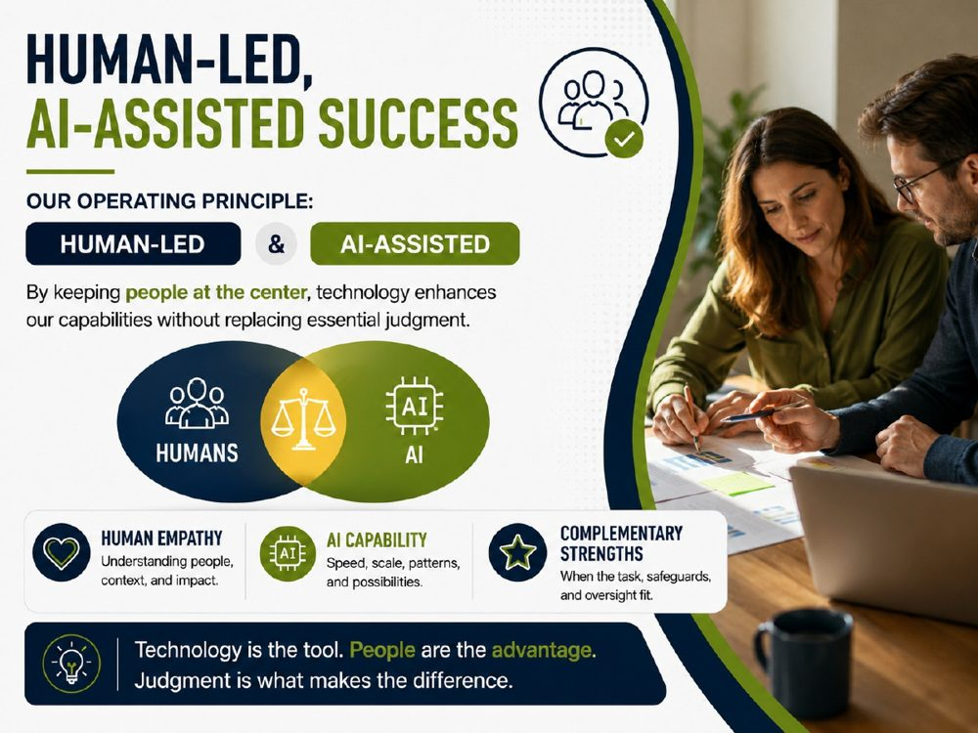 | TRAINER SNAPSHOT  Delivery: CORE  Suggested time: 2 min  Purpose: Establish the course’s operating principle without claiming that adding AI automatically improves results.
Suggested Script
“Here is the principle we are going to use throughout the rest of the session: human-led, AI-assisted.
That does not mean humans plus AI automatically produce a better result. Sometimes AI helps. Sometimes it introduces error, bias, distraction, or overconfidence.
What it means is that when we choose to use AI in professional conflict work, we should be deliberate about the division of roles.
AI may bring speed, scale, pattern recognition, drafting, or option generation.
People retain relationship, values, professional judgment, accountability, and responsibility for consequences.”
KEY TEACHING POINT
Human-led, AI-assisted is a responsible-use principle, not a prediction that human-AI teams always outperform humans.
IMPORTANT NUANCE — DO NOT OVERSTATE
Human-led does not mean that every technical operation requires a person. It means people and organizations retain appropriate authority, oversight and accountability for consequential professional use.
TRANSITION
“If that is our operating model, the next question is: what makes that use responsible?”

Slide 29 — Ethics Builds Trust
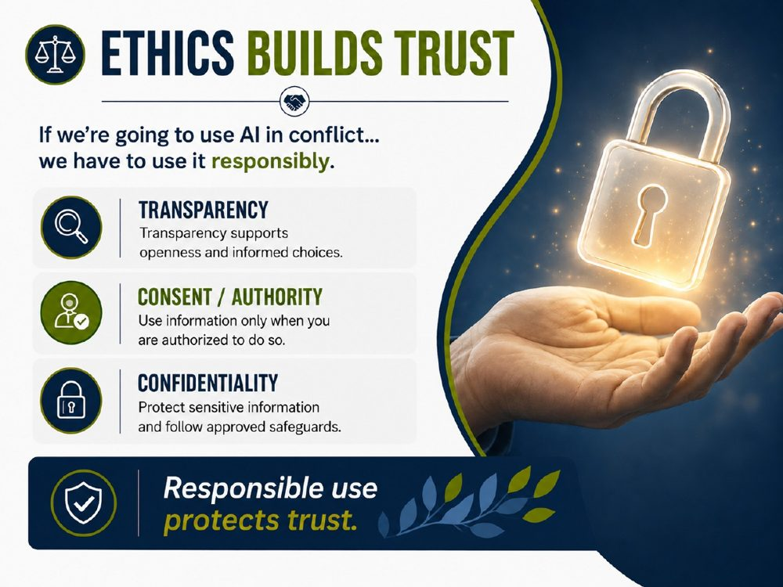 | TRAINER SNAPSHOT  Delivery: CORE  Suggested time: 2–3 min  Purpose: Identify three practical responsibilities that protect trust when AI enters conflict work.
Suggested Script
“Responsible AI use involves more than obtaining consent.
Transparency matters because people may reasonably need to know that AI has played a role.
Authority matters because we must actually be permitted to use the information in this way. Sometimes consent is the legal authority; sometimes another lawful authority applies. And even valid consent does not automatically make every use appropriate.
Confidentiality matters because conflict work can involve some of the most sensitive information people possess.
These are not the only ethical requirements. They are three practical responsibilities we should carry into every AI-assisted task.”
IMPORTANT NUANCE — DO NOT OVERSTATE
Use the phrase consent or other appropriate authority. Do not teach trainers that “the person consented” automatically resolves privacy, ethical, contractual or organizational-policy concerns. Canadian regulators expressly distinguish consent from broader questions of legal authority and appropriate purpose. (Office of the Privacy Commissioner)
TRANSITION
“And even when all of those safeguards are in place, someone still has to own what happens next.”

Slide 30 — The Final Responsibility Remains Human
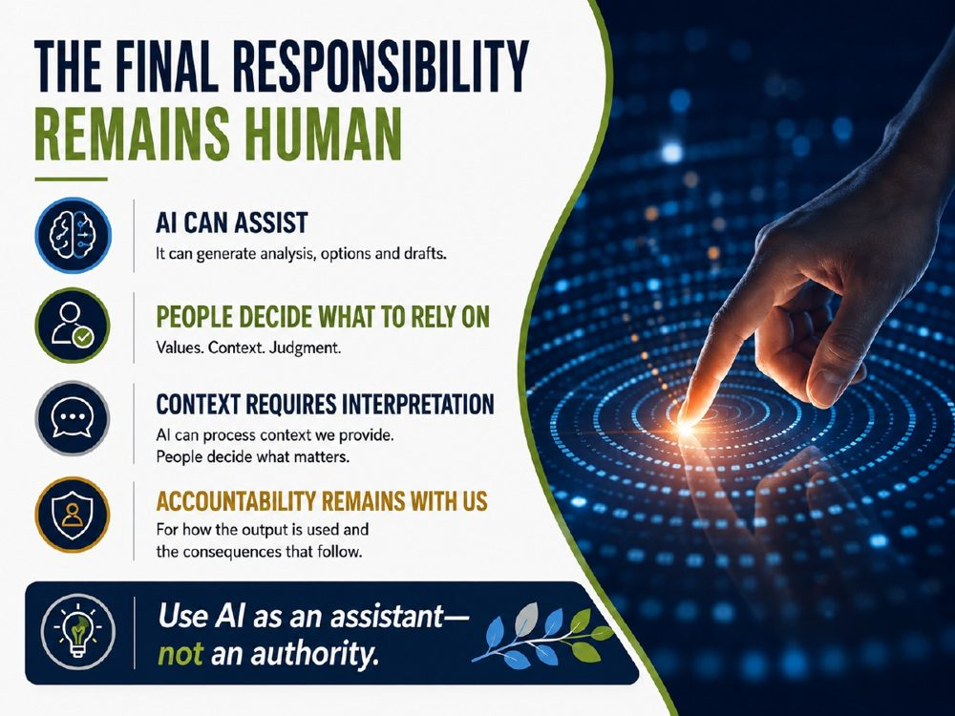 | TRAINER SNAPSHOT  Delivery: CORE  Suggested time: 2 min  Purpose: Reinforce that in consequential professional use, decision authority and accountability should remain with people and organizations.
Suggested Script
“AI can assist with analysis, options, drafts, and organization. But our professional responsibility does not transfer to the model. People decide what to rely on, what context matters, and how the output is used. AI can process context we provide; we remain responsible for interpreting its relevance and for the consequences that follow. Use AI as an assistant—not an authority.”
KEY TEACHING POINT
Capability can be delegated. Accountability cannot simply be delegated to the model.
IMPORTANT NUANCE — DO NOT OVERSTATE
This is a prescriptive professional principle, not a claim that AI systems are technically incapable of autonomous decisions. Responsibility may be distributed among the professional, employer, public body, system owner, or other actors.
TRANSITION
“The next fictional clip gives us a simple way to see that division of labour.”

Slide 31 — Movie Clip: Human-Led, AI-Assisted Illustration
 | TRAINER SNAPSHOT  Delivery: OPTIONAL • MEDIA  Suggested time: 3–5 min  Purpose: Use a fictional scene to illustrate division of labour between human judgment and computational assistance.  ⚠ MEDIA: confirm source/permission, captions, AV, and fallback.  ⚠ CONTENT NOTE: profanity; science fiction, not technical evidence.
Suggested Script
“We have just spent three slides talking about human-led, AI-assisted work. This fictional scene gives us a surprisingly useful way to see that division of roles.
Do not watch it as a demonstration of what present-day AI can actually do. It is science fiction.
Instead, watch for four things:
Who frames the problem?
What does the system contribute?
Who interprets the result?
And who still has to decide what happens next?”
“The machine performed something the human could not practically do in the same way or at the same speed.
But the machine did not determine what mattered morally, what risks were worth taking, or what should happen next.
That remained a human problem.”
IMPORTANT NUANCE — DO NOT OVERSTATE
This is fiction, not evidence about real-world AI capability.
Also flag that the clip contains profanity. Trainers need to know that in advance.
And for the train-the-trainer package: include a copyright/licensing instruction, caption requirement, internet-failure backup, and organizational-content check.
TRANSITION
“And once technology begins contributing meaningfully to the work, some harder questions appear. Who created it? Does effort matter? Does intention matter? And where does meaning come from?”

Slide 32 — There Are No Easy Answers. But Great Questions Help.
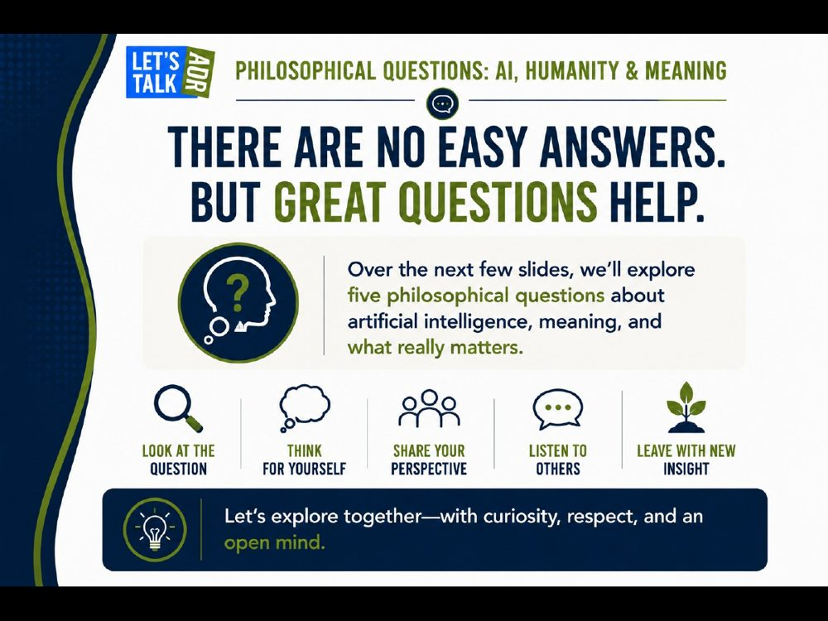 | TRAINER SNAPSHOT  Delivery: CORE  Suggested time: 1 min  Purpose: Explicitly shift from technical instruction to facilitated philosophical inquiry.
Suggested Script
“For the next few minutes, we are changing gears.
These are not questions with an official answer hidden in the facilitator guide.
They are questions about authorship, value, authenticity, intention and meaning.
The purpose is not to get everyone to agree. In fact, disagreement is part of the exercise.
What I want us to notice is what causes our answers to change—and what that tells us about the role we want AI to have in human work.”
IMPORTANT NUANCE — DO NOT OVERSTATE
The yes/no positions on the next slides are deliberately simplified discussion starters, not the only defensible answers.
Trainer / Facilitation Instructions
Do not announce the “correct” position after the vote.

Slide 33 — Philosophical Question 1: Does the Origin Matter?
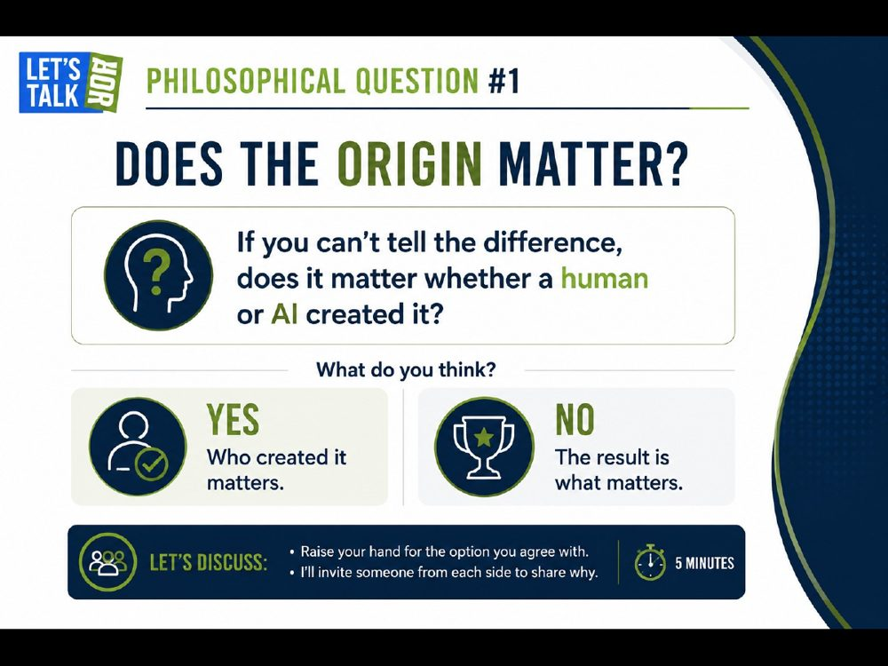 | TRAINER SNAPSHOT  Delivery: OPTIONAL • DISCUSSION  Suggested time: 3–5 min  Purpose: Explore how authorship and origin can affect perceived value, while showing that the answer depends on context.
Suggested Script
“If you cannot tell the difference, does it matter whether a human or AI created it? Choose one of two positions for the purpose of the exercise: YES—who created it matters; or NO—the result is what matters. Someone who said yes—why? Someone who said no—why? Now the more interesting question: what change in the context would make you switch sides?”
KEY TEACHING POINT
The yes/no choice is a deliberate discussion device. Origin may matter very differently in art, education, professional advice, editing, or disclosure.
IMPORTANT NUANCE — DO NOT OVERSTATE
Do not resolve the question or imply that either position is the course answer.
Audience Interaction
Hands or poll; one voice from each side; finish with “What change in context would make you switch sides?”
TRANSITION
“Let’s apply the same tension to art and emotional experience.”

Slide 34 — Philosophical Question 2: Is AI-Created Art Really Art?
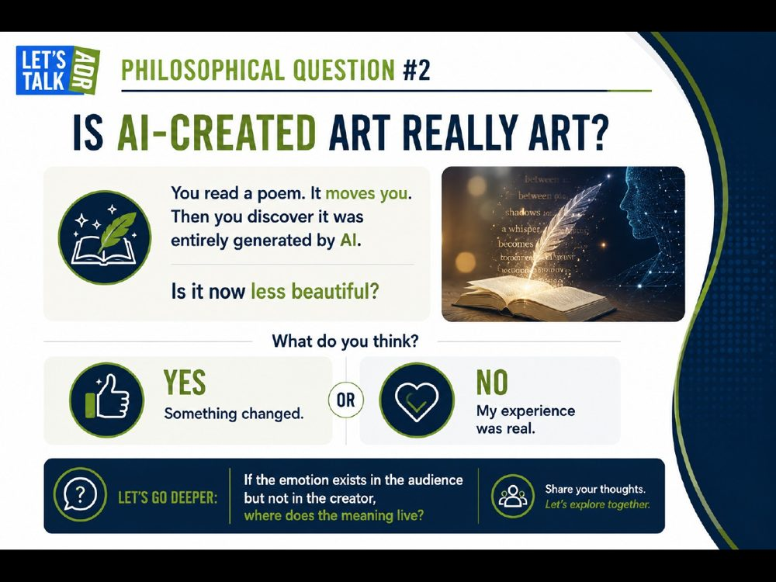 | TRAINER SNAPSHOT  Delivery: OPTIONAL • DISCUSSION  Suggested time: 3–5 min  Purpose: Explore whether an audience’s emotional experience changes when they learn that a work was AI-generated.
Suggested Script
“You read a poem. It moves you. Then you discover it was entirely generated by AI. Is it now less beautiful? YES—something changed. NO—my experience was real. If the emotional experience is real for the audience, how much does the creator’s experience matter?”
KEY TEACHING POINT
Aesthetic value, authorship, and legal ownership are related but different questions.
IMPORTANT NUANCE — DO NOT OVERSTATE
Do not turn an audience answer about whether something is “art” into a claim about authorship or copyright rights.
Audience Interaction
Invite arguments on both sides; do not declare a winner.
TRANSITION
“Now let’s ask whether the process and effort behind a result affect how we value it.”

Slide 35 — Philosophical Question 3: Do We Value the Result or the Struggle?
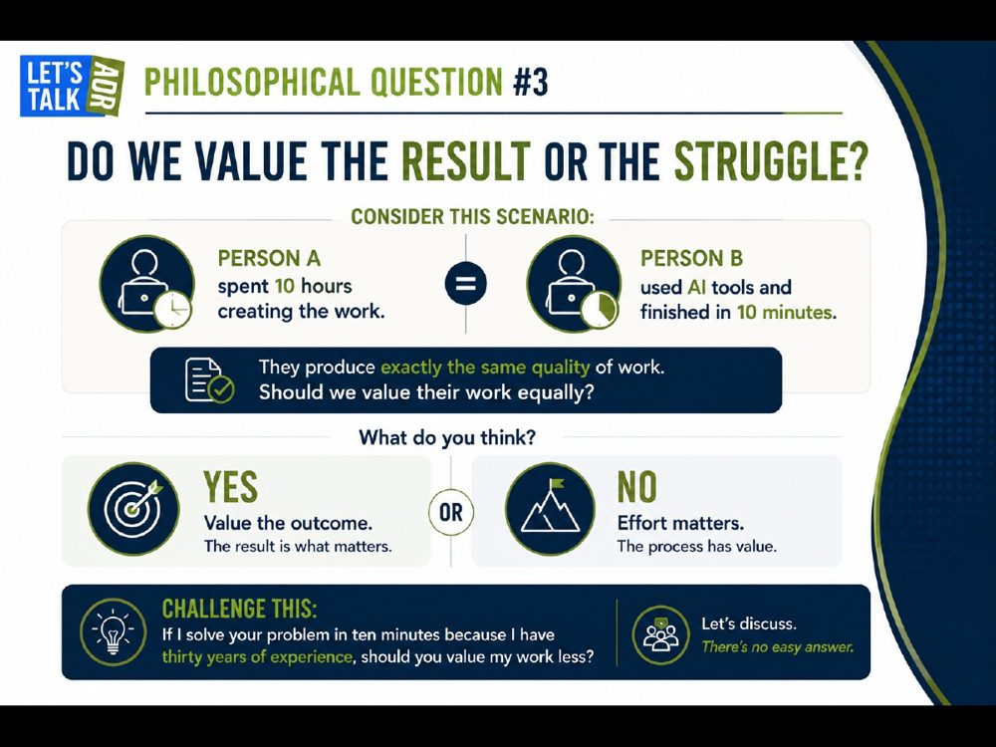 | TRAINER SNAPSHOT  Delivery: OPTIONAL • DISCUSSION  Suggested time: 3–5 min  Purpose: Examine whether we value outcomes, effort, expertise, learning process, or some combination of them.
Suggested Script
“Two people produce work of exactly the same quality. One spends ten hours. The other uses AI and finishes in ten minutes. Should we value the work equally? YES—value the outcome. NO—effort matters. Now complicate it: if I solve your problem in ten minutes because I have thirty years of experience, should you value my work less? And would your answer change if the purpose were learning rather than producing a deliverable?”
KEY TEACHING POINT
Time spent is not always the same thing as value; the answer depends on the purpose of the work.
IMPORTANT NUANCE — DO NOT OVERSTATE
Do not use the expertise analogy as proof that AI-assisted work should be valued identically. The analogy is meant to expose assumptions, not settle the issue.
Audience Interaction
Poll the room, then ask how the answer changes across education, professional services, and creative work.
TRANSITION
“The next question moves from value to authenticity in conflict communication.”

Slide 36 — Philosophical Question 4: Does Disclosure Change Your Reaction?
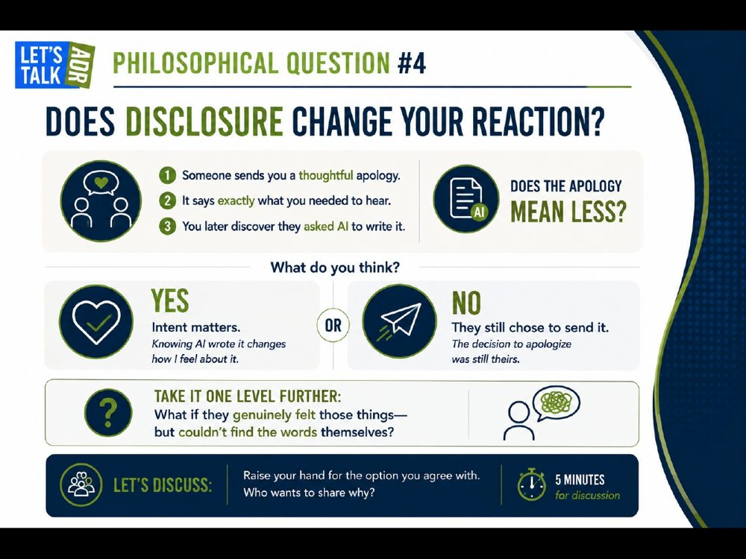 | TRAINER SNAPSHOT  Delivery: CORE • DISCUSSION  Suggested time: 4–6 min  Purpose: Explore authenticity, disclosure, and the degree of AI involvement in a personally meaningful apology.
Suggested Script
“Someone sends you a thoughtful apology. It says exactly what you needed to hear. You later discover they asked AI to write it. Does the apology mean less? YES—intent matters. NO—they still chose to send it. Now change one fact: what if they genuinely felt those things but could not find the words themselves? What makes an apology authentic—the words, the feeling, the choice to send it, the willingness to take responsibility, or what the person does afterward?”
KEY TEACHING POINT
AI involvement is not binary; assistance can range from word choice to full authorship, and disclosure can change how people interpret authenticity.
IMPORTANT NUANCE — DO NOT OVERSTATE
This is a hypothetical. Do not invite participants to paste real apologies, personal communications, workplace conflicts, or client information into an AI tool.
Audience Interaction
Poll before and after the “could not find the words” variation; ask what changed.
TRANSITION
“That brings us to the deepest question: where does meaning come from?”

Slide 37 — Philosophical Question 5: Can Something Without Intention Have Meaning?
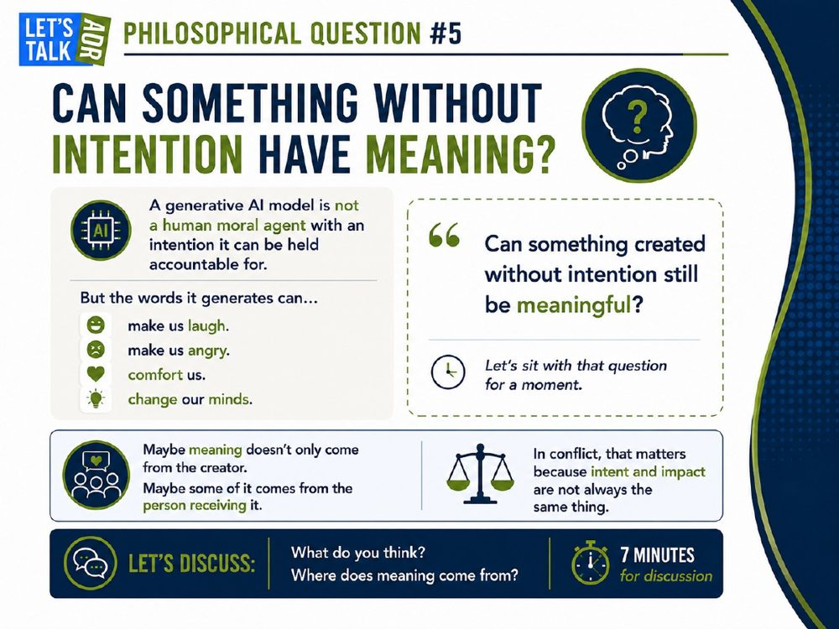 | TRAINER SNAPSHOT  Delivery: CORE • DISCUSSION  Suggested time: 5–7 min  Purpose: Explore the relationship among intention, meaning, impact, and moral agency without making unnecessary claims about machine consciousness.
Suggested Script
“A generative AI model is not a human moral agent with an intention it can be held accountable for. But the words it generates can make us laugh, make us angry, comfort us, or change our minds. Can something created without human-like accountable intention still be meaningful? Maybe meaning does not only come from the creator. Some of it may come from the person receiving it. In conflict work we deal with this all the time: intention and impact are not the same thing. And remember, there can still be very clear human intention around AI output—the person who prompts it, selects it, edits it, and sends it may be acting very intentionally.”
KEY TEACHING POINT
Meaning, intention, and impact are distinct. The model need not be the accountable moral actor for AI-mediated communication to have real human impact.
IMPORTANT NUANCE — DO NOT OVERSTATE
Avoid anthropomorphizing the model or making claims about consciousness. Also avoid implying that AI-mediated communication lacks human intention; users may act with clear purposes when they prompt, select, edit, or send output.
Audience Interaction
Let the question sit before taking responses. Ask: “Where does meaning come from?”
TRANSITION
“After five questions, we can now simplify the lesson.”

Slide 38 — So… Does It Matter?
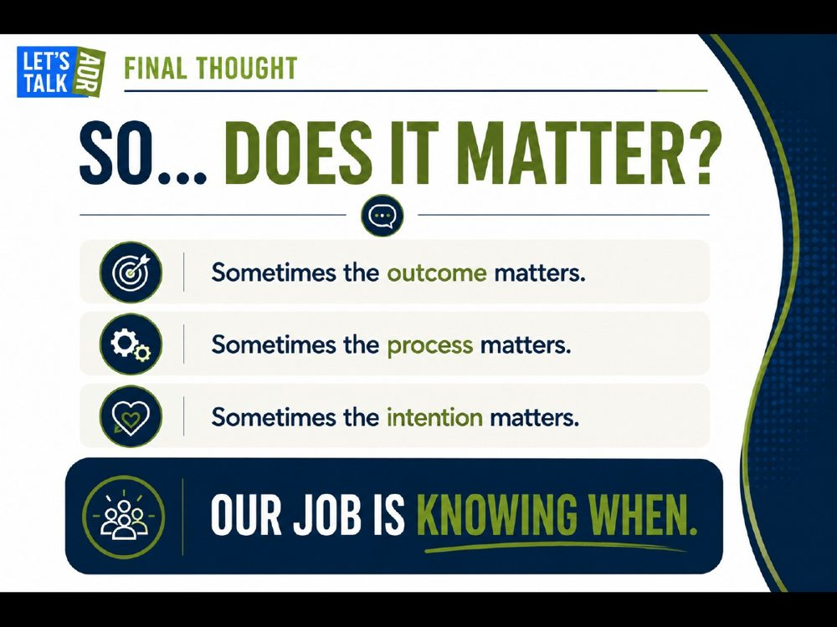 | TRAINER SNAPSHOT  Delivery: CORE  Suggested time: 2 min  Purpose: Synthesize the philosophical block into a practical conflict-resolution conclusion.
Suggested Script
“Sometimes the outcome matters. Sometimes the process matters. Sometimes the intention matters. Our job is knowing when. AI can generate arguments on every side of the questions we just discussed. The interesting part begins when people disagree about what should matter—and have to explain why.”
KEY TEACHING POINT
Professional judgment often requires deciding which values matter in the specific context.
IMPORTANT NUANCE — DO NOT OVERSTATE
Do not imply that philosophical questions have one hidden course answer.
TRANSITION
“And these questions are not merely philosophical. They show up in something as ordinary as an email.”

Slide 39 — Is Using AI Passive-Aggressive?
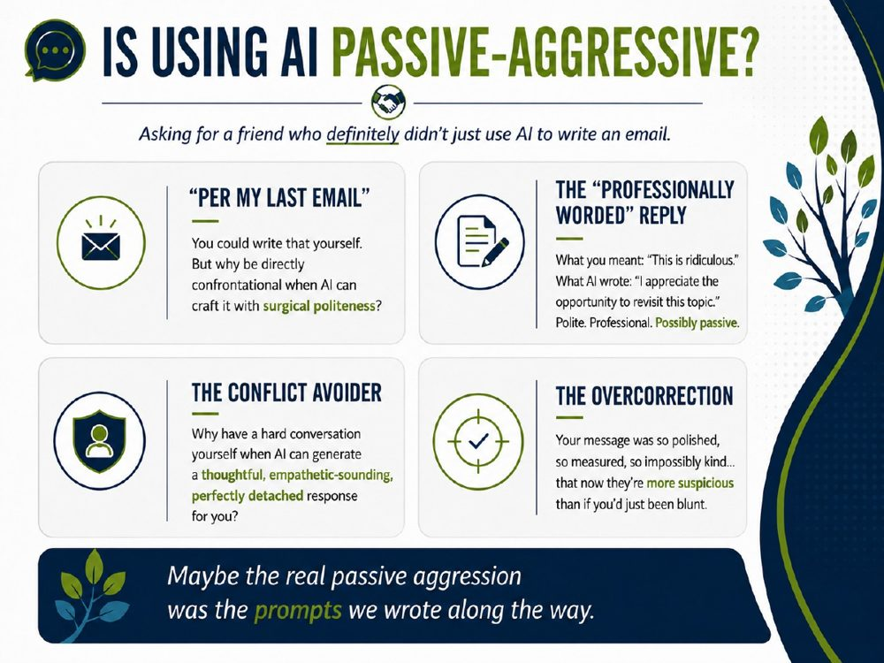 | TRAINER SNAPSHOT  Delivery: OPTIONAL • HUMOUR  Suggested time: 3–4 min  Purpose: Use humour to bring the philosophical discussion back into everyday workplace communication. Show that AI is not inherently passive-aggressive; the risk comes from how people use it, what they ask it to do, and whether the final message genuinely reflects their intent.
Suggested Script
“Alright, after all of those big philosophical questions, let’s bring this back to something much more practical.
Is using AI passive-aggressive?
Obviously, the answer is no. AI itself is not sitting there thinking, ‘How can I make this email just polite enough to irritate them?’
But people can absolutely use AI that way.
Take the classic:
‘Per my last email.’
You could write that yourself.
But why be directly confrontational when AI can help you achieve surgical politeness?
Or maybe what you really want to write is:
‘This is ridiculous.’
So you ask AI to make it more professional, and suddenly you get:
‘I appreciate the opportunity to revisit this topic.’
Perfectly polite.
Perfectly professional.
And, depending on the context, possibly even more passive-aggressive than what you started with.
Then there’s the conflict avoider.
Instead of having the difficult conversation ourselves, we can ask AI to produce something thoughtful, empathetic-sounding, and perfectly detached.
That may help us organize our thoughts.
But it can also become a way of avoiding the actual human conversation.
And then there’s my favourite: the overcorrection.
The message becomes so polished, so measured, so impossibly kind that the person receiving it thinks:
‘Okay… what are they really trying to say?’
So maybe the question isn’t whether AI is passive-aggressive.
Maybe the question is whether we are using AI to communicate more clearly—or simply to disguise what we really mean.
Because AI can help us shape the language.
But the intention behind sending the message is still ours.
Which leads to the line at the bottom:
Maybe the real passive aggression was the prompts we wrote along the way.”
KEY TEACHING POINT
AI can change the tone and presentation of a message, but the user remains responsible for the intent, substance, authenticity, and consequences of what is ultimately sent.
IMPORTANT NUANCE — DO NOT OVERSTATE
Do not describe AI as actually being empathetic, passive-aggressive, angry, polite, or manipulative. It can generate empathetic-sounding, polite, confrontational, or strategically worded language, but the human user determines the purpose for which that language is used.
Also, “per my last email” is not inherently passive-aggressive. The slide is using a familiar workplace stereotype for humour.
AI-assisted rewriting can sometimes genuinely improve communication by reducing unnecessary blame or helping someone find words they are struggling to express. The concern is not that polished language is dishonest; it is whether the final message still reflects what the person genuinely intends to communicate.
For any demonstration or audience exercise, use fictional examples only. Do not invite participants to paste real workplace, client, mediation, personal, privileged, or confidential emails into an AI tool unless that use is explicitly authorized and appropriately protected.
Audience Interaction
Ask:
“Have you ever received an email that was technically perfectly polite—but somehow felt more hostile because of how polished it was?”

Slide 40 — Ethics Before Algorithms
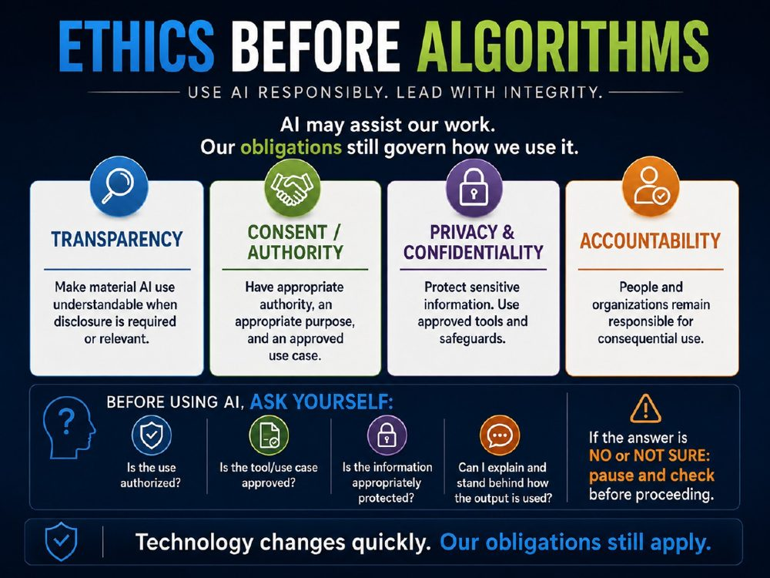 | TRAINER SNAPSHOT  Delivery: CORE  Suggested time: 4–5 min  Purpose: Establish a practical ethical checkpoint before participants use AI in professional work. Reinforce that responsible AI use depends not only on what the technology can do, but on authority, purpose, approved tools, protection of information, transparency, and accountability.
Suggested Script
“We’ve talked about what AI can do.
But before we ask whether AI can help with a task, there is a more important question:
Are we allowed—and is it appropriate—to use it this way?
That is what I mean by ethics before algorithms.
AI may assist our work. But our professional, legal, organizational, and ethical obligations do not disappear because a new tool becomes available.
There are four responsibilities I want us to keep in mind.
First: transparency.
That does not mean we need to announce every time AI helped us correct a sentence or organize a thought.
But where AI use is material to the work, or where disclosure is required or relevant, people should be able to understand how the technology was used.
Second: consent and authority.
Consent can be important—but consent is not the whole question.
We also need to ask:
Do I actually have the authority to use this information in this way?
Is there an appropriate purpose?
And is this an approved use case within my organization?
Third: privacy and confidentiality.
Conflict work can involve deeply sensitive information.
Workplace issues. Client information. Mediation communications. Financial records. Health information. Family information.
So the question is not simply, ‘Can this tool process it?’
The question is:
Am I permitted to put this information into this particular system, and is it appropriately protected?
That means using approved tools and following the safeguards that apply to our role and organization.
And fourth: accountability.
AI can contribute analysis, drafting, organization, or options.
But responsibility for consequential professional use does not simply transfer to the technology.
People and organizations remain responsible for deciding how the output is used and for the consequences that follow.
So before using AI, I want us to build a very simple habit.
Ask yourself four questions:
Is the use authorized?
Is the tool and the use case approved?
Is the information appropriately protected?
And:
Can I explain and stand behind how the output is being used?
If the answer to one of those questions is no—or even I’m not sure—that does not mean we guess.
It means we pause.
We check the policy.
We clarify the authority.
We find out what safeguards apply.
And only then do we proceed.
Because technology changes quickly.
Our obligations still apply.”
KEY TEACHING POINT
The fact that AI is technically capable of performing a task does not establish that using it is authorized, appropriate, ethical, or safe.
Responsible use requires people to consider the purpose, authority, approved tool and use case, protection of information, transparency, and accountability before proceeding.
IMPORTANT NUANCE — DO NOT OVERSTATE
Do not present consent as a universal permission slip. Depending on the situation, the relevant requirement may involve consent, another form of legal or organizational authority, an appropriate purpose, professional obligations, contractual requirements, or organizational policy.
Similarly, do not imply that all AI systems merely “recommend” while humans make every decision. AI systems can be configured to take actions or make decisions. The teaching point here is normative: in consequential professional use, people and organizations should retain appropriate oversight, decision authority, and accountability.
“Transparency” does not mean that every trivial use of AI must always be disclosed. The relevant question is whether disclosure is required, expected, or material to the people affected.
An approved AI tool is also not blanket permission to enter any information into it. The particular use case, information, safeguards, and organizational policy still matter.
If a participant is unsure whether a use is authorized, the appropriate response is pause and check, not assume permission.
Audience Interaction
Ask:
“Which of these four questions do you think people are most likely to skip when they are in a hurry?”
Invite two or three responses.
Then ask:
“What is the difference between ‘the tool can do this’ and ‘I am authorized to use it this way’?”
If useful, offer a quick fictional example:
“Imagine an AI tool can summarize a workplace investigation file beautifully.
Does that tell us whether the file should be uploaded to that tool?”
Let the room answer: No.
Then reinforce:
“Capability answers a technical question. Authorization and appropriateness answer a professional one.”
TRANSITION
“And privacy is where this becomes especially concrete.
Because even when AI is useful, the information we give it may be some of the most sensitive information we handle.
So next, let’s look at what we actually need to think about before we put information into an AI system.”

Slide 41 — Privacy Matters
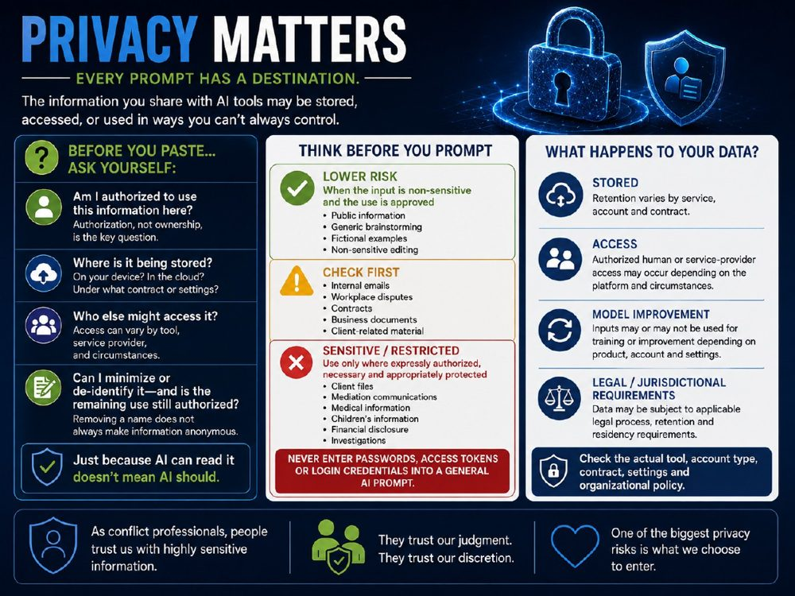 | TRAINER SNAPSHOT  Delivery: CORE  Suggested time: 5–6 min  Purpose: Help participants understand that privacy risk depends on what information they enter, which AI environment they use, and what rules govern that environment. Reinforce that no single privacy rule applies to every AI product, account type, contract, or organizational deployment.
Suggested Script
“Privacy is one of the areas where we have to be especially careful about making broad statements about AI.
Because there is no single answer to the question:
‘What happens to my data when I use AI?’
It depends.
It depends on the tool.
The account type.
The contract.
The settings.
The organization.
And sometimes the jurisdiction.
So before we paste anything into an AI system, I want us to build another simple habit:
Stop and ask a few questions first.
The first question is not:
‘Who owns this information?’
A more useful question is:
Am I authorized to use this information here?
I may have legitimate access to information for one purpose without having authority to send it to an external AI service for another purpose.
Second:
Where is the information going?
Is it staying within an approved organizational environment?
Is it being processed in the cloud?
What contract or account settings apply?
Third:
Who else might be able to access it?
That answer can differ substantially among products.
Depending on the service and circumstances, there may be service providers, authorized personnel, administrators, or other access pathways.
And fourth:
Can I minimize or de-identify the information?
But there is an important warning here.
Removing someone's name does not automatically make information anonymous.
If I describe a specific employee, a particular incident, their position, location, dates, and circumstances, someone may still be identifiable even though I removed their name.
And even if I successfully de-identify something, I still need to ask whether I am authorized to use it in that system.
Now look at the middle of the slide.
I've deliberately avoided calling anything completely ‘safe.’
Instead, think in terms of lower risk, check first, and sensitive or restricted.
If I am using public information, fictional examples, generic brainstorming, or non-sensitive text in an approved tool, the risk may be relatively low.
But internal emails, workplace disputes, contracts, business documents, or client-related material should trigger a different response:
Check first.
What does policy allow?
What tool is approved?
What information is actually necessary?
Then we reach the most sensitive material:
Client files.
Mediation communications.
Medical information.
Children's information.
Financial disclosure.
Investigations.
Those kinds of information should only be used where the use is expressly authorized, necessary, and appropriately protected.
And there is one category I want to make especially clear:
Do not enter passwords, login credentials, or access tokens into a general AI prompt.
Now let's look at the right-hand side.
What happens to information after we enter it?
Again, the answer varies.
Some services retain information for different periods.
Human or service-provider access may be possible in some circumstances.
Some products or account types may use inputs to improve models.
Others explicitly do not.
Different legal, contractual, residency, and retention requirements may apply.
So I don't want anyone leaving this presentation with the idea that:
‘AI stores everything forever,’
or
‘AI trains on everything I type,’
or even
‘My organization has an enterprise account, so anything I enter must be fine.’
Those are all overgeneralizations.
The practical rule is simpler:
Check the actual tool, the actual account type, the actual contract and settings, and your organizational policy.
Because in conflict work, people may trust us with extraordinarily sensitive information.
They trust our judgment.
They trust our discretion.
And one of the biggest privacy risks is still very simple:
what we choose to enter.”
KEY TEACHING POINT
Privacy practices vary among AI systems. Before entering information, users should determine whether the use is authorized, necessary, appropriately protected, and permitted within the specific tool and organizational environment.
The fact that an AI system is capable of processing information does not mean that the information should be provided to it.
IMPORTANT NUANCE — DO NOT OVERSTATE
Do not tell participants that AI services universally store prompts, allow employees to read them, or use them to train models. Those practices vary by product, account type, contract, configuration, settings, and deployment.
Likewise, do not describe generic brainstorming or drafting as automatically “safe.” The risk depends on the content entered, not merely the task being performed.
De-identification reduces risk but does not automatically make information anonymous. A combination of details may still identify an individual.
An approved AI tool is also not blanket permission to enter all workplace, client, mediation, health, financial, privileged, personal, or security-sensitive information. The particular use case and organizational rules still apply.
The terms lower risk, check first, and sensitive/restricted are practical teaching categories, not universal legal classifications.
Audience Interaction
Ask:
“What is something people might think is anonymous—but could still identify someone once enough details are included?”
Invite two or three examples.
Then ask:
“If your organization tells you that an AI tool is approved, what else would you still need to know before entering sensitive information?”
Listen for:
whether the specific use case is approved,
what information is necessary,
retention,
access,
account settings,
contractual protections,
organizational policy,
legal or professional obligations.
Then offer a quick scenario:
“Suppose I remove the names from a workplace dispute, but I include the department, job titles, location, dates, and a very unusual incident.
Is that necessarily anonymous?”
Allow the room to answer: No.
Reinforce:
“Removing identifiers is helpful. It is not the same thing as eliminating identification risk.”
TRANSITION
“So privacy asks us to think carefully about the information and the environment.
But even if the privacy questions are satisfied, there is still a broader decision to make:
Should AI be involved in this task at all—and if so, what role should it play?
That brings us to the AI Decision Framework.”

Slide 42 — AI Decision Framework
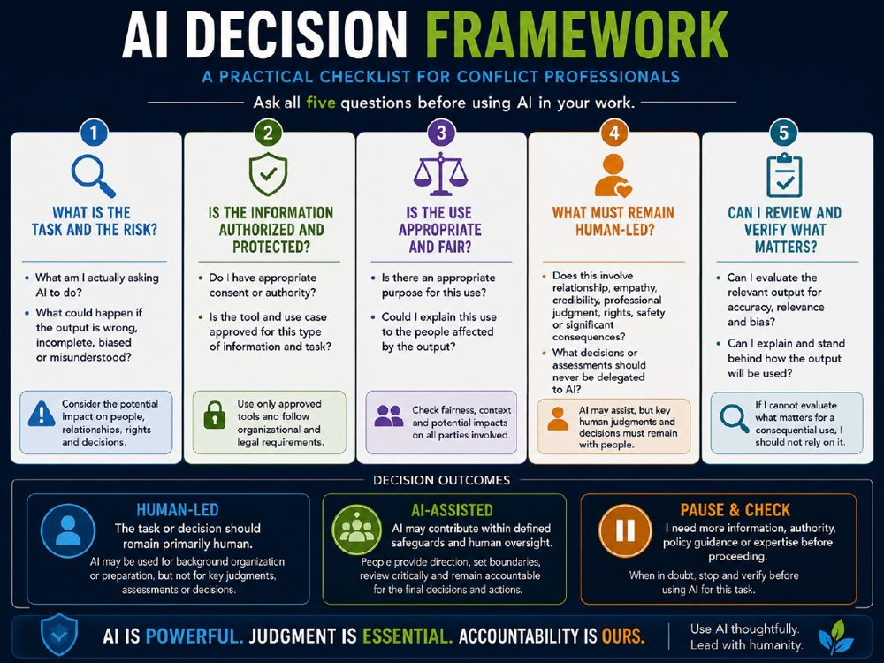 | TRAINER SNAPSHOT  Delivery: CORE  Suggested time: 6–8 min  Purpose: Give participants a practical decision framework for determining whether AI should be used for a task, what role it should play, and what must remain human-led. Reinforce that the framework is not about choosing between “AI” and “no AI,” but about matching the technology to the task, the risk, the safeguards, and the professional responsibility involved.
Suggested Script
“We’ve now looked at ethics and privacy separately.
This framework brings those ideas together into one practical question:
Should I use AI for this?
And the key is not to jump straight to the tool.
Start with the task.
There are five questions.
1. What is the task and the risk?
What am I actually asking AI to do?
Am I brainstorming?
Drafting?
Summarizing?
Organizing?
Or am I asking it to influence something much more consequential?
And then:
What happens if the output is wrong, incomplete, biased, or misunderstood?
The risk of a bad brainstorming idea is very different from the risk of a bad legal citation, an incorrect financial calculation, or an inappropriate assessment about another person.
So before we ask whether AI can do the task, we ask how much the task matters.
2. Is the information authorized and protected?
Do I have appropriate consent or authority to use this information this way?
Is the tool approved?
Is the use case approved?
And are the safeguards appropriate for the information involved?
Remember: having access to information does not automatically mean I am authorized to enter it into an AI system.
3. Is the use appropriate and fair?
There may be a technically possible and even legally permissible use that is still inappropriate in the circumstances.
So ask:
Is there an appropriate purpose?
And:
Could I explain this use to the people affected by it?
That doesn’t mean every use requires disclosure.
It means the use should be something we can reasonably justify.
4. What must remain human-led?
This is the question I think matters most in conflict work.
Does the task involve:
relationship?
empathy?
credibility?
professional judgment?
rights?
safety?
or significant consequences?
AI may still assist.
It might organize information.
Suggest questions.
Draft language.
Generate possible options.
But there are some judgments and responsibilities we should not simply delegate to the system.
And that distinction matters:
Human-led does not mean human-only.
AI may contribute without becoming the authority.
5. Can I review and verify what matters?
Can I evaluate the output well enough to know whether it is useful, accurate, relevant, and appropriate?
The level of verification should fit the level of risk.
If AI gives me ten brainstorming ideas, I don’t need to fact-check every idea as though it were sworn evidence.
But if it gives me a legal citation, a financial calculation, a policy interpretation, or something that could materially affect another person, the standard is much higher.
So the practical rule is:
If I cannot evaluate what matters for a consequential use, I should not rely on the output for that use.
And once we’ve asked all five questions, we have three possible outcomes.
Human-Led
The task or decision should remain primarily human.
AI might still assist with background organization or preparation, but the key judgment stays with people.
AI-Assisted
AI may contribute within defined safeguards and human oversight.
People still set the direction, review what matters, and remain accountable for how the output is used.
Pause & Check
And this one is important.
Sometimes the responsible answer is:
I don’t know yet.
Maybe I need more information.
Maybe I need authority.
Maybe I need to check policy.
Maybe I need legal, privacy, security, or professional guidance.
That is not hesitation.
That is judgment.
So the point of this framework is not to make every AI decision for us.
It is to slow us down just enough to make the decision deliberately.
AI is powerful.
Judgment is essential. Accountability is ours.”
KEY TEACHING POINT
The appropriate question is not simply “Can AI do this?”
It is:
“Should AI be used for this task, under what conditions, and what must remain human-led?”
Responsible AI use requires consideration of task risk, authorization, privacy, fairness, human judgment, verification, and accountability.
IMPORTANT NUANCE — DO NOT OVERSTATE
Do not teach the Human-Led outcome as meaning “AI must not be involved at all.” Human-led means that the consequential judgment, relationship, or decision remains primarily with people. AI may still assist with lower-risk supporting tasks.
Do not say AI is technically incapable of generating credibility assessments, judgments about sincerity, emotional interpretations, or recommendations. It can generate such outputs. The professional point is that those outputs should not be treated as authoritative in consequential conflict-resolution decisions.
Verification is also risk-based. Not every AI-generated output requires the same level of checking. A creative suggestion, brainstorming list, legal citation, financial calculation, or recommendation affecting someone’s rights should not be treated as equivalent.
The three outcomes are not rigid legal categories. They are a practical decision aid. Organizational policy, applicable law, professional duties, contractual obligations, and the specific AI system may impose additional requirements.
Audience Interaction
Present a short fictional scenario:
“You want AI to help you prepare for a difficult workplace conversation. You plan to give it a summary of the situation and ask for possible questions to explore.”
Then walk through the framework with the room:
1. What is the task and the risk?
“Preparation and brainstorming. What could go wrong?”
2. Is the information authorized and protected?
“What information are we planning to enter? Is the tool approved?”
3. Is the use appropriate and fair?
“Would we be comfortable explaining this use if necessary?”
4. What must remain human-led?
“Should AI decide whether either person is credible? Should it determine who is right?”
5. Can we review what matters?
“Can we distinguish useful questions from assumptions or inappropriate suggestions?”
Then ask:
“Which outcome would you choose: Human-Led, AI-Assisted, or Pause & Check?”
Emphasize that more than one answer may be reasonable depending on the facts and safeguards.
TRANSITION
“This framework helps us decide whether and how AI belongs in the task.
The next worksheet gives you a way to apply the same thinking to your own work—before you ever open the tool or write the prompt.”

Slide 43 — Worksheet 3: Before You Prompt
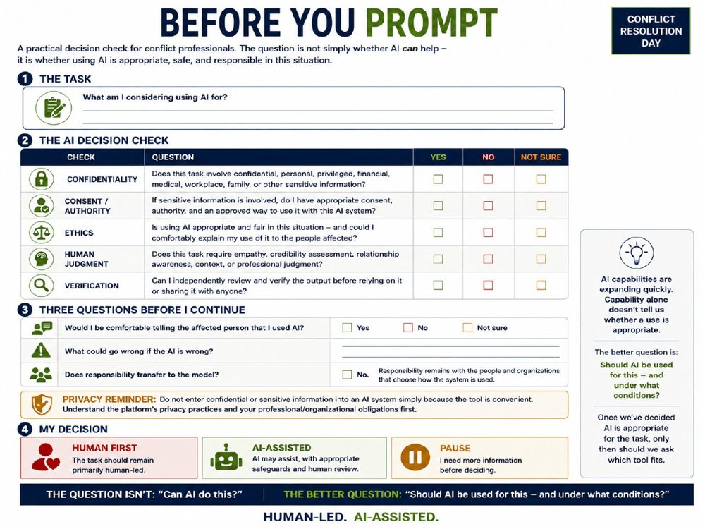 | TRAINER SNAPSHOT  Delivery: CORE • WORKSHEET  Suggested time: 6–8 min  Purpose: Give participants a practical worksheet they can use before opening an AI tool. Help them distinguish between what AI is capable of doing and whether its use is appropriate, authorized, safe, and responsible in the specific situation.
Suggested Script
“We’ve now worked through the decision framework together.
This worksheet gives you a way to use that same thinking in your own work.
And I want you to notice something important right away:
It does not begin with AI.
It begins with the task.
1. The Task
Before opening ChatGPT, Copilot, Gemini, Claude—or any other tool—ask:
What am I actually considering using AI for?
Am I brainstorming?
Drafting?
Summarizing?
Preparing for a conversation?
Analyzing information?
Helping with a decision?
Because the risk can change dramatically depending on the task.
2. The AI Decision Check
Then run that task through five checks.
First: confidentiality.
Does the task involve confidential, personal, privileged, financial, medical, workplace, family, or other sensitive information?
If it does, that is not automatically a stop sign.
But it means we need to ask the next question very carefully.
Second: consent and authority.
Do I actually have appropriate consent or other authority to use the information this way?
And do I have an approved way to use it with this particular AI system?
That distinction matters.
The fact that I have access to information does not necessarily mean I am authorized to put it into an AI tool.
Third: ethics.
Is this use appropriate and fair?
And could I comfortably explain my use of AI to the people affected?
That question does not automatically determine the answer.
But if your immediate reaction is:
‘Absolutely not—I would never want them to know,’
that is probably telling you to stop and think.
Fourth: human judgment.
Does this task involve empathy?
Relationship awareness?
Credibility assessment?
Context?
Professional judgment?
If the answer is yes, that does not necessarily mean AI cannot assist.
It means we need to be very clear about what must remain human-led.
AI may help organize information or suggest questions.
It should not become the authority on the human judgment itself.
And fifth: verification.
Can I review and evaluate what matters before I rely on the output or share it with someone else?
The level of verification should fit the risk.
A brainstorming suggestion is different from a legal citation, a financial calculation, or something affecting another person’s rights or wellbeing.
3. Three Questions Before I Continue
Then I want you to ask yourself three broader questions.
First:
Would I be comfortable telling the affected person that I used AI?
Second:
What could go wrong if the AI is wrong?
And third:
Does responsibility transfer to the model?
No.
The model may contribute to the work.
But responsibility remains with the people and organizations that choose how the system is used.
That is why the privacy reminder is here as well.
Convenience is not permission.
Before entering confidential or sensitive information, understand the platform, the account, the safeguards, and your professional or organizational obligations.
4. My Decision
And then you have three legitimate outcomes.
Human First.
The task should remain primarily human-led.
AI-Assisted.
AI may contribute with appropriate safeguards, review, and human oversight.
Or:
Pause.
I need more information before deciding.
Maybe I need to check policy.
Maybe I need authority.
Maybe I need to understand the privacy settings.
Maybe I need professional advice.
‘I don’t know yet’ can be a very responsible answer.
And that brings us to the shift I want you to remember.
AI capabilities are expanding quickly.
But capability alone does not tell us whether a use is appropriate.
So the question isn’t simply:
‘Can AI do this?’
The better question is:
‘Should AI be used for this—and under what conditions?’
Human-led.
AI-assisted.”
KEY TEACHING POINT
Responsible AI use begins with the task and the context, not with the tool.
Participants should consider confidentiality, authority, ethics, human judgment, verification, and potential consequences before deciding whether a task should be Human First, AI-Assisted, or Paused for further checking.
IMPORTANT NUANCE — DO NOT OVERSTATE
A yes to the Human Judgment question does not automatically mean “do not use AI.” It means that the consequential judgment, relationship, or decision should remain human-led even if AI assists with a supporting task.
“Would I be comfortable telling the affected person?” is a useful ethical test, but it is not a legal rule and does not replace formal requirements around disclosure, consent, privacy, professional duties, or organizational policy.
Responsibility may rest with an individual professional, employer, public body, system owner, or several actors together. The key teaching point is that responsibility does not transfer to the AI model itself.
“Not sure” is deliberately included throughout the worksheet. Participants should understand that uncertainty is a signal to pause and check, not to guess.
Audience Interaction
Give participants several minutes to complete the worksheet using a fictional, generic, or fully de-identified task.
Ask them not to record real confidential workplace, client, mediation, financial, health, privileged, or personal details.
Then invite them to focus on one question:
“Which check changed your initial answer the most?”
Do not ask participants to disclose the underlying situation.
Then ask:
“Did anyone begin thinking the task was clearly AI-assisted and end up choosing Human First or Pause?”
Follow with:
“What changed your thinking?”
Finally ask:
“Which of the three outcomes do you think professionals find hardest to choose?”
Reinforce that Pause is a legitimate and often responsible outcome.
TRANSITION
“Once we’ve decided that AI is appropriate for the task, only then should we ask:
Which tool actually fits the job?
Because AI is not one thing—and different tools are designed for very different purposes.”

Slide 44 — The AI Landscape
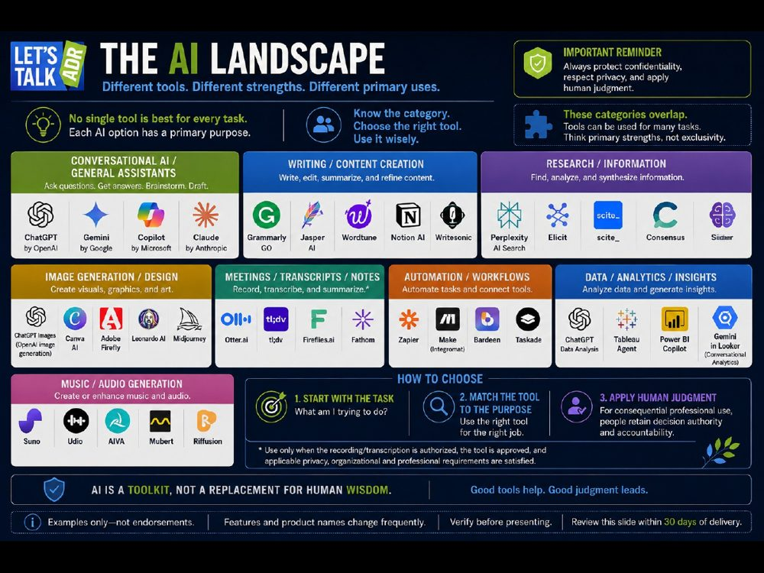 | TRAINER SNAPSHOT  Delivery: OPTIONAL • CURRENT TOOLS  Suggested time: 4–5 min  Purpose: Help participants understand that AI is not one tool or one category. Different systems have different strengths, risks, privacy settings, and intended uses. Reinforce the decision sequence:  Start with the task → choose the appropriate tool → apply human judgment.  ⚠ FRESHNESS: review named tools within 30 days of delivery.
Suggested Script
“Now that we’ve decided whether AI belongs in the task, the next question is:
Which tool actually fits the job?
Because AI is not ChatGPT.
ChatGPT is one tool in a much larger—and rapidly changing—ecosystem.
And one of the biggest mistakes we can make is starting with:
‘Which AI should I use?’
The better place to start is:
What am I actually trying to accomplish?
If I want conversational help, brainstorming, drafting, or general assistance, I might look at tools such as ChatGPT, Gemini, Copilot, or Claude.
If I’m primarily writing or editing, there are tools designed around content creation and refinement.
If I’m researching, the tools may be different again. Something like Perplexity is much more naturally thought of as a research and information tool than simply another chatbot.
We also have tools for image generation and design.
Meeting transcription and note-taking.
Workflow automation.
Data analysis.
And now increasingly sophisticated tools for music and audio generation as well.
But there is an important warning here:
These boxes overlap.
ChatGPT can create images and analyze data.
Canva does much more than graphic design.
Research tools may write.
Writing tools may summarize.
Automation tools may contain their own AI assistants.
So these categories represent primary strengths—not exclusive functions.
And the names change quickly too.
Products get renamed.
Features move.
Capabilities expand.
Some disappear.
That is why this slide carries a very deliberate reminder:
Examples only—not endorsements.
And trainers should verify the slide before presenting it.
Now, there is another reason the tool matters.
Different tools can have very different privacy, retention, access, security, and contractual arrangements.
So choosing the tool is not simply a feature comparison.
For example, suppose I want to transcribe a meeting.
The fact that a transcription tool can do it does not answer whether I should.
Is the recording or transcription authorized?
Is the tool approved?
Are the privacy, organizational, professional, and legal requirements satisfied?
Only then does functionality become relevant.
So I want you to remember three steps.
1. Start with the task.
What am I trying to do?
2. Match the tool to the purpose.
Which system is actually suited to this particular job—and approved for this particular use?
3. Apply human judgment.
For consequential professional use, people still retain appropriate decision authority and accountability.
That is why I describe AI as a toolkit.
You don’t need every tool in the box.
And you certainly don’t need to use one simply because it exists.
The skill is knowing:
which tool to pick up, when to use it, and when to leave it in the toolbox.”
KEY TEACHING POINT
AI tools have different primary strengths, limitations, privacy arrangements, and use cases.
The correct sequence is:
Identify the task first.
Choose the appropriate and approved tool second.
Apply human judgment throughout.
Tool choice should follow the task—not drive it.
IMPORTANT NUANCE — DO NOT OVERSTATE
The categories on the slide are intentionally simplified. Many modern AI systems operate across several categories, so trainers should describe these as primary uses rather than rigid classifications.
Named products are included as examples, not endorsements. Features, product names, pricing, privacy practices, and capabilities can change quickly. Trainers should verify this slide close to the delivery date.
Do not imply that a product’s presence on the slide means it is approved for use within a particular organization.
For meeting recording or transcription, consent alone may not be sufficient. The use should be authorized, the tool approved, and applicable privacy, organizational, professional, and legal requirements satisfied.
Likewise, do not say that humans are technically always the decision-maker in every AI system. AI systems may be configured to make or execute decisions. The professional principle being taught here is that for consequential professional use, people and organizations should retain appropriate authority, oversight, and accountability.
Audience Interaction
Ask:
“Which category on this slide do you think you use most often—or would be most useful in your work?”
Invite a few responses.
Then ask:
“What is the danger of choosing the tool before clearly defining the task?”
Listen for answers such as:
using AI simply because it is available,
selecting the wrong tool,
unnecessary privacy exposure,
automating something that should remain human-led,
overpaying or overcomplicating the task,
relying on a feature that is poorly suited to the job.
Then ask:
“What would you want to know about a tool besides what it can do?”
Reinforce:
whether it is approved,
privacy and retention,
account type,
security,
contractual protections,
reliability,
cost,
professional or organizational restrictions.
TRANSITION
“So once we understand that AI is a toolkit rather than a single technology, we can make this very practical.
The next question is:
How might a conflict professional actually use these tools in real practice—without handing over the judgment, the relationship, or the responsibility?
That brings us to AI in mediation.”

Slide 45 — AI in Mediation
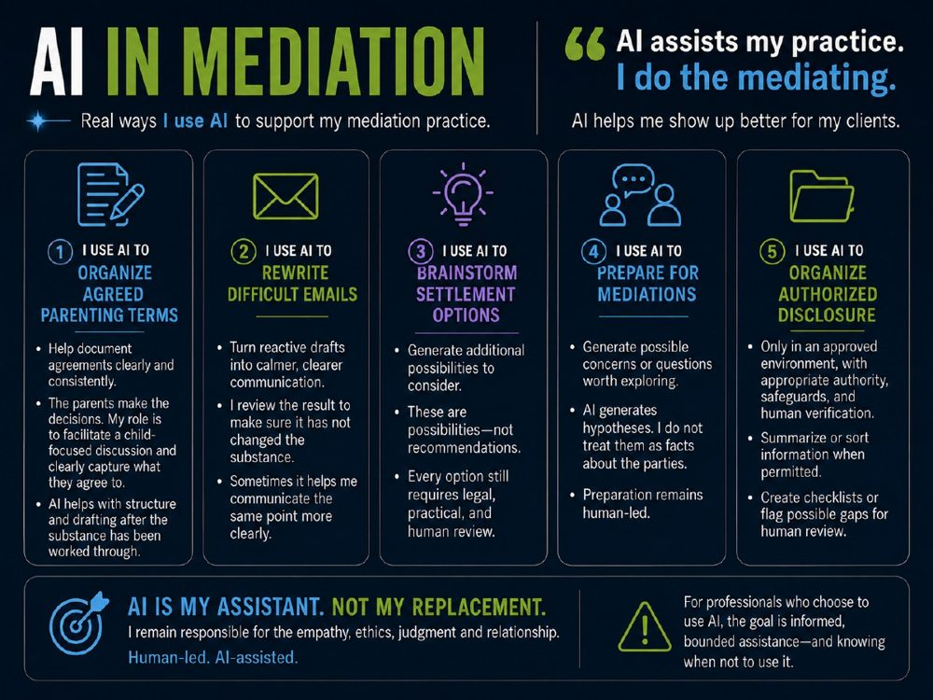 | TRAINER SNAPSHOT  Delivery: CORE  Suggested time: 5–7 min  Purpose: Show participants how AI can support a mediation practice without taking over the mediation, the decision-making, or the professional responsibility. Make the course practical by illustrating bounded, real-world uses while reinforcing privacy, authorization, review, and human accountability.
Suggested Script
“Everything we’ve talked about so far can sound fairly theoretical.
So I want to make it practical.
These are some of the ways I use AI in my own mediation practice.
And the principle is simple:
AI assists my practice.
I do the mediating.
I don’t delegate the relationship.
I don’t delegate the judgment.
And I don’t delegate the responsibility.
1. Organize Agreed Parenting Terms
One example is parenting plans.
I do not ask AI to decide what is best for the children.
The parents make the decisions.
My role is to facilitate an informed, child-focused discussion and help them clearly document what they agree to.
Once the substance has been worked through, AI can sometimes help organize those agreed terms into a clearer structure.
That can save time on drafting and formatting.
But the decisions remain with the parents, and the final document still requires human review.
2. Rewrite Difficult Emails
I also sometimes use AI to help me revise difficult communications.
Maybe I have written something that is technically accurate but more reactive than I want it to be.
I can ask for a calmer or clearer version.
But there is an important safeguard:
I review the result to make sure it has not changed the substance.
Because AI absolutely can change meaning while making something sound smoother.
Sometimes it helps me communicate the same point more clearly.
But I am still responsible for what I send.
3. Brainstorm Settlement Options
Sometimes people become stuck around a very small number of possible solutions.
AI can be useful for generating additional possibilities we might not immediately have considered.
But I treat those as exactly that:
possibilities—not recommendations.
AI is not determining the fair outcome.
It is helping expand the menu.
Every option still requires legal, practical, and human review.
And often the real value is not in the suggestion itself.
It is in the conversation the suggestion creates.
4. Prepare for Mediations
AI can also help me prepare.
For example, I might ask:
‘What possible concerns or questions might be worth exploring?’
Or:
‘What issues have I not yet considered?’
That can challenge my thinking and help me prepare more thoroughly.
But I am very careful about one thing:
AI generates hypotheses. I do not treat them as facts about the parties.
It may suggest a possibility worth asking about.
That does not mean the possibility is true.
Preparation remains human-led.
5. Organize Authorized Disclosure
And finally, AI can sometimes assist with organizing disclosure.
But this is the use that requires the strongest caution.
Financial disclosure can include bank records, tax information, account numbers, employment details, addresses, and family information.
So this is not an invitation to upload client documents into any convenient AI tool.
I would only use AI with this kind of material in an approved environment, with appropriate authority, safeguards, and human verification.
Where permitted, it may help summarize or sort information, create checklists, or flag possible gaps for review.
But again:
A flag is not a finding.
A summary is not proof.
And the professional remains responsible for checking what matters.
So if you look across all five examples, the theme is the same.
AI may help me with structure.
Drafting.
Possibilities.
Preparation.
Organization.
But I remain responsible for the empathy, the ethics, the judgment, and the relationship.
That is what I mean by:
Human-led. AI-assisted.
And for professionals who choose to use AI, I think the goal should be informed, bounded assistance—and knowing when not to use it.”
KEY TEACHING POINT
AI can support discrete parts of mediation practice without becoming the mediator, the decision-maker, or the authority.
The appropriate role is bounded assistance: AI may help with drafting, organization, preparation, or option generation while people retain responsibility for the relationship, professional judgment, decisions, verification, and consequences.
IMPORTANT NUANCE — DO NOT OVERSTATE
Do not teach these examples as blanket permission to use AI with real client or mediation information.
Some of the tasks shown—especially parenting matters, financial disclosure, and mediation preparation—may involve highly sensitive, confidential, privileged, or identifying information. Use should occur only where the tool and use case are approved, appropriate authority exists, safeguards are in place, and professional and organizational obligations are satisfied.
For parenting plans, the mediator does not decide what is best for the children. The parents make the decisions; the mediator facilitates the discussion and helps document agreement.
For rewritten emails, AI may alter meaning as well as tone. Human review is required to ensure the substance has not changed.
For settlement options and mediation preparation, AI-generated possibilities are hypotheses or options, not findings about the parties and not recommendations to be adopted without review.
For disclosure, AI may miss documents, miscategorize information, or incorrectly flag gaps. Any output should be treated as an aid to human review.
Audience Interaction
Ask:
“Which of these five uses feels most helpful—and which feels most sensitive?”
Invite a few responses.
Then ask:
“What makes one of these uses AI-assisted rather than AI-led?”
Listen for:
people make the decisions,
AI does not determine credibility,
the professional checks the output,
the relationship remains human,
the tool is used for a bounded task,
sensitive information is appropriately protected.
Then ask:
“Which of these examples would require you to check organizational policy before proceeding?”
The best answer is:
Potentially all of them, depending on the information and the tool.
Reinforce:
“The task may look harmless. The information involved can change the risk completely.”
TRANSITION
“So this is not a course about getting everyone to use AI.
It is about making better decisions if and when we choose to use it.
And that brings us back to the larger question we began with:
What should AI help us do—and what must we remain responsible for ourselves?”

Slide 46 — Call to Awareness
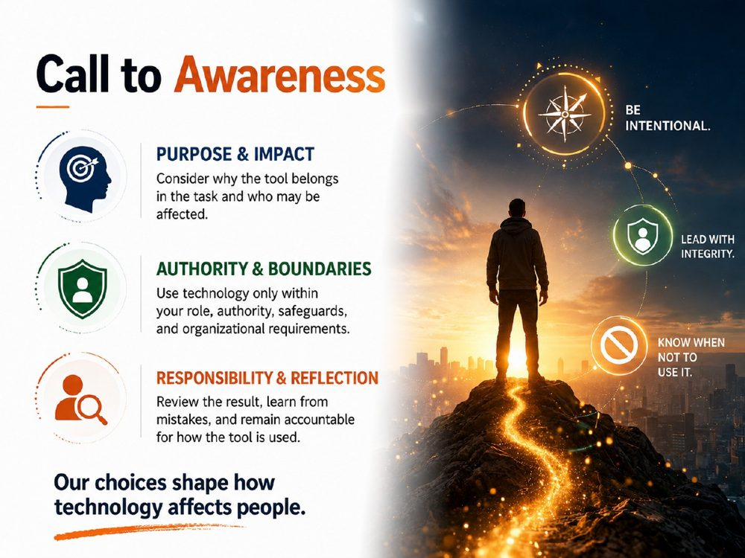 | TRAINER SNAPSHOT  Delivery: CORE  Suggested time: 3–4 min  Purpose: Close the substantive teaching portion of the session by shifting from what AI can do to how people choose to use it. Reinforce that the course is not an encouragement to adopt AI, but a framework for making deliberate, ethical, and accountable choices about whether and how technology belongs in the work.
Suggested Script
“As we come toward the end, I want to bring everything back to one idea:
This is not a call to use more AI.
It is a call to be more intentional about the choices we make around it.
There are three things I want us to carry forward.
First: purpose and impact.
Before using a tool, ask:
Why does this technology belong in the task?
What problem am I actually trying to solve?
And who might be affected by the way I use it?
Capability is not enough.
A tool may be able to do something very well and still be unnecessary, inappropriate, or poorly suited to the situation.
Second: authority and boundaries.
Our role matters.
Our organizational requirements matter.
Privacy and confidentiality matter.
The safeguards around the tool matter.
So even if AI could help, we still need to ask whether we are authorized to use it this way, with this information, in this environment.
And sometimes the responsible answer is simply:
No.
Or:
Not yet.
Or:
Not for this task.
Third: responsibility and reflection.
If we use AI, we still need to review what it gives us.
Notice when something goes wrong.
Learn from mistakes.
And remain accountable for how the technology affects the people involved.
That is why the three reminders on the right matter.
Be intentional.
Don’t use technology simply because it is available.
Lead with integrity.
Use it in a way you could explain and stand behind.
And:
Know when not to use it.
Because judgment is not only about knowing when to say yes.
Sometimes good judgment is knowing when to stop.
So the final thought on this slide is deliberately simple:
Our choices shape how technology affects people.
That is the responsibility we keep.”
KEY TEACHING POINT
Responsible AI practice is fundamentally about choice.
Professionals should consider purpose, impact, authority, boundaries, safeguards, and accountability before deciding whether AI belongs in a task at all.
Knowing when not to use AI is as important as knowing how to use it responsibly.
IMPORTANT NUANCE — DO NOT OVERSTATE
Do not present this slide as a call for AI adoption.
The course position is neutral: AI may be useful in some circumstances, inappropriate in others, and unnecessary in many.
“Lead with integrity” and “be intentional” are values statements, not technical claims. Trainers should connect them back to the concrete safeguards already taught: authorization, approved tools and use cases, privacy, confidentiality, human judgment, and verification.
“Know when not to use it” does not mean that AI is inherently risky or unsuitable. It means that the decision should depend on the task, consequences, information involved, organizational requirements, and professional responsibilities.
Audience Interaction
Ask:
“Which of these three feels hardest in practice: deciding the purpose, knowing the boundary, or taking responsibility for the result?”
Invite two or three brief responses.
Then ask:
“Can you think of a situation where the most responsible AI decision would simply be not to use it?”
Keep the examples generic. Do not invite participants to disclose confidential workplace, client, mediation, personal, health, financial, or privileged information.
Close the discussion with:
“That answer is just as legitimate as identifying a good AI-assisted use.”
TRANSITION
“So with that in mind, I want to ask one final question—not whether you are now more enthusiastic about AI, but whether you feel more deliberate about how you would approach it.
Let’s see where the room has landed.”

Slide 47 — Final Poll: What’s Your Takeaway?
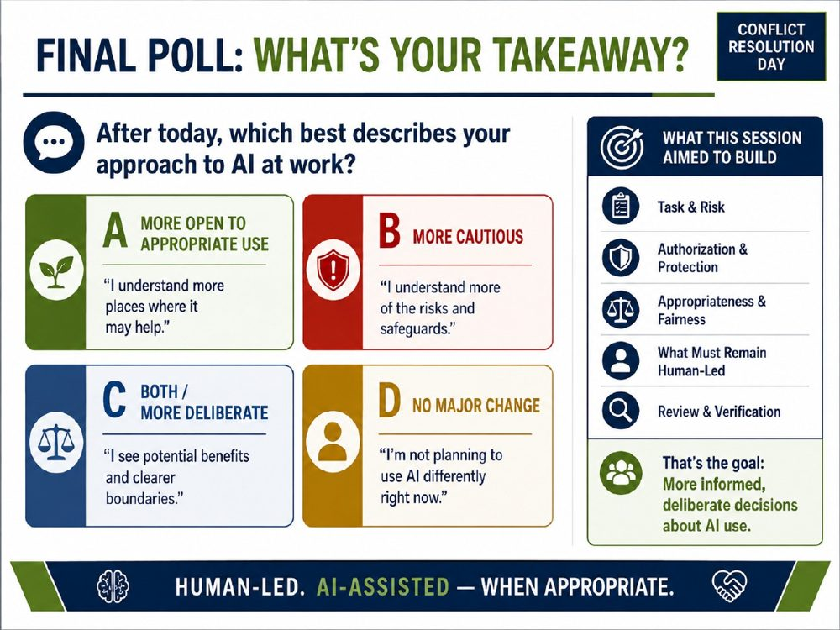 | TRAINER SNAPSHOT  Delivery: CORE • POLL  Suggested time: 4–5 min  Purpose: Give participants a neutral closing reflection on how the session has affected their approach to AI. Reinforce that the learning goal is not increased AI adoption, but more informed and deliberate decision-making about when AI may help, when caution is warranted, and what must remain human-led.
Suggested Script
“We’ve covered a lot today.
We’ve talked about what AI can do.
We’ve talked about where it can go wrong.
We’ve looked at privacy, ethics, verification, human judgment, and responsibility.
So I want to finish with one simple question:
After today, which best describes your approach to AI at work?
There is no preferred answer here.
A — More Open to Appropriate Use
Maybe you came in fairly skeptical or unsure what these tools could actually do.
And now you can see some places where AI might genuinely help—perhaps with preparation, drafting, brainstorming, organization, or another appropriate task.
That is a perfectly reasonable takeaway.
B — More Cautious
Maybe today made you more aware of the risks.
Privacy.
Confidentiality.
Hallucinations.
Bias.
Over-reliance.
Or the importance of using approved tools and understanding what happens to the information we enter.
That is also a perfectly reasonable takeaway.
C — Both / More Deliberate
Maybe you see more potential than you did before—but also clearer boundaries.
You can see where AI may be useful, while also becoming more intentional about where it should not be relied upon.
Again, completely legitimate.
D — No Major Change
And maybe your answer is:
‘I understand the technology better, but I’m not planning to use AI differently right now.’
That is also a valid outcome.
Understanding a technology does not obligate us to adopt it.
The goal of this session was never to get everyone to the same answer.
It was to give us a better set of questions.
And those questions are here on the right.
What is the task, and what is the risk?
Do I have the authority and protections I need?
Is the use appropriate and fair?
What must remain human-led?
And:
Can I review and verify what matters before relying on the output?
If those questions become part of how you think about AI, then this session has done what it was intended to do.
Because the goal is not more AI.
The goal is:
more informed, deliberate decisions about AI use.
Human-led.
AI-assisted—when appropriate.”
KEY TEACHING POINT
There is no correct poll answer.
Participants may reasonably leave the session more open to AI, more cautious, more deliberate, or with no intention of changing their current use.
The learning objective is greater understanding, judgment, and intentionality, not adoption.
IMPORTANT NUANCE — DO NOT OVERSTATE
Do not praise one poll category more than another or suggest that “Both / More Deliberate” is the ideal response.
Someone who concludes that AI is inappropriate for their current role or circumstances may have applied the framework just as successfully as someone who identifies an appropriate AI-assisted use.
Likewise, “more cautious” should not be framed as fear or resistance. Increased caution may reflect a better understanding of privacy, confidentiality, risk, professional obligations, or organizational policy.
The five framework items on the right are practical decision prompts, not a complete legal or professional compliance checklist. Applicable law, policy, contractual obligations, and professional duties may add further requirements.
Audience Interaction
Ask for a show of hands, digital poll, or anonymous response:
“A, B, C, or D—which best describes where you are now?”
Pause and look at the distribution without judging it.
Then ask one or two volunteers from different categories:
“What changed—or didn’t change—for you?”
Follow with:
“Was there one question from the decision framework that affected your thinking more than the others?”
Do not ask participants to justify or defend their choice.
Close the interaction with:
“Every answer is valid. What matters is that the choice is informed and deliberate.”
TRANSITION
“Now that you’ve identified where you stand, the final exercise is about turning that reflection into something practical.
Not necessarily something you will do with AI—but one choice, safeguard, habit, or boundary you want to carry into your work.
Let’s finish with your AI Practice Plan.”

Slide 48 — Worksheet 4: My AI Practice Plan
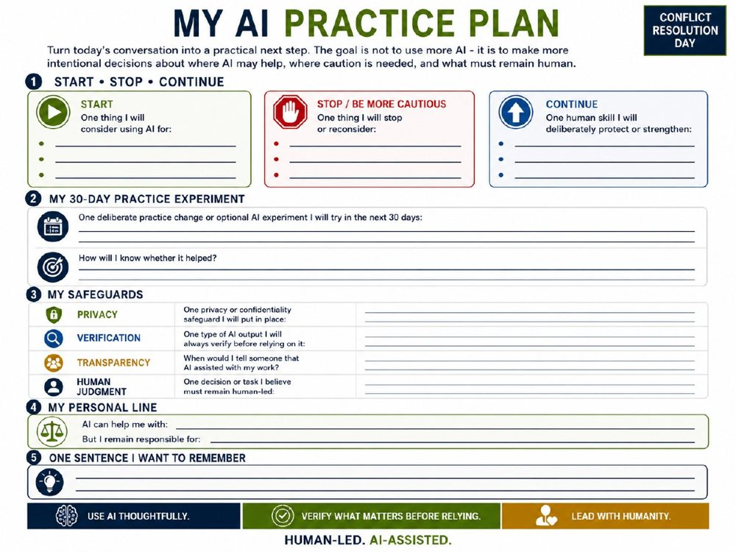 | TRAINER SNAPSHOT  Delivery: OPTIONAL • WORKSHEET  Suggested time: 8–10 min  Purpose: Turn the session into a practical next step without implying that participants should adopt AI. Help them identify one deliberate change, one safeguard, one human capability to protect, and one personal boundary for responsible AI use.
Suggested Script
“We’ve spent today talking about what AI can do, where it can fail, and where human judgment and responsibility remain essential.
This last worksheet is about turning all of that into something practical.
And I want to emphasize the sentence at the top:
The goal is not to use more AI.
The goal is to make more intentional decisions about where AI may help, where caution is needed, and what must remain human.
1. Start • Stop • Continue
Let’s begin with three simple questions.
First:
Start.
Is there one thing you might consider using AI for?
Not because you feel you should.
Not because everyone else is doing it.
But because you can identify a specific, appropriate task where it may genuinely help.
Maybe that is brainstorming.
Organizing your thoughts.
Drafting an agenda.
Preparing questions.
Or maybe you leave this section blank because there is nothing appropriate for you right now.
That is completely fine.
Next:
Stop—or be more cautious.
Is there something you want to reconsider?
Maybe you’ve been accepting AI output too quickly.
Maybe you’ve used information without thinking enough about privacy.
Maybe you’ve allowed AI-generated wording to become more polished than authentic.
Or maybe there is simply a task where you now realize:
‘I need to check before I use AI here.’
And then:
Continue.
What human capability do you want to deliberately protect or strengthen?
Listening?
Curiosity?
Empathy?
Reading the room?
Asking better questions?
Sitting with silence?
Because as AI capabilities continue to change, we need to be equally deliberate about the human skills we still need to practise.
2. My 30-Day Practice Experiment
This section is intentionally broader than an AI experiment.
Choose one deliberate practice change or optional AI experiment you might try over the next 30 days.
It might involve AI.
It might not.
Maybe you want to test a low-risk AI-assisted task.
Maybe your experiment is to verify citations every time before relying on them.
Maybe it is to stop pasting sensitive material into tools until you understand the policy.
Maybe it is to have one difficult conversation directly instead of drafting around it.
Or maybe your experiment is deliberate non-use in a particular area.
The question is:
What change are you going to try—and how will you know whether it actually helped?
Did it save time?
Improve your preparation?
Reduce risk?
Make communication clearer?
Strengthen a human skill?
The point is not to adopt technology because it is impressive.
The point is to ask whether the change actually improves the way you work.
3. My Safeguards
Then we move to guardrails.
What is one privacy or confidentiality safeguard you will put in place?
What kind of AI output will you always verify before relying on it?
When should you be transparent that AI assisted with your work?
And what is one decision or task that you believe must remain human-led?
Your answers may be different from the person sitting beside you.
Different roles, organizations, professions, and situations carry different responsibilities.
What matters is that you are making those choices consciously.
4. My Personal Line
This may be the most important part of the page.
Complete these two sentences:
AI can help me with…
and:
But I remain responsible for…
Those two statements can coexist.
Using AI does not mean surrendering responsibility.
And taking responsibility does not mean refusing to use AI.
That is the balance we’ve been talking about all day:
Human-led. AI-assisted.
5. One Sentence I Want to Remember
And finally, write down one sentence from today that you want to carry with you.
It does not have to be something I said.
It might be something another participant said.
It might be something you realized yourself.
Maybe it is:
Confidence is not competence.
Maybe:
Capability does not transfer accountability.
Maybe:
Should AI be used for this—and under what conditions?
Or maybe your sentence is completely different.
The important thing is that you leave with something you can actually remember and use.
And if you remember nothing else from this worksheet, remember the three lines at the bottom:
Use AI thoughtfully.
Verify what matters before relying.
And:
Lead with humanity.”
KEY TEACHING POINT
A responsible AI practice plan is not an adoption plan.
It is a decision-making and boundary-setting plan.
Participants should leave with a clearer sense of:
where AI may appropriately assist,
where greater caution is needed,
what safeguards they will use,
what human capabilities they want to protect,
and what responsibilities they will not delegate.
IMPORTANT NUANCE — DO NOT OVERSTATE
The Start section is optional. Trainers should not pressure participants to identify an AI use if they do not believe one is appropriate.
The 30-day experiment may be:
AI-assisted,
entirely human-led,
a privacy improvement,
a verification habit,
a policy check,
or deliberate non-use.
“Verify what matters before relying” is intentionally risk-based. Not every brainstorming idea needs the same verification as a legal citation, financial calculation, policy interpretation, or other consequential output.
Participants should not write confidential, privileged, mediation, client, health, financial, workplace, or other sensitive details on the worksheet if doing so would itself create a privacy or confidentiality concern.
Audience Interaction
Suggested timing: 8–10 minutes
Give participants approximately:
2 minutes for Start • Stop • Continue,
2 minutes for the 30-day experiment,
2 minutes for safeguards,
1 minute for their personal line,
1 minute for the sentence they want to remember.
Then ask:
“Which section was easiest to answer?”
and:
“Which one made you think the hardest?”
Do not ask participants to share confidential examples.
If time permits, ask:
“Did anyone choose a practice experiment that does not involve using AI at all?”
Reinforce that this is a fully valid outcome.
TRANSITION
“Keep this worksheet.
You don’t need to act on everything today.
But I hope you leave with one clearer choice, one stronger safeguard, and one better question to ask before AI enters your work.
Because the goal was never simply to use AI.
The goal was to use judgment.”

Slide 49 — Alberta AI Academy
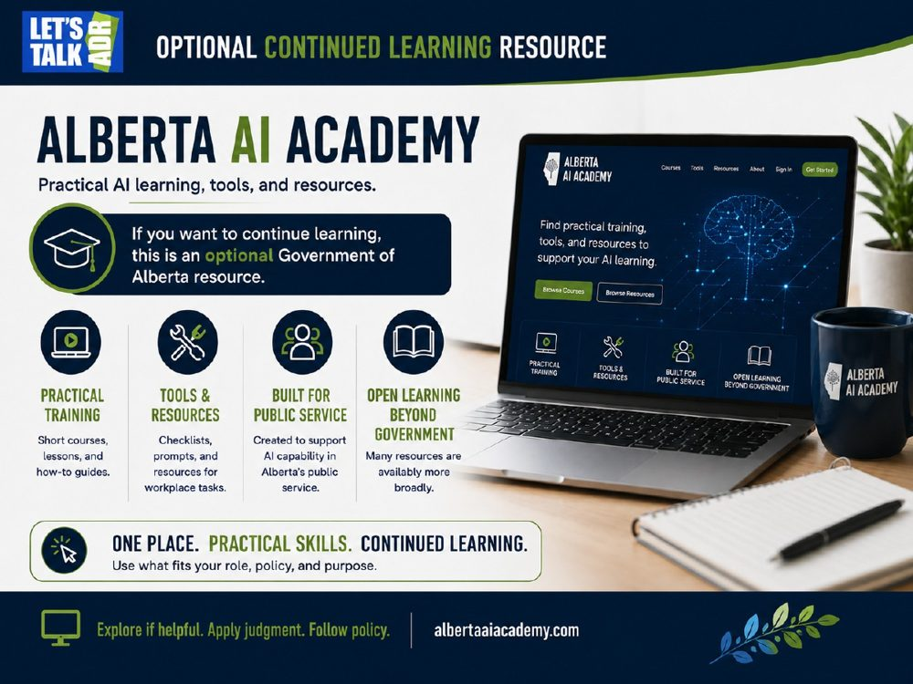 | TRAINER SNAPSHOT  Delivery: OPTIONAL • RESOURCE  Suggested time: 2–3 min  Purpose: Introduce the Alberta AI Academy as an optional Government of Alberta learning resource for participants who want to continue developing their understanding of AI after the session. Reinforce that further learning does not imply an expectation to adopt AI or use it in every role.  ⚠ FRESHNESS: verify Academy links/resources before delivery.
Suggested Script
“If today has left you wanting to learn more, there is one Government of Alberta resource I want to point you toward.
The Alberta AI Academy.
And I want to frame this carefully:
This is an optional continued-learning resource.
The message is not:
‘You’ve finished this course, now go use AI.’
It is:
‘If AI is relevant to your role—or if you simply want to understand it better—there are resources available to help you continue learning.’
The Academy was created to support AI capability within Alberta’s public service, and many of its learning resources are available more broadly.
You’ll find practical training.
Short courses and how-to material.
Tools, prompts, checklists, and resources intended to help people think through workplace applications.
So for those of you working within public service, it can provide a useful place to continue developing your understanding.
And for people outside government, there may still be resources that are useful and accessible.
But I want to connect this directly to everything we have discussed today.
Learning more about AI does not mean you are required to use it.
And discovering that a tool exists does not mean it is approved for your particular workplace, role, information, or task.
The principles we’ve already discussed still apply.
Start with the task.
Understand the risk.
Follow your organizational requirements.
Protect sensitive information.
And apply human judgment.
That is why I like the line at the bottom:
Explore if helpful. Apply judgment. Follow policy.
The Academy is there if continued learning is useful to you.
Use what fits your role, your purpose, and your responsibilities.”
KEY TEACHING POINT
The Alberta AI Academy is a continued-learning resource, not an AI adoption requirement.
Participants may use it to build knowledge and practical understanding while continuing to apply the same principles taught throughout the session: appropriate purpose, authorization, privacy, policy, human judgment, and accountability.
IMPORTANT NUANCE — DO NOT OVERSTATE
Do not describe the Alberta AI Academy as being universally designed for “everyone.” It was created to support AI capability in Alberta’s public service, although many resources may be available more broadly.
Do not imply that tools, prompts, techniques, or examples found through the Academy are automatically approved for every Government of Alberta role or workplace use. Participants must still follow applicable organizational policies, approved-tool requirements, privacy obligations, and professional duties.
Also avoid presenting continued AI learning as a required next step. A participant who chooses not to use AI may still benefit from understanding the technology, its risks, and how it may affect their workplace.
Because courses, features, and availability can change, trainers should verify the Academy and its current resources before delivering the session.
Audience Interaction
Ask:
“How many of you would be interested in continuing to learn about AI, even if you’re not yet sure whether you want to use it more?”
Allow a show of hands.
Then ask:
“What would you most want additional training on?”
Possible responses might include:
prompting,
privacy,
approved tools,
verification,
workplace applications,
automation,
data analysis,
understanding AI limitations.
Reinforce:
“Learning more does not commit you to using more. It simply gives you better information for deciding.”
TRANSITION
“So whether you continue exploring AI or decide that your current approach is exactly where it should be, the important thing is that the choice is informed.
And that brings us to our final thought:
human-led, AI-assisted—when appropriate.”

Slide 50 — With Thanks
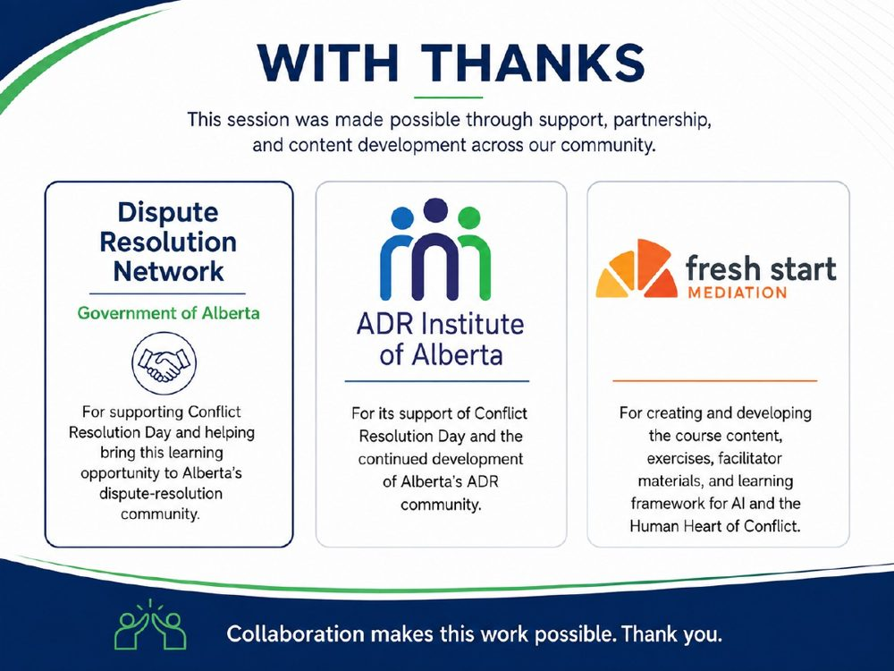 | TRAINER SNAPSHOT  Delivery: CORE • ACKNOWLEDGEMENT  Suggested time: 2 min  Purpose: Acknowledge the organizations that supported the session, clearly distinguish their roles, and invite interested participants to become more involved by joining the Conflict Resolution Day Committee.
Suggested Script
“Before we finish, I want to take a moment to acknowledge the organizations that helped make this session possible.
First, the Dispute Resolution Network of the Government of Alberta.
Thank you for supporting Conflict Resolution Day and for helping create opportunities like this for Alberta’s dispute-resolution community.
Second, the ADR Institute of Alberta—ADRIA.
Thank you for your continued support of Conflict Resolution Day and for the work you do to strengthen Alberta’s ADR community.
And finally, Fresh Start Mediation.
Fresh Start created and developed the course content, exercises, facilitator materials, and learning framework for AI and the Human Heart of Conflict.
Each organization contributed in a different way, and together that support made this learning opportunity possible.
And there is one more thing I want to mention.
Conflict Resolution Day is very much a community effort.
We are always looking for people who care about conflict resolution and want to help shape what this initiative becomes.
So if today has sparked your interest and you would like to become more involved, we are looking for people to join the Conflict Resolution Day Committee.
Whether you want to contribute ideas, help with planning, support events, or simply be part of the conversation, please get in touch with us.
We would love to hear from you.
So to DRN, ADRIA, Fresh Start Mediation—and everyone who helps make Conflict Resolution Day possible:
thank you.
Collaboration really does make this work possible.”
KEY TEACHING POINT
This is an acknowledgement and community-building slide, not a teaching slide. It recognizes the organizations involved while also giving participants a clear, low-pressure way to become involved in the ongoing work of Conflict Resolution Day.
IMPORTANT NUANCE — DO NOT OVERSTATE
Keep the invitation voluntary and open. Do not imply that participation in the committee is expected as a result of attending the session.
If contact information or a QR code for joining the committee is available, it would be worth adding a small callout to the slide:
Interested in joining the Conflict Resolution Day Committee?
Please get in touch—we’d love to hear from you.
That would make the invitation actionable without cluttering the acknowledgement.
Audience Interaction
None required, but you can briefly say:
“Please come speak to one of us afterward if you’re interested.”
TRANSITION
“And with that, there’s only one thing left to say:
Thank you for being part of today’s conversation.”
Then advance to the final Thank You slide.

Slide 51 — Thank You
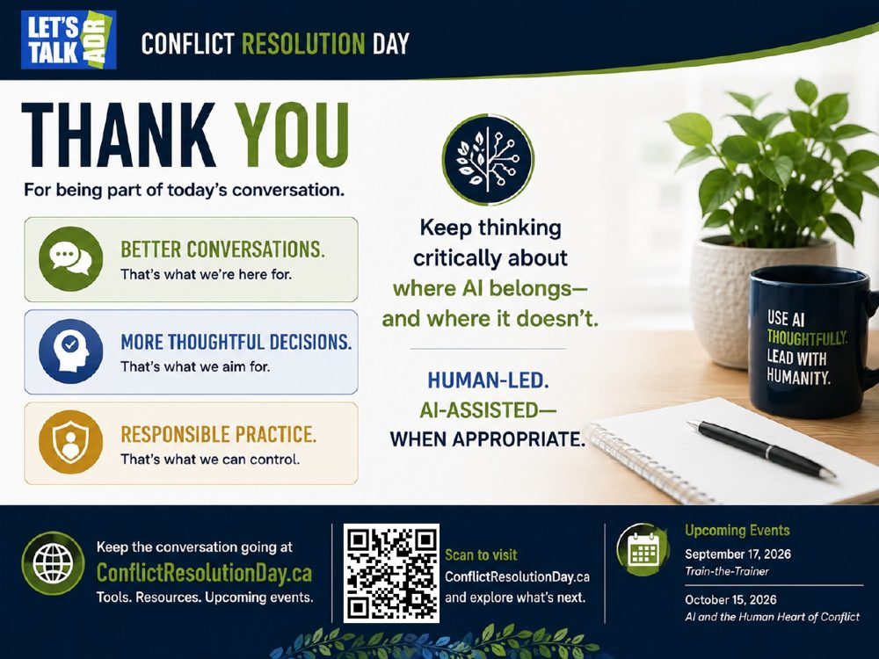 | TRAINER SNAPSHOT  Delivery: CORE • CLOSE  Suggested time: 2 min  Purpose: Close the session on a clear, neutral, human-centred note. Reinforce that the goal was not to persuade participants to adopt AI, but to help them make more thoughtful decisions about where AI belongs, where it does not, and what responsibilities remain human.
Suggested Script
“Thank you for being part of today’s conversation.
We’ve covered a lot.
We’ve looked at what AI can do.
We’ve looked at where it can fail.
We’ve talked about privacy, ethics, authorization, verification, human judgment, and responsibility.
And through all of that, I hope one idea has remained consistent:
The goal is not more AI.
The goal is better thinking about AI.
Better conversations—that’s what we’re here for.
More thoughtful decisions—that’s what we aim for.
And responsible practice—that’s what we can control.
So as you leave today, I don’t want to tell you:
‘Go use AI.’
And I don’t want to tell you:
‘Don’t use AI.’
I want to leave you with a better question:
Where does AI belong—and where doesn’t it?
If it genuinely helps with an appropriate task, if the use is authorized, if the information is protected, if you can verify what matters, and if the important human judgment remains where it belongs—then AI may be a useful assistant.
And if those conditions are not there, the responsible decision may be to pause, check, or simply not use it.
That is why the final line of the presentation is:
Human-led.
AI-assisted—when appropriate.
If you want to keep exploring the ideas from today, you can find resources and upcoming events at ConflictResolutionDay.ca.
And most importantly, keep the conversation going.
Because the technology will continue to change.
Our responsibility is to keep asking good questions about how it affects people.
Thank you.”
KEY TEACHING POINT
The course does not advocate AI adoption or rejection.
It advocates informed, deliberate, responsible choice.
Participants should leave understanding that AI may be useful in some circumstances, inappropriate in others, and unnecessary in many—and that professional judgment remains central to deciding which is which.
IMPORTANT NUANCE — DO NOT OVERSTATE
Do not end the session with language that assumes participants will continue using AI.
Avoid phrases such as:
“Keep using AI wisely.”
Instead, preserve the neutral framing:
“Keep thinking critically about where AI belongs—and where it doesn’t.”
The phrases “better conversations” and “more thoughtful decisions” are aspirations, not promises that AI itself will improve those outcomes.
Likewise, “Human-led. AI-assisted—when appropriate.” is a professional-use principle, not a technical claim that all AI systems are incapable of autonomous action.
The QR code and website should be presented as optional continued resources, not a required next step.
Audience Interaction
Because this is the closing slide, keep interaction minimal.
You can ask one final reflective question:
“If you remember one question from today, what do you want it to be?”
Allow one or two responses.
If no one volunteers, offer the course’s central question:
“Should AI be used for this—and under what conditions?”
Then close without reopening discussion.
CLOSING
“Thank you for your time, your questions, and your willingness to think critically about this.
Keep asking better questions.
Protect the human relationship.
And wherever AI does belong in the work:
Human-led. AI-assisted—when appropriate.”

Slide 52 — Video Clip: Why Does It Feel Like AI Wants the Last Word?
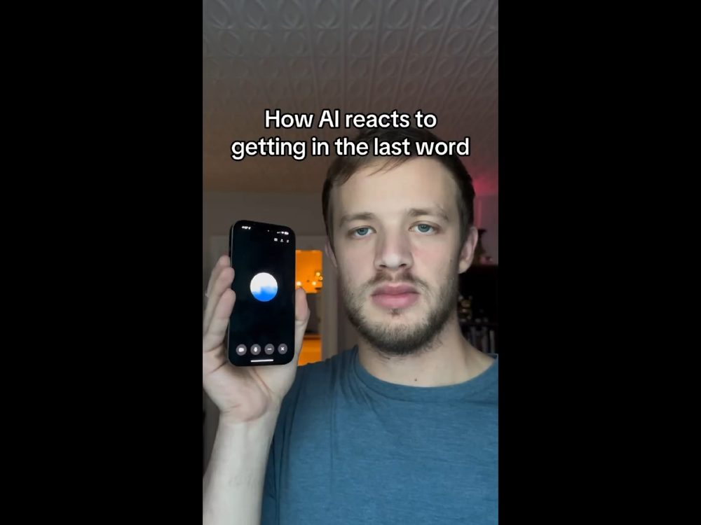 | TRAINER SNAPSHOT  Delivery: OPTIONAL • MEDIA  Suggested time: 3–5 min  Purpose: Use a light, memorable clip to demonstrate anthropomorphism—our tendency to assign human motives, emotions, personality, or intention to an AI system based on its behaviour. Connect that instinct directly to conflict resolution, where distinguishing observable behaviour from inferred motive is equally important.  ⚠ MEDIA: confirm source/permission, captions, AV, and fallback.  ⚠ ORDER: recommended before acknowledgements/final Thank You.
Suggested Script
“Before we finish, I want to show you one last clip.
It’s funny—but there is actually an important lesson underneath it.
As you watch, notice how quickly your brain starts assigning a personality or motive to the system.
You may find yourself thinking:
‘It wants the last word.’
‘It’s annoyed.’
‘It’s being competitive.’
‘It won’t let him win.’
Just notice that reaction.”
[Play clip.]
“Alright.
What did the AI actually do?”
[Allow responses.]
“It kept responding.
There was a back-and-forth.
There may have been interruption, overlap, or awkward turn-taking.
Those are things we can observe.
Now let me ask a different question:
What intention did you automatically attribute to it?”
[Allow responses: stubborn, annoyed, competitive, wanted the last word, etc.]
“And that distinction is the lesson.
The clip does not demonstrate that the AI wanted anything.
It does not demonstrate that it was irritated.
It does not show that it cared who spoke last.
And it certainly does not establish that it has an ego.
Those are interpretations we place on the behaviour.
Voice AI is specifically designed to create natural-feeling conversation. And natural conversation includes timing, pauses, interruptions, turn-taking, and sometimes imperfect responses.
Because the interaction feels social, our brains very naturally begin treating the system as though there is a person behind the behaviour.
There is a term for that:
anthropomorphism.
We attribute human characteristics, feelings, or motives to something that is not a human being.
And there’s a wonderful conflict-resolution lesson hiding in this too.
How often do we do exactly the same thing with people?
Someone interrupts us.
That is behaviour.
We decide:
‘They don’t respect me.’
That is an interpretation.
Someone doesn’t respond to an email.
That is behaviour.
We decide:
‘They’re ignoring me.’
That is an interpretation.
Someone crosses their arms.
Behaviour.
‘They’re angry with me.’
Interpretation.
Sometimes our interpretation is right.
Sometimes it isn’t.
So whether we are dealing with people or technology, there is value in separating:
What did I actually observe?
from:
What meaning or motive did I assign to it?
And that gives us the line I want you to remember from this clip:
Behaviour is observable.
Motive is an interpretation.
Apparently even AI can give us a conflict-resolution lesson without intending to.”
KEY TEACHING POINT
Human beings readily anthropomorphize conversational AI because it communicates in ways that resemble human social interaction.
A system’s observable behaviour does not, by itself, establish human-like intention, emotion, ego, irritation, competitiveness, or motive.
The broader conflict-resolution lesson is to distinguish observation from interpretation.
IMPORTANT NUANCE — DO NOT OVERSTATE
Do not present this clip as evidence about AI consciousness, emotion, intention, or personality.
The appropriate claim is limited to what can actually be observed: the system produced conversational responses and exhibited particular turn-taking behaviour.
Voice systems can experience imperfect timing, interruptions, overlapping speech, pauses, recognition errors, or other conversational irregularities. Those behaviours do not establish an underlying emotional state or motive.
If the provenance of the clip has not been independently verified, describe it as a social-media illustration, not a controlled demonstration of AI behaviour.
Before trainers use the clip, the facilitator package should record:
the original source,
date accessed,
product/model if known,
whether the clip appears edited or staged,
copyright or permission status,
caption availability,
and a backup plan if the video does not play.
Audience Interaction
Before the clip, ask:
“As you watch, notice what personality or motive your brain assigns to the AI.”
After the clip, ask two questions in this order:
“What did the system actually do?”
Keep answers focused on observable behaviour.
Then:
“What intention did you automatically attribute to it?”
Once the distinction appears, connect it to conflict:
“Can you think of a time when you interpreted someone’s behaviour as evidence of a motive—but later discovered another explanation?”
Do not require participants to share personal or sensitive conflict details.
Land the discussion with:
“Behaviour is observable. Motive is an interpretation.”
TRANSITION
“And that may be a fitting place to end.
AI can produce remarkably human-like interaction.
That makes these tools powerful—but it also makes our judgment even more important.
So whether you use AI frequently, cautiously, or not at all:
stay curious, question your assumptions, and keep the human judgment where it belongs.”

Appendix A — Recommended 90-Minute Core Route
This is a suggested facilitation route, not a new deck. It preserves the core learning arc while treating some media, philosophical questions, and worksheets as optional modules. Adjust for local requirements, clip length, and discussion depth.
Time | Slides | What to do | Compression note
0–8 min | 1–5 | Welcome, Land Acknowledgement, CR Day, boundaries, opening poll. | Use Slide 6 as pre-work/take-home if needed.
8–22 min | 7–10, 12–13 | Human/AI roles, GPT, language-model working model, context, human leadership. | Slide 11 optional; if used, keep to 2 minutes.
22–35 min | 14–20 | Conflict model, present-day AI, capabilities, hallucinations, bias/privacy. | Slide 16 optional.
35–47 min | 21–24 | Reframing communication. | Choose Slide 22 live demo OR Slide 23 worksheet, not both.
47–58 min | 26–30 | Incomplete context, Good Will Hunting, human-led principle, ethics/accountability. | Prioritize Slide 27; Slide 31 is optional.
58–66 min | 32, 33, 36, 37, 38 | Compressed philosophical block. | Do not run all five questions in a 90-minute session.
66–82 min | 40–43 | Ethics, privacy, AI Decision Framework, Before You Prompt. | Protect this block; it is the practical risk-management core.
82–87 min | 45–47 | Mediation example, Call to Awareness, final poll. | Slide 44 is optional/current-tools reference.
87–90 min | 49 / 52 / 50 / 51 | Optional learning resource, final comic beat if time, acknowledgements, thank you. | Slide 48 Practice Plan may be take-home.
DO NOT COMPRESS AWAY
The privacy/ethics/decision-framework content; the non-endorsement boundary; the requirement to use approved tools and authorized information; the distinction between AI assistance and human accountability.

Appendix B — Extended / Modular Delivery
For a half-day or professional-development session, retain the full worksheet practice, the Good Will Hunting discussion, the complete five-question philosophical block, the AI Decision Framework scenario, and the Practice Plan. Build at least one 10-minute break into any delivery exceeding two hours.
Philosophical block: full vs compressed
Mode | Use | Facilitator rule
Full 20–30 min | Slides 33–37 | Give each question room; do not declare a correct position.
Compressed 8–10 min | Slides 33, 36, 37 | One origin/value question, one authenticity question, one meaning/intention question.
Very tight 4–5 min | Slides 36–38 | Use the apology question and the synthesis only.

Appendix C — Authoritative Source Reference
Use this list when a participant wants the technical or policy basis behind a teaching point. Links were checked against the current course audit in September 2026. Trainers should still verify time-sensitive product and policy information before presenting.
NIST — AI Risk Management Framework (AI RMF 1.0): https://www.nist.gov/publications/artificial-intelligence-risk-management-framework-ai-rmf-10
NIST — Generative Artificial Intelligence Profile (NIST AI 600-1): https://www.nist.gov/publications/artificial-intelligence-risk-management-framework-generative-artificial-intelligence
Office of the Privacy Commissioner of Canada — Principles for responsible, trustworthy and privacy-protective generative AI: https://www.priv.gc.ca/en/privacy-topics/technology/artificial-intelligence/gd_principles_ai?wbdisable=true
Law Society of Alberta — The Generative AI Playbook: https://www.lawsociety.ab.ca/resource-centre/key-resources/professional-conduct/the-generative-ai-playbook/
Government of Alberta — IMT Policy Tools Portal / Artificial Intelligence Usage Policy: https://www.alberta.ca/lookup/imt-policy-tools-portal.aspx
Conflict Resolution Day Alberta: https://www.conflictresolutionday.ca/
Alberta AI Academy: https://albertaaiacademy.com/
Vaswani et al. — Attention Is All You Need: https://arxiv.org/abs/1706.03762
OpenAI — Why language models hallucinate: https://openai.com/index/why-language-models-hallucinate/
OpenAI — Voice Mode FAQ: https://help.openai.com/en/articles/8400625-voice-mode-faq
Source freshness rule
Evergreen frameworks (NIST, privacy principles) should still be checked periodically. Product capabilities, names, account-level privacy practices, GoA-approved tools/use cases, and training resources are time-sensitive and should be re-verified close to delivery.

Appendix D — Participant Worksheet Copies
These copies are included for trainer reference. Use the participant-ready originals supplied with the course when printing or distributing materials.
Slide 6 — AI & Me: Where Do I Stand?
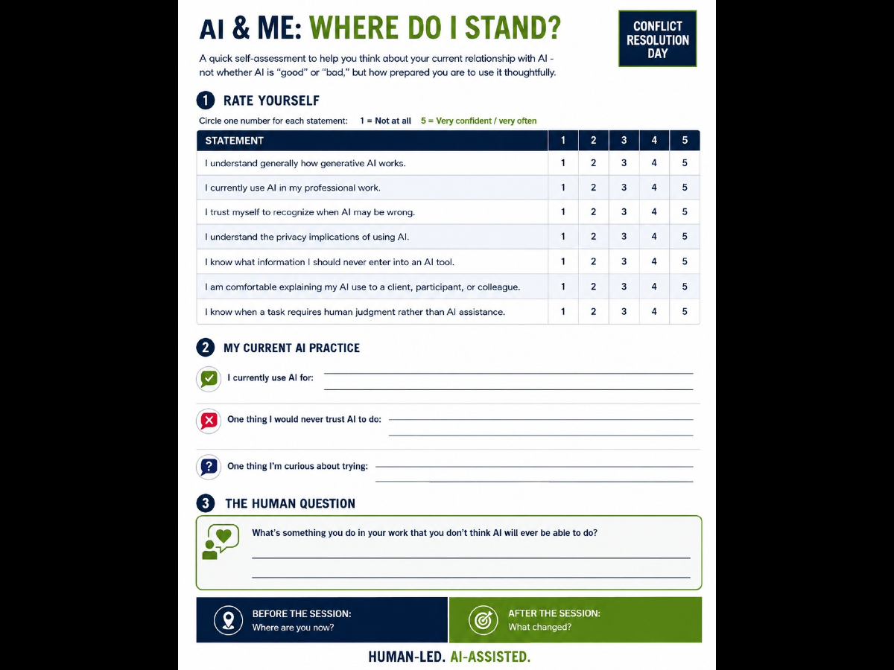

Slide 23 — Worksheet 2: From Reaction to Response
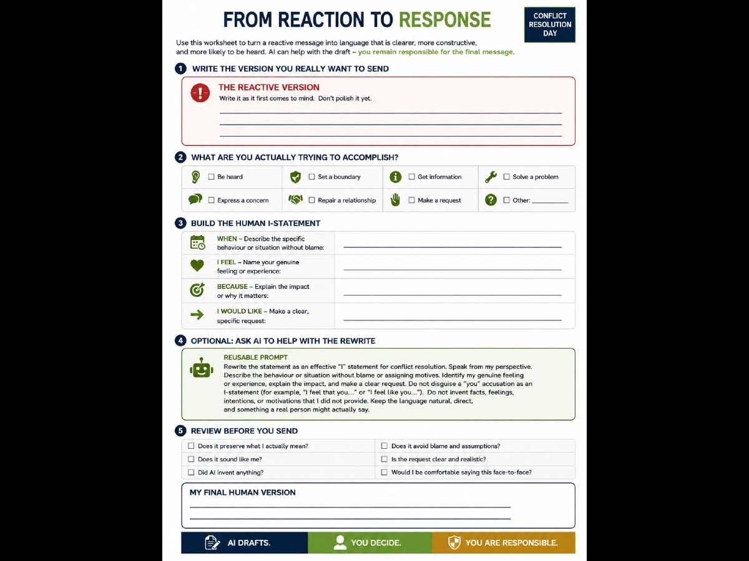

Slide 43 — Worksheet 3: Before You Prompt
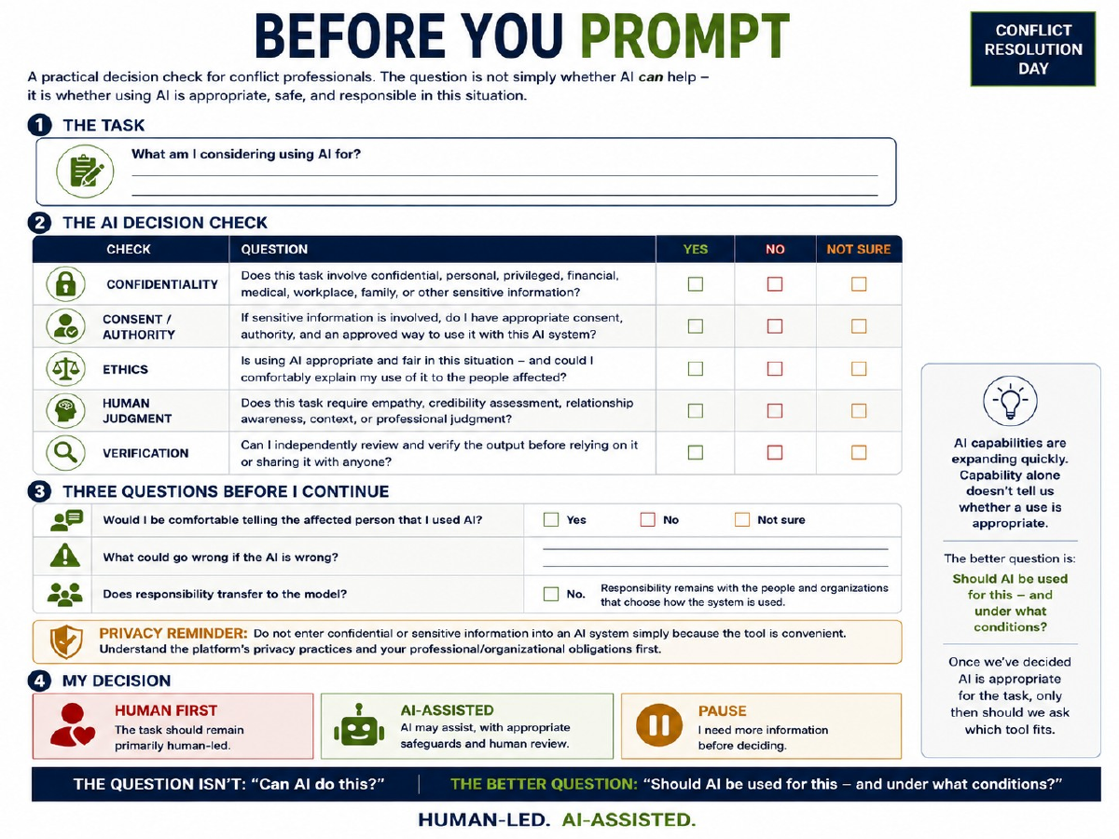

Slide 48 — Worksheet 4: My AI Practice Plan
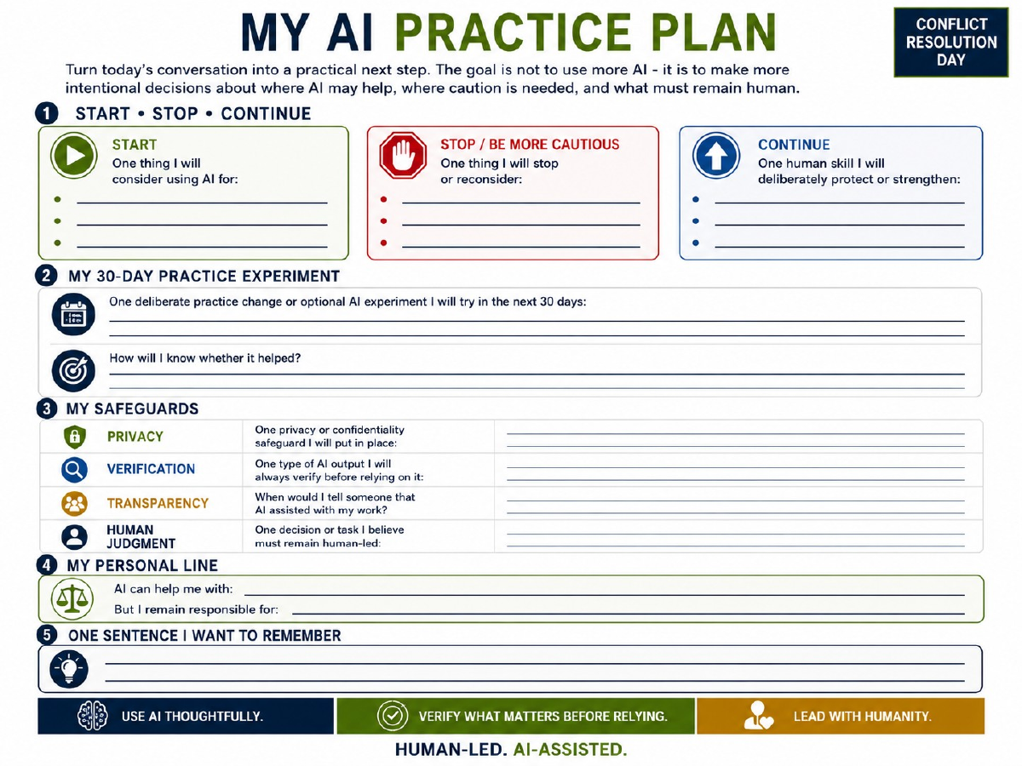

Appendix E — Version & Trainer Update Log
Use this page to capture changes that should be incorporated into the next master version rather than allowing individual trainers to drift into different course claims.
Date | Slide / topic | What changed or was questioned? | Source / policy checked | Action for next version
Trainer debrief questions
- Where did participants need more nuance than the slide provided?
- Which exercise took longer than planned?
- Did any wording sound like an AI endorsement rather than neutral education?
- Did any participant raise a privacy, legal, or policy question that should be formally sourced?
- Which product/tool names changed?
- Which clip or live demo needs a better fallback?
- What should be clarified before the next Train-the-Trainer session?

